|  |  |  |  |  |  |  |  |  |  |  |  |  |
| --- | --- | --- | --- | --- | --- | --- | --- | --- | --- | --- | --- | --- |
| Roll No |  |  |  |  |  |  |  |  |  |  |  |  |



**Presidency University**

**Bengaluru**

**SCHOOL OF COMMERCE**

**Summer Term End Term Examinations, August 2024**

**Winter Semester**: 2023 - 24

**Course Code**: MAH2004

**Course Name**: Strategic Financial Management

**Program & Sem**: BBA & 5th Semester

**Date**: 05-08-2024

**Time**: 09:30 AM to 12:30PM

**Max Marks**: 100

**Weightage**: 50%

**Instructions:**

1. *Read the all questions carefully and answer accordingly.*
2. *Question paper consists of three parts.*
3. *Scientific and Non Programable Calculators are Permitted.*
4. *Do not write any information on the question paper other than roll number.*

**Part A**

**Answer any FIVE Questions. (5 Q x 2 M = 10 M)**

1.What is ROA? (C.O.1) [Understanding]

2. Briefly explain the concept Common Size Analysis. (C.O.1) [Understanding]

3. List out the Profitability Ratios. (C.O.2) [Understanding]

4. Give the formula for Net Profit Ratio. (C.O.2) [Understanding]

5. What is Cost of Capital? (C.O.3) [Understanding]

6. What is Circulating Capital? (C.O.4) [Understanding]

7. Write a short note on Merger. (C.O.5) [Understanding]

**Part B**

**Answer any FIVE Questions. (5 Q x 10 M = 50 M)**

8. List out the difference between Fixed, Flexible and Floating Exchange Rates in Detail. (C.O.5) [Apply]

9. Explain Various Working Capital Approaches. (C.O.4) [Apply]

10. Comparative Analysis

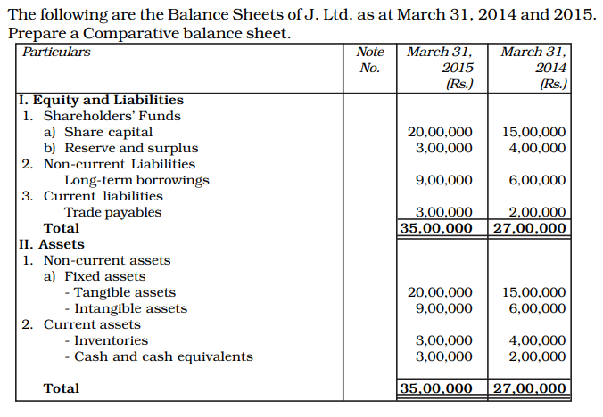 (C.O.1) [Apply]

11. How do you measure the performance of any firms? (C.O.2) [Apply]

12. Other Current Assets – 50000, Cash – 5000, Inventories – 10000, Prepaid Expenses – 5000, Current Liabilities – 10000. Calculate Current Ratio, Quick Ratio and Cash Ratio. (C.O.2) [Apply]

13. Explain the ways to calculate cost of capital for Equity, Preference and Debentures (C.O.3) [Apply]

14. Common Size Analysis

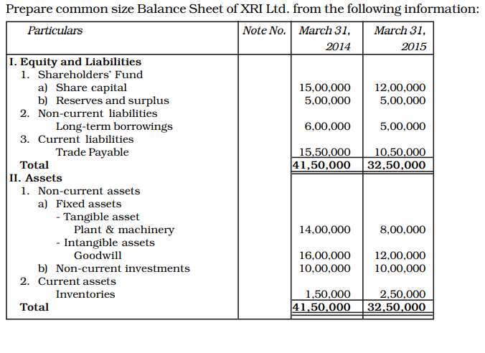 (C.O.1) [Apply]

**Part C**

**Answer any TWO Questions. (2 Q x 20 M = 40 M)**

15. List out the formulae for Profitability, Liquidity and Activity Ratio with Ideal Ratios (C.O.2) [Analysis]

16.Calculate following Ratios from the Given Data.

|  |  |
| --- | --- |
| **Particulars** | **Rs** |
| Current Assets | 100000 |
| Current Liabilities | 10000 |
| Total Assets | 500000 |
| Revenue | 10000 |
| Equity Shares | 5000 |
| Inventories | 25000 |
| Prepaid Expenses | 25000 |
| Cash | 10000 |
| Net Profit | 20000 |
| Sales | 200000 |
| Cost of Goods Sold | 100000 |
| Calculate,   1. Current Ratio 2. Quick Ratio 3. Cash Ratio 4. Net Profit Ratio 5. Gross Profit Ratio 6. ROA 7. ROE | |

(C.O.2) [Analysis]

17. Prepare Common Size and Comparative Analysis for the Following Data.

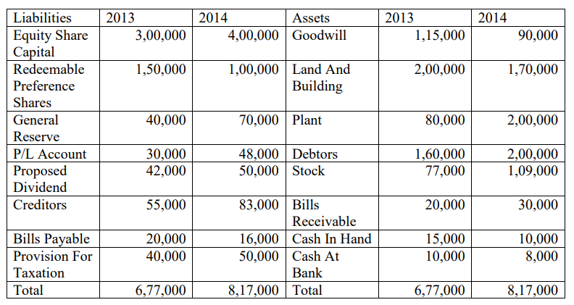

(C.O.1) [Analysis]