|  |  |  |  |  |  |  |  |  |  |  |  |  |
| --- | --- | --- | --- | --- | --- | --- | --- | --- | --- | --- | --- | --- |
| Roll No |  |  |  |  |  |  |  |  |  |  |  |  |



**Presidency University**

**Bengaluru**

**SCHOOL OF ENGINEERING**

**SUMMER TERM END TERM EXAMINATION - AUGUST 2024**

**Date: 05-08-2024**

**Time: 9.30am to 12.30pm**

**Max Marks: 100**

**Weightage: 50%**

**Summer term: 2023 - 24**

**Course Code: MEC 219/4007**

**Course Name: Design of Machine Elements – II**

**Program & Sem: B. Tech. (Mechanical Engg.) – VI Sem**

**Instructions:**

1. *Read the all questions carefully and answer accordingly.*
2. *Use of Design Data Hand book permitted*
3. *Use of Scientific Calculator permitted.*

**Part A [Memory Recall Questions]**

**Answer any 5 Questions. Each question carries 2 marks. (5Qx2M= 10M)**

1. Enlist any 2 advantages of Chain Drives. (C. O. No.1) [Knowledge]

2. Identify the different types of springs with diagram (C. O. No.2) [Knowledge]

3. Describe the Self Energizing in brakes. (C. O. No.5) [Knowledge]

4. Define Clutch. Identify the advantages and disadvantages of a positive clutch.

(C. O. No.4) [Knowledge]

5. Enlist any two properties of Lubricants (C. O. No.5) [Knowledge]

6. Define solid length of the helical spring. (C. O. No.2) [Knowledge]

7. Define NIP in a leaf spring design. . (C. O. No.2) [Knowledge]

**Part B [Thought Provoking Questions]**

**Answer any 5 Questions. Each question carries 10 marks. (5Qx10M=40M)**

8. Volvo Eicher wants to conduct the study of belt tension ratios in Belt drives Design. As An Engineer suggest and derive the suitable relation for ratio.

(C. O. No.1) [Comprehension]

9. A car crash test spring is drop tested as a chunk of metal weighing 1kN load is suddenly dropped on it from a height of 250mm. the spring has 20 turns and has a wire diameter of 20mm. Assuming spring index of 8 & Modulus of rigidity of 84 GPa. Predict the deflection experienced by the spring.

(C. O. No.2) [Comprehension]

10.Asia Motor Works (AMW) is a Heavy Commercial Manufacturing Company having manufacturing plant at Gandhidham, Bhuj. The company wants to re look into the clutch design procedures. As an Engineer suggest the criterions used for clutch design to AMW and explain any one with procedure

(C. O. No.4) [Comprehension]

11. A good lubrication between moving surfaces is desired and can be achieved by many suitable means with the required properties. Enlist any 3 lubrication mechanism with a neat sketch and explain the same. (C.O. No. 5)[Comprehension]

12. A worn out clutch has come for redesign and the engineer illustrates that it has multiple conical surfaces. Identify the type of clutch and enlist the design procedure for the same.

. (C.O. No. 5)[Comprehension]

13. An electric motor has to drive an exhaust fan. A flat leather belt is used in the drive. The thickness of the belt is 6.25 mm and maximum permissible stress in the belt is 2.1 MPa. The belt weighs 9708 N/m3.Identify which pulley governs the design and width of the belt from the above data.

|  |  |  |
| --- | --- | --- |
| **Particulars** | **Motor pulley** | **Fan pulley** |
| **Diameter** | **300 mm** | **1200 mm** |
| **Contact Angle** | **2.5 radian** | **3.78 radian** |
| **Coefficient of friction** | **0.3** | **0.25** |
| **Speed** | **900 rpm** |  |
| **Power transmitted** | **22 kW** |  |

(C.O. No. 1)[Comprehension]

**Part C [Problem Solving Questions]**

**Answer any 2 Questions. Each question carries 20 marks. (2Qx20M=40M)**

14. Design a pair of steel straight toothed gears to transmit 12 kW between parallel non-intersecting shafts at 1200 rpm of pinion. The velocity ratio required is 4:1. The pitch line velocity of gears is not to exceed 12 m/s.

(C. O. No.3) [Application]

15. A single plate clutch is used to connect or disconnect a machine to the source of 30 kW power running at 1200 rpm. The outer diameter of the friction lining used in clutch is 1.5 times the inner diameter. The friction lining material is woven asbestos and opposing plate material is steel. The shaft is made up of C40 steel having yield point strength 324 MPa and take fos= 2.5

Determine some of the main design parameters considering uniform wear criteria.

(C. O. No.4) [Application]

16. A shoe brake is used to stop a drum which receives 23.5 kW of power at 1000rpm. Diameter of brake drum is 720mm and the friction material is asbestos. Illustrate whether the brake will self-lock or not.

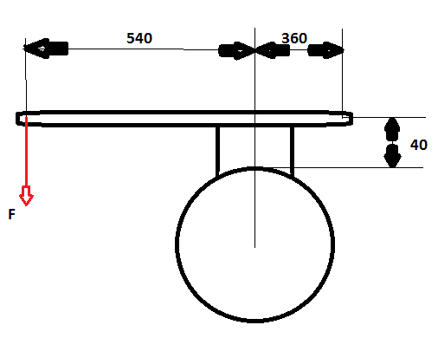

(C. O. No.4) [Application]