|  |  |  |  |  |  |  |  |  |  |  |  |  |
| --- | --- | --- | --- | --- | --- | --- | --- | --- | --- | --- | --- | --- |
| Roll No. |  |  |  |  |  |  |  |  |  |  |  |  |



**Presidency University Bengaluru**

**SCHOOL OF ENGINEERING**

**SUMMER END TERM EXAMINATION AUG-2024**

**Semester**: Summer Term

**Course Code**: PHY1002

**Course Name**: Optoelectronics and device Physics

**Programme**: B.Tech

**Date**: 08-08-2024

**Time**: 9:30am to 12:30pm

**Max Marks**: 100

**Weightage**: 50%

**Instructions: (i) Read all the questions carefully and answer accordingly.**

**(ii) Question paper consists of 3 parts.**

**(III) Scientific and non-programmable calculator are permitted**

**(iv) Do not write any information on the question paper other than roll number**

**(v) Given: k=1.38x10-23J/K, h=6.626x10-34Js, me=9.1x10-31kg and c=3x108m/s**

**Part A**

**ANSWER ANY TEN QUESTIONS 10Q⨉2M=20M**

1. Define Fermi Level. . (CO1) [Knowledge]
2. Write any two applications of LED. (CO2) [Knowledge]
3. Define critical temperature. (CO2) [Knowledge]
4. What are semiconductors? Give 2 examples. (CO1) [Knowledge]
5. How are solids classified based on band theory. (CO2) [Knowledge]
6. Define metastable state. (CO1) [Knowledge]
7. What is a zener diode? (CO1) [Knowledge]
8. Find the de Broglie wavelength of an electron when it is accelerated through a potential difference of 200V. (CO3) [Knowledge]
9. Define Meissner effect?
10. What is stimulated emission of light? (CO4) [Knowledge]
11. Calculate the minimum uncertainty in the momentum of an electron if its position is 0.1nm.

(CO4) [Knowlwdge]

1. Define Hall Effect. (CO1) [Knowledge]

**Part B**

**ANSWER ANY EIGHT QUESTIONS 8Q⨉5M=40M**

1. It is possible to destroy the superconductivity in the material by applying certain magnetic field. This field is called critical field HC based on this concept discuss the differences between Type I and Type II Superconductors.

(CO1) [Comprehension]

1. Calculate the Hall voltage when a conductor carrying a current of 100 A, is placed in a magnetic field of 1.5 T. The conductor has a thickness of 1 cm, and the number density of charges inside the conductor is 5.9 ×1028 /m3. (CO4) [Comprehension]
2. Estimate the fraction of electrons in the conduction band at 300K in Ge with Eg=0.72eV.

(CO4) [Comprehension]

1. The ratio of population of two energy levels is 1.46x10-30. Calculate the wavelength of light emitted at the thermal equilibrium temperature of 300K. (CO4) [Comprehension]
2. Are superconductor’s diamagnetic materials? Justify with proof.
3. SiC based LED emits blue light of the wavelength 450nm. Find the band gap of LED.

(CO2) [Comprehension]

1. Explain the concept of matter waves in the context of quantum mechanics with their characteristic properties. (CO2) [Comprehension]
2. Calculate the critical angle for a given refractive index core and cladding at 1.48 and 1.46.

(CO2) [Comprehension]

1. Identify the optical semiconductor device which emits light when voltage is applied. Explain its construction and working principle. (CO2) [Comprehension]
2. Derive an expression for de Broglie wavelength in terms of energy of the particle.

(CO3) [Comprehension]

**Part C**

**ANSWER ANY FOUR QUESTIONS 4Q⨉10M=40M**

1. Electron-electron interaction via phonon. Explain the theory behind the concept

(CO2) [Application]

1. Explain the conditions, characteristics and any two applications of lasers in modern technology. (CO2) [Application]
2. The light signal can be used to transfer information over long distances with negligible energy loss. Describe the concept with neat labelled block diagram. (CO4) [Application]
3. (a) Particles A and B having masses m and 4m are moving with same kinetic energies. Calculate the ratio of de Broglie wavelength of particle A to B.

(b) Find the population of the two states in a diode laser that produces a light of wavelength 600nm at 305K. (CO4) [Application]

1. It is observed that an optoelectronic device creates a significant voltage when exposed to sunlight. Identify the device and explain its construction, working principle and I-V Characteristics. (CO4) [Application]
2. The I-V characteristics of a pn junction device is as shown in figure. (CO4) [Application]

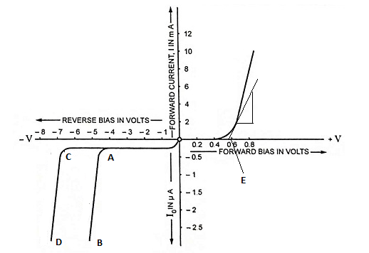

1. Define E
2. Differentiate AB and CD
3. Calculate the input resistance.