|  |  |  |  |  |  |  |  |  |  |  |  |  |  |
| --- | --- | --- | --- | --- | --- | --- | --- | --- | --- | --- | --- | --- | --- |
| Roll No. |  |  |  |  |  |  |  |  |  |  |  |  |  |

 **Presidency University**

**Bengaluru**

**SCHOOL OF ENGINEERING**

**Summer Term End Term Examination –August 2024** 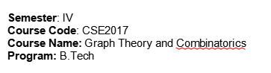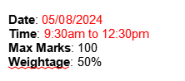

**Instructions:**

1. *Read all the questions carefully and answer accordingly.*
2. *Question paper consists of 3 parts.*
3. *Scientific and Non-programmable calculators are permitted.*

**Part A [Memory Recall Questions]**

**Answer any FIVE questions 5Q x 4M = 20M**

1. Among a group of students, 49 study Physics, 37 study English and 21 study Biology.If 9 of these students study Physics and English, 5 study English and Biology, 4 study Physics and Biology and 3 study Physics, English and Biology,find the number of students in the group. (CO1) [Knowledge]
2. Define bipartite graph and star graph. Give one example for each .
   * + 1. (CO2) [Knowledge]
3. Can there be a graph with 10 vertices such that 2 of the vertices have degree 3 each and the remaining 8 vertices have degree 4 each. (CO2) [Knowledge]

4. Draw a cubic graph and a C:\Users\ADMINI~1\AppData\Local\Temp\ksohtml6056\wps4.jpg graph. (CO2) [Knowledge]

5. Define spanning tree of a graph G and give one example. (CO3) [Knowledge]

6. Define m-ary tree and complete m-ary tree. Give one example for each .

(CO4) [Knowledge]

**Part B [Thought Provoking Questions]**

**Answer any FIVE questions. 5Q x 10M = 50M**

7. An apple, a banana, a mango, and an orange are to be distributed to 4 boys B1 , B2 ,B3, andB4. The boys B1 and B2  do not wish to have apple, B3 does not want either banana or mango and B4 does not like orange. In how many ways the distribution can be made so that no boy is displeased? (CO1) [Comprehension]

8. Find the adjacency matrix and incidence matrix for the following graph.

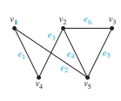CO2) [Comprehension]

9. Define isomorphism and Verify the graphs shown below are isomorphic or not.

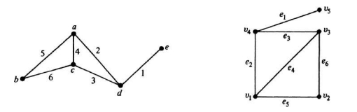

(CO2) [Comprehension]

10. Define Chromatic number of a graph and How can the final exams at a university be scheduled so that no student has two exams at the same time?

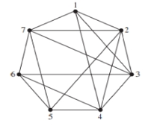 (CO3) [Comprehension]

11.Define binary search tree with example and form the binary search tree for the following names Build a binary search tree for the word’s banana, peach, apple, pear, coconut, mango, apricot, watermelon, blackberry, blueberry and papaya using alphabetical order. (CO3) [Comprehension]

12. Write Kruskal’s algorithm steps and explain with an example.

(CO3) [Comprehension]

**Part C [Problem Solving Questions]**

**Answer ANY TWO questions. 2Q x 15M = 30M**

13.How many solutions does C:\Users\ADMINI~1\AppData\Local\Temp\ksohtml6056\wps8.png have, where C:\Users\ADMINI~1\AppData\Local\Temp\ksohtml6056\wps9.png are non -negative integers with C:\Users\ADMINI~1\AppData\Local\Temp\ksohtml6056\wps10.png? (CO1) [Application]

14.a) Prove that complete bipartite graph C:\Users\ADMINI~1\AppData\Local\Temp\ksohtml6056\wps11.jpg and C:\Users\ADMINI~1\AppData\Local\Temp\ksohtml6056\wps12.jpg are non-planar graphs.(CO3) [Application]

b). Explain DFS algorithm with an example. (CO4) [Application]

14. (a) Explain Krushkal’s algorithm.

(b) Apply Dijistra’s algorithm for the following graph to find shortest path

from u to v.

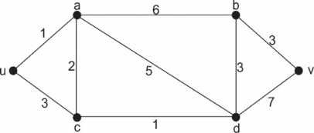

(CO5) [Application]