|  |  |  |  |  |  |  |  |  |  |  |  |
| --- | --- | --- | --- | --- | --- | --- | --- | --- | --- | --- | --- |
| Roll No |  |  |  |  |  |  |  |  |  |  |  |



PRESIDENCY UNIVERSITY BENGALURU

SCHOOL OF ENGINEERING

SUMMER TERM

END TERM EXAMINATION - AUGUST 2024

|  |  |
| --- | --- |
| **Course Code : ECE3029** | **Date :** 06-08-2024 |
| **Course Name :** **Digital Image Processing** | **Time :** 1pm to 4pm |
| **Program : B.Tech. Electronics and Communication Engineering** | **Max Marks :** 100 |
|  | **Weightage :** 50% |

**Instructions:**

1. *Read all questions carefully and answer accordingly.*
2. *Scientific and non-programmable calculator are permitted.*
3. *Do not write any information on the question paper other than Roll Number.*

**PART A**

**Answer any 5 questions out of 7 questions 5Q X 2M = 10M**

1. After digitization process a digital image with M rows and N columns have to be positive and for the number, intensity “L”. Then, number of bits required to store the image is B=MXNXK Determine the of “K” value for gray image _______ and color image ________ respectively.

(CO1) [Knowledge]

1. Digital image processing deals with manipulation of digital images through a digital compute. So _______ is the term most widely used to denote the smallest elements of a digital image and name the third step in digital image processing____. (CO1) [Knowledge]
2. Histogram is graphical representation of a digital image. The discrete function given as h(rk)=nk, here “rk” is ______ and “nk” is______. (CO2) [Knowledge]
3. An image transform can be applied to an image to convert it from one domain to another. So, log transformation can be represented by ____ formula and power law transformation by ______ formula. (CO2) [Knowledge]
4. A color image is a digital image that includes color information for each pixel. Name the three secondary colors ______. (CO4) [Knowledge]
5. Light is a form of electromagnetic energy that can be completely specified at a point in the image plane by its wavelength distribution. The visible spectrum ranges from_____ to ___.

(CO4) [Knowledge]

1. Radiance is the total amount of energy that flows from the light source and luminance is the measure of amount of energy an observer perceives from a light source. So radiance is measured in_______units and Luminance is measured in______units. (CO4) [Knowledge]

**PART B**

**Answer any 2 questions out of 3 questions 2Q X 15M = 30M**

1. The purpose of image enhancement is to or to provide ‘better’ input for other system to improve the interpretability or perception of information in images for human viewing automated image processing techniques. Say a 3 bit 5x5 size digital image is obtained of a TAJ MAHAL (foreground) with tourists (background) using camera perform intensity level slicing where input intensity **r1=3 and r2=5**. (CO2) [Comprehension]

(a) Intensity level slicing with background

(b) Intensity level slicing without background

(c) Image negative

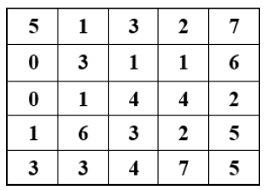

1. Huffman Coding is a lossless data compression algorithm, where variable-length code is assigned to different source input characters. Most frequent characters have the smallest codes and longer codes for least frequent characters. Suppose that we want to encode a message constructed from symbol “A to F” where respective probabilities are given which is shown in the table below. How many bits are required to encode each symbol and also mention the average length of the code. (CO3) [Comprehension]

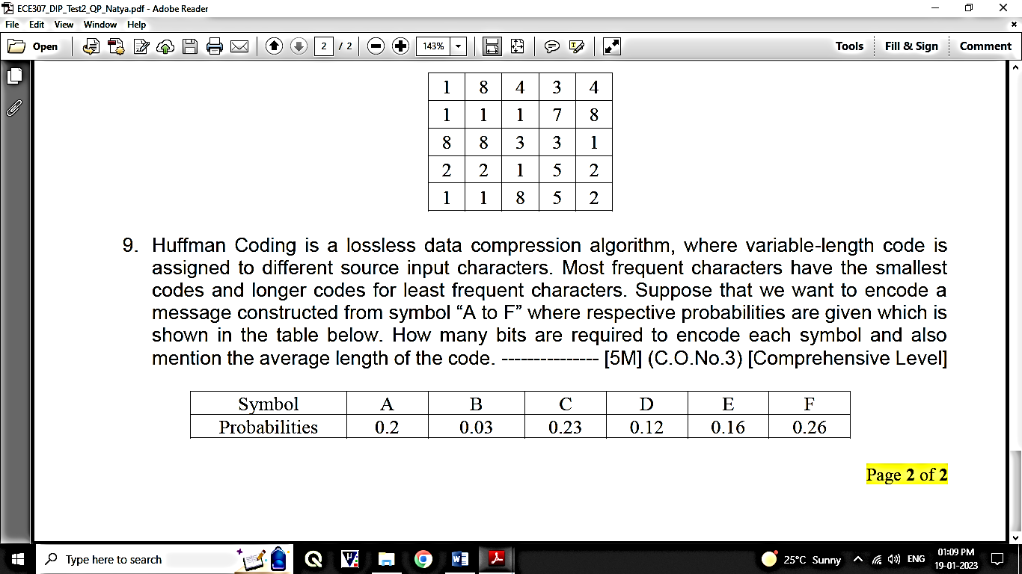

1. Segmentation subdivides an image into its constituent regions or objects and is for non-trivial images and one of the most difficult tasks in image processing. Its accuracy determines the eventual success of failure of the computerized analysis. To extract basic features such as points, edges and lines by abrupt changes in intensity can be detected using derivatives. An image strip ‘x’ a section of horizontal intensity profile given below taken from a glass building of a mall, identify the cracks by using 1st and 2nd derivative method. (CO3) [Comprehension]

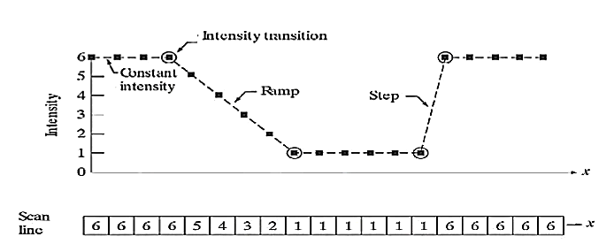

**PART C**

**Answer any 3 questions out of 4 questions 3Q X 20M = 60M**

1. H is a general operator, that operates on the input image f(x,y) to produce an output image g(x,y).
2. Considering F1 and F2 images given below with a1=1 and a2= -1 for the Operator H=MAX, The output of the system depends on the nature of the operator used in the system. Identify the nature of the given operator.
3. Repeat the above problem for the operator H= MIN (CO1) [Comprehension]

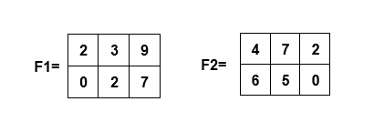

1. Consider an images having 4 coordinates, perform translation by a translation vector (2,2) and then scale the image by a factor 2 for the image formed by the coordinates (0,0), (0,4), (3,0) and (3,4) Draw the new transformed figure with its new coordinates values. (CO2) [Comprehension]
2. Given an Image **“A”** and its structuring element **“B”**. Compute the Output Image.

(CO4) [Comprehension]

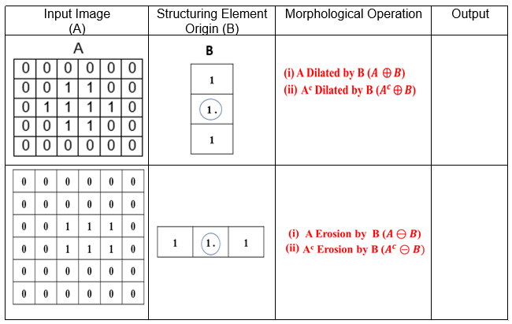

1. In digital x-rays in which colors achieved are a palette of whites and blacks, different types of colors give the physician an idea of the type of density that he/she is observing. For example, in the case of the chest the heart, lungs, and blood vessels are so close together that contrast is critical for achieving an accurate diagnosis. Hence histogram equalization is a straightforward image-processing technique often used to achieve better quality images in black and white color scales in medical applications. Considering above problem statement, suppose a 3-bit image of size 5x5 having intensity distribution as shown in figure below, where intensity levels are in the range 0-7, perform histogram equalization transformation by scaling the intensity to 0-15. Note: Approximate the result obtained during simplification to only 2 decimal places.

(CO2) [Comprehension]

