|  |  |  |  |  |  |  |  |  |  |  |  |  |  |
| --- | --- | --- | --- | --- | --- | --- | --- | --- | --- | --- | --- | --- | --- |
| Roll No. |  |  |  |  |  |  |  |  |  |  |  |  |  |



**Presidency University**

**Bengaluru**

**SUMMER TERM END TERM EXAMINATION AUGUST 2024**

**School/Department**: Engineering

**Course Code**: ECE3111

**Course Name**: Microprocessor & Microcontroller

**Course Credit: 3-0-3**

**Date**: 05/08/2024

**Time**: 1.00PM-4.00PM

**Max Marks**: 100

**Weightage**: 50%

**Instructions:**

1. *Read the question properly and answer accordingly.*
2. *Question paper consists of 3 parts.*

**Part A [Memory Recall Questions]**

**Attempt any five questions. Each question carries 4 marks. (5Qx4M=20M)**

1. Write the addressing mode of the following instructions of 8086.   4 Marks  
   i) MOV [4560H], AX  
   ii) ADD BL, 89H  
   iii) ADD BX, [DI]  
   iv) MOV 6[BP][DI], AL [CO1, BT-Knowledge]
2. The buses in the 8086 microprocessor play a crucial role in allowing the microprocessor to access and transfer data from memory, as well as to interact with other components in the computer system. How many address and data lines are needed for the memory chips with the following organization?  4 Marks

256 × 4

512 × 8

1K × 16

32 K × 8 [CO1, BT-Knowledge]

1. The architecture of the 8086 microprocessor is based on a complex instruction set computer (CISC) architecture. Attempt the following questions: 4×1 marks  
   a) Name the 8-bit registers of 8086.  
   b) Which are the first and last memory addresses that an 8086 can address?  
   c) Which unit (EU or BIU) is responsible for performing arithmetic calculations?  
   d) What is the difference in operation between the carry flag and the overflow flag? [CO1, BT-Knowledge]
2. There are a total of 14 registers in the 8086 microprocessor. Write down all the registers of 8086.
3. In Arithmetic instructions, the flag register is modified. What is the difference between ADD and ADC instruction? Explain with one example.

[CO1, BT-Knowledge]

**Part B [Thought Provoking Questions]**

**Attempt any four questions. Each question carries 10 marks. (4Qx10M=40M)**

1. 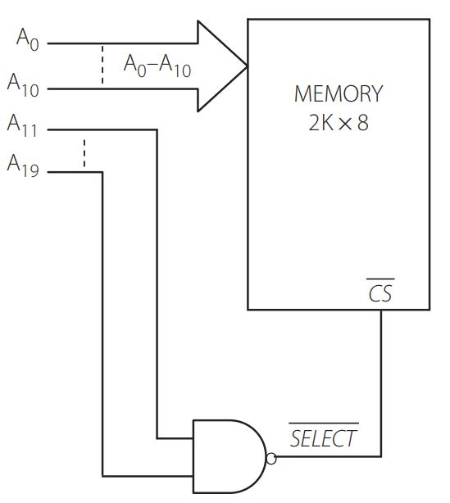Find out the range of addresses that the memory chip in Figure contains

[CO2, BT- Comprehension]

1. The 8086’s ability to use various buses efficiently and effectively helps to ensure that it remains competitive in its performance and capabilities, even as technology continues to advance. Design an address decoder using OR logic for a 32 K × 8 RAM. Find the address space of this memory chip.

[CO2, BT- Comprehension]

1. The 8086 CPU segments memory into 16 64kB segments to increase execution and fetching speed. The CPU has four segment registers named CS, DS, ES, and SS  
   a) The contents of the following segment registers of 8086 are as given. CS = 1111H, DS = 3333H, SS = 2526H. IP = 1232H, SP = 1100H, off set in data segment = 0020H. Calculate the corresponding physical addresses for the addressed byte in      6 Marks  
     
   i) Code segment    
   ii) Stack segment  
    iii) Data segment.  
   b) Find the address of physical memory for the following instructions of 8086 if the content of the required registers are as given  SS = 2344H, DS = 4022H, BX = 0200H, BP = 1402H, SI = 4442H                                            4 Marks  
   i) MOV CL, 1234H[SI]  
   ii) MOV AL, 5[SI][BP]

[CO2, BT- Comprehension]

1. The logical instructions are the instruction that performs logical operation between the source operand and destination operand and the result is saved in the destination. Write the output (AX) of the following programs.  
   a) MOV AX, 1234H  
       MOV BX, 5678H  
       AND AX, BX  
       HLT                                         2.5M  
     
   b) MOV AX, 1234H  
       MOV BX, 5678H  
       XOR AX, BX  
       HLT                                         2.5M

b) Write an Assembly Language Program (ALP) in 8086 for counting numbers of 1’s in the content of the Accumulator (AL) register. Assume any number in the AL register. Store the total count in the register BL 5Marks

[CO2, BT- Comprehension]

**Part C [Problem Solving Questions]**

**Attempt both questions. Each question carries 20 marks. (2Qx20M=40M)**

1. (i) The way in which operands are specified in an assembly language instruction is called its addressing mode. Explain the addressing modes of the 8086 microprocessor with one example for each one. 10 M [CO1, BT-Knowledge]

(ii)Write an Assembly Language Program (ALP) in 8086 to find the factorial of 10. 10 Marks [CO2, BT- Comprehension]

1. (i)Explain the architecture of 8086 Microprocessor.
2. Marks [CO1, BT-Knowledge]

(ii)Write an Assembly Language Program (ALP) in 8086 to find the sum of the first 10 natural numbers (1+2+3….+10). Assume that the numbers are stored in memory address 2000H onwards. Store the sum in memory address 3000H.

10 Marks [CO2, BT- Comprehension]