|  |  |  |  |  |  |  |  |  |  |  |  |  |
| --- | --- | --- | --- | --- | --- | --- | --- | --- | --- | --- | --- | --- |
| Roll No |  |  |  |  |  |  |  |  |  |  |  |  |



**Presidency University**

**Bengaluru**

**SCHOOL OF ENGINEERING**

**SUMMER TERM END TERM EXAMINATION- AUGUST 2024**

**Date**: 06-08-2024

**Time**: 09:30 AM to 12:30 PM

**Max Marks**: 100

**Weightage**: 50%

**Semester:** VIII

**Course Code**: CIV 3004

**Course Name**: DESIGN OF STRUCTURAL STEEL ELEMENTS

**Program & Sem**: B.TECH. & VI SEM

**Instructions:**

1. *Assume any suitable data if any*
2. IS: 800 -2007 and IS: 808 codes are permitted.

**Part A [Memory Recall Questions]**

**Answer any FOUR Questions. Each Question carries 05 marks. (4Qx 5M = 20M)**

1. Enumerate the advantages and disadvantages of steel as a structural material.

(C.O.No.1) [Knowledge]

1. Discuss the different load combinations in limit state design as specified by IS: 800 code.

(C.O.No.1) [Knowledge]

1. Write the advantages of bolted connection. (C.O.No.1) [Knowledge]
2. Write short notes on i) Lap joint ii) Butt joint. (C.O.No.2) [Knowledge]
3. Write brief note on concept of shear lag. (C.O.No.3) [Knowledge]
4. List the factors depends on the strength of the column. (C.O.No.4) [Knowledge]

**Part B [Thought Provoking Questions]**

**Answer any FOUR questions. Each Question carries 10 marks. (4Qx10M = 40M)**

1. Write short notes on the limit state of strength and serviceability as specified in IS: 800 code.

(C.O.No.1) [Comprehension]

1. Explain the different types of failures in tension members. (C.O.No.3) [Comprehension]

1. Explain the different failure modes in compression members with sketch.

(C.O.No.4) [Comprehension]

1. A 300 ISF 10mm of grade Fe 410 is used as a tension member in a lattice girder. It is connected to a 12mm thick gusset plate by 20mm diameter bolts of grade 4.6. Calculate the effective net area for the member shown in **Fig.Q.10**

(C.O.No.1) [Comprehension]

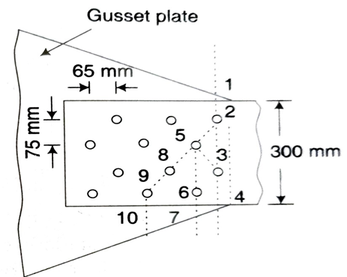

**Fig.Q.10**

1. Determine the block shear strength of the welded tension member shown in Fig.Q11. Steel is of grade Fe410. (C.O.No.1) [Comprehension]

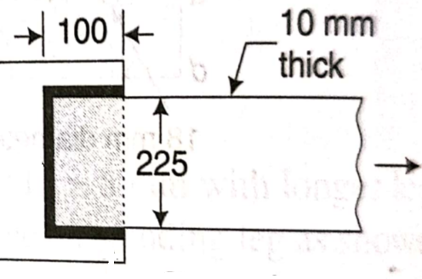

**Fig.Q11**

1. Determine the block shear strength of the tension member shown in Fig.Q.12 below.

(C.O.No.1) [Comprehension]

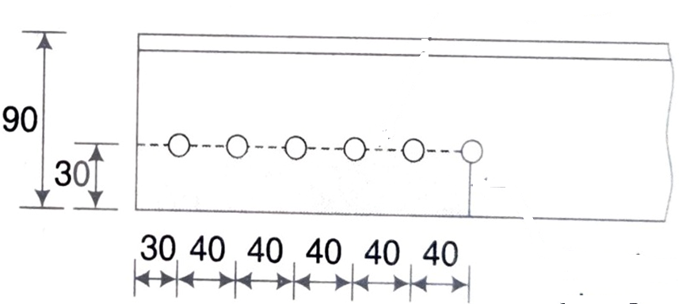

**Fig.Q.12**

**Part C [Problem Solving Questions]\**

**Answer any TWO Questions. Each Question carries 20 marks. (2Qx20M = 40M)**

1. Calculate the strength of a 20mm diameter bolt of grade 4.6 for the following cases: the main plates to be jointed are 12mm thick.  
   a) Lap Joint  
   b) Double cover butt joint, the cover plates being 8mm thick. (C.O.No.1) [Application]
2. A single unequal angle 100x75x8mm (A = 1050mm2) is connected to a 12mm thick gusset plate at the ends with six 18mm dia bolts to transfer tension as shown in Fig. Q14. Determine the design tensile strength of the angle if the gusset plate is connected to 100mm leg. Take fu = 410 MPa and fy = 250 MPa. (C.O.No.3) [Application]

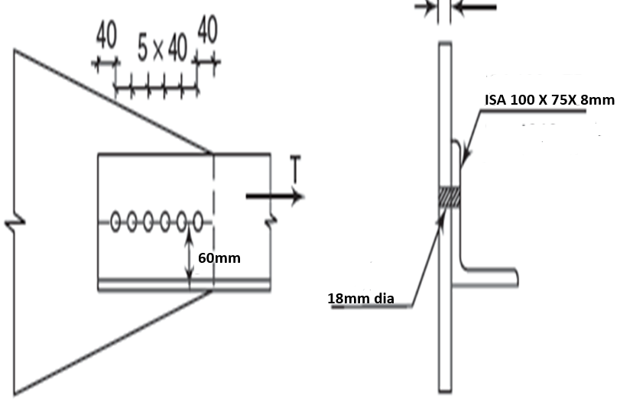

**Fig. Q14**

1. Design a single angle section for a tension member of a roof truss to carry a factored tensile force of 250kN. The members are subjected to the possible reversal of stress due to the action of wind. The effective length of member is 3m. Use 20mm shop bolts of grade 4.6 for the connection.

(C.O.No.3) [Application]