|  |  |  |  |  |  |  |  |  |  |  |  |  |
| --- | --- | --- | --- | --- | --- | --- | --- | --- | --- | --- | --- | --- |
| Roll No |  |  |  |  |  |  |  |  |  |  |  |  |



**Presidency University**

**Bengaluru**

**SCHOOL OF ENGINEERING**

**SUMMER TERM END TERM FINAL EXAMINATION-AUGUST 2024**

**Summer Term**: 2023-2024

**Course Code**: MAT 2004

**Course Name**: Discrete Mathematical Structures

**Program &Sem**: B. TECH

**Date**: 19-08-2024

**Time**: 1:00AM -4:00 PM

**Max Marks**:100

**Weightage**: 50%

**Instructions:**

1. *Read the all questions carefully and answer accordingly.*
2. *Question paper consists of 3 parts.*
3. *Scientific and non-programmable calculator is permitted.*
4. *Do not write any information on the question paper other than Roll number.*

**Part A [Memory Recall Questions]**

**Answer any FIVE Questions. Each question carries 4 marks. (5Qx 4M= 20M)**

1. Construct the truth table of $\left(p⋁q\right)⟶\left(p⋀q\right)$. [4M] (C01) [Knowledge]

2. Define universal quantification and find the truth value of the quantification $∀xp\left(x\right),$ if

$p\left(x\right)=x+1>x,$ where the domain consists of all real numbers. [4M] (C01) [Knowledge]

3. If is defined by $f\left(x\right)=ax+b$ for $a, b ∈R$ and $a≠0.$ Show that $f$ is invertible and find the

inverse of $f.$ [4M] (C02) [Knowledge]

4. Find the relation of the poset and draw the directed graph of $\left(\left\{1, 2, 3 , 4 \right\}, <\right)$.

[4M] (C02) [Knowledge]

5. Let f and g be the functions from the set of integers to the set of integers defined by f (x) = 2x+ 3 and

g(x) = 3x + 2. What is the composition of f and g? What is the composition of g and f ?

[4M] (C02) [Knowledge]

6. Find the minimal and maximal elements of the given figure and greatest lower bound and the least upper bound of $\left\{4, 5\right\}$.

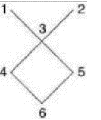

[4M] (C03) [Knowledge].

7. Define complemented lattice and give an example. [4M] (C03) [Knowledge].

**Part B [Thought Provoking Questions]**

**Answer any FOUR Questions. Each question carries 10 marks. (4Qx10M=40M)**

8. Obtain PDNF of $(p→(\left(p→q\right)∧¬\left(¬q∨¬p\right))$) . [10M] (CO.1) [Comprehension]

9. Define the following notions over sets and also provide Venn diagram for each.

(i) Union (ii) intersection (iii) difference of sets (iv) complement of a set (v) disjoint set.

[10M] (CO.2) [Comprehension]

10. Let and $R= \left\{\left(x,y\right)| x-y is divisible by 3\right\}.$ Show that $R$ is equivalence

relation over $X.$ [10M] (CO.2) [Comprehension]

11. Find the minimal, maximal for the given figure and great lower bound and the least upper bound of

{b, d, g}

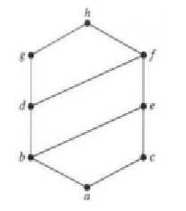

[10M] (CO.3) [Comprehension]

12. Show that the divisibility relation $|$ partial ordering on the set of positive integers

[10M] (CO.3) [Comprehension]

13. Show that the following lattices are not distributive

[10M] (CO.4) [Comprehension]

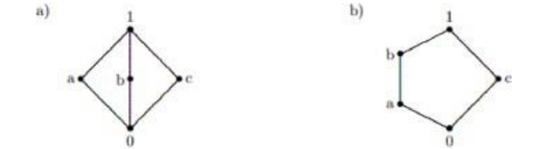

**Part C [Problem Solving Questions]**

**Answer any TWO Questions. Each question carries 20 marks. (2Qx20M=40M)**

14. a) Show that p → q and ¬p ∨ q is logically equivalent by using truth table.

b) “If there was a ball game, then travelling was difficult. If they arrived on time, then travelling was not difficult. They arrived on time. Therefore, there was no ball game.” Show that these statements constitute a valid argument. [20 M] (CO.1) [Application]

15. Define an equivalence relation over a set. Prove that the relation “congruence modulo m” over the set of positive integers is an equivalence relation.

[20M] (CO.2) [Application]

16. Prove that $(P(S),⊆)$ is a Boolean Algebra. Where $S=\{a,b,c\}$.

[20M] (CO.3) [Application]