|  |  |  |  |  |  |  |  |  |  |  |  |  |
| --- | --- | --- | --- | --- | --- | --- | --- | --- | --- | --- | --- | --- |
| Roll No |  |  |  |  |  |  |  |  |  |  |  |  |



**Presidency University**

**Bengaluru**

**School of Management**

**End-Term Examination - August 2024**

**Date**: 5th August 2024

**Time**: 1:00 pm – 4:00Pm

**Max Marks**: 100

**Weightage**: 50%

**Semester**: Summer End Term July

**Course Code**: MBA 3015

**Course Name**: Operational Analytics

**Department:** SOM

**Instructions:**

1. *Read the all questions carefully and answer accordingly.*
2. *Do not write any information on the question paper other than roll number.*
3. *Question paper consists of 3 parts.*

**PART A**

**Answer any 10 Questions. Each question carries 3 marks. (10Qx 3M= 30)**

1. How do you analyze and improve operational processes? (CO:02:Knowledge)
2. Can you describe a time when you used data to make a decision that significantly impacted operations? (CO:01:Knowledge)
3. What is operational Analytics ?Give examples! (CO:01:Knowledge)

1. Mention important step of a decision Model (CO:01: Knowledge)
2. What is Linear Program?Give examples! (CO:02:Knowledge)

1. What are popular methods to solve Transportation problems (CO:03:Knowledge)
2. Define two person zero sum game ?(CO:02:Knowledge)
3. What experience do you have with ERP systems, and how have you used them to support operational efficiency? (CO:03:Knowledge)
4. Define Penalty method ? (CO:03:Knowledge)
5. Define saddle point ,dominance rule and game value (CO:03:Knowledge)

### How would you calculate the employee turnover rate for a business? (CO:02:Knowledge).

### 

1. Name a few tools used in operational Analytics (CO:03:Knowledge)

**PART B**

**Answer any 4 Questions. Each question carries 10 marks. (4Qx 10M= 40)**

1. Explain the concept of Transhipment for a 3PL company with neat diagram(CO:02:Application)

1. Describe Linear Programming method of optimization constraint ,explain advantages and disadvantages of varios techniques used? (CO:01: Application)
2. Determine the conditional average row wise (CA-r) and column wise(Ca-c) . Consider a random set of data generated in the range of 100 to 999 in 10x10 table. Use calculator or Excel.(CO:02: Application)

|  |  |  |  |  |  |  |  |  |  |  |
| --- | --- | --- | --- | --- | --- | --- | --- | --- | --- | --- |
|  | **C1** | **C2** | **C3** | **C4** | **C5** | **C6** | **C7** | **C8** | **C9** | **C10** |
| **R1** | 687 | 723 | 893 | 957 | 545 | 348 | 739 | 573 | 357 | 525 |
| **R2** | 727 | 230 | 931 | 348 | 675 | 649 | 171 | 108 | 283 | 923 |
| **R3** | 657 | 795 | 731 | 733 | 162 | 778 | 600 | 324 | 167 | 951 |
| **R4** | 839 | 136 | 603 | 794 | 588 | 396 | 524 | 155 | 594 | 130 |
| **R5** | 127 | 166 | 569 | 555 | 445 | 547 | 886 | 534 | 742 | 399 |
| **R6** | 308 | 860 | 101 | 798 | 574 | 234 | 958 | 206 | 854 | 389 |
| **R7** | 429 | 891 | 304 | 780 | 961 | 235 | 975 | 743 | 132 | 278 |
| **R8** | 541 | 163 | 920 | 576 | 697 | 135 | 954 | 314 | 171 | 696 |
| **R9** | 718 | 684 | 468 | 218 | 950 | 671 | 186 | 724 | 355 | 116 |
| **R10** | 797 | 252 | 889 | 517 | 417 | 846 | 267 | 141 | 913 | 312 |

1. Sunrise Resorts wants to decide upon the best alternative among the four locations for which the annual revenues are estimated along with their respective probability. The estimates were based upon the survey conducted by experts at the location. Assume initial investment and ROI same for each alternative. Calculate the EMV for the data below (CO:03:Application)

|  |  |  |  |  |  |  |  |
| --- | --- | --- | --- | --- | --- | --- | --- |
| **Mahabaleshwar** | | **Munnar** | | **Kodaikanal** | | **Darjeeling** | |
| **Rs-L** | **P()** | **Rs-L** | **P()** | **Rs-L** | **P()** | **Rs-L** | **P()** |
| **85** | **.15** | **75** | **.3** | **80** | **.2** | **65** | **.6** |
| **75** | **.3** | **80** | **.4** | **60** | **.4** | **70** | **.2** |
| **90** | **.15** | **60** | **.1** | **70** | **.2** | **75** | **.1** |
| **60** | **.4** | **65** | **.2** | **75** | **.2** | **80** | **.1** |

1. Solve the following game.Show steps (CO:03:Application)

|  |  |  |  |  |
| --- | --- | --- | --- | --- |
|  | **B1** | **B2** | **B3** | **B4** |
| A1 | -4 | 2 | 0 | -10 |
| A2 | 6 | 4 | 3 | 5 |
| A3 | 7 | -6 | 2 | -4 |
| A4 | 8 | 6 | -8 | 4 |

1. What is Game Theory ? What do you mean by a game in game theory? What are the assumptions made in game theory? Explain maximin and minimax criterion used in game theory giving an example? (CO:04:Comprehension)

**PART C**

**Answer the following Questions. (2Qx 15M= 30)**

1. Solve the following transportation problem by LPP method. Determine optimum cost.(CO:03:Application)

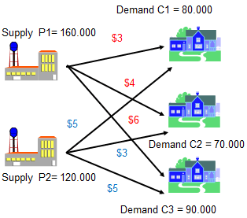 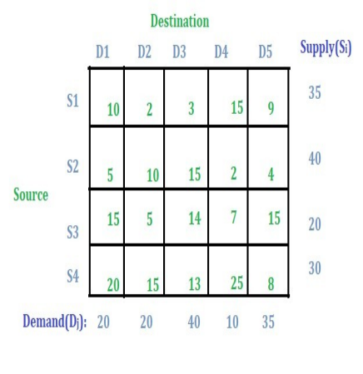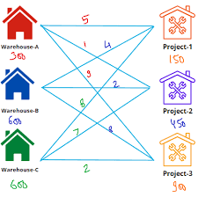

1. A. Explain various methods of decision tree models and compare with the types of Linear Programming (CO:03:Comprehension)
2. Five different items are loaded into a vessel. The weight and volume of each unit of the different items as well as their corresponding returns per unit are tabulated as shown. Formulate a LP model to optimize the return. The maximum cargo weight is 112 tonnes and the volume is 109 cmt.(CO:03:Analysis)



