Roll No.


PRESIDENCY UNIVERSITY
Bengaluru
End - Term Examinations – JANUARY 2025
Date: 08 / 01/ 2025 Time: 09:30 am –12:30 pm

School: SOCSE | Program: B.Tech ISE/ISR/ISB
Course Code: CSE3071 | Course Name: Computer Vision
Semester: V | Max Marks:100 | Weightage: 50%

CO - Levels | CO1 | CO2 | CO3 | CO4 | CO5
Marks | 38 | 36 | 62 | 44
Instructions:
- Read all questions carefully and answer accordingly.
- Do not write anything on the question paper other than roll number.
Part A
Answer ALL the Questions. Each question carries 2marks. 10Q x 2M=20M
1 | Define edge detection. | 2 Marks | L1 | CO2
2 | List two types of noise in digital images. | 2 Marks | L1 | CO1
3 | Define aliasing. | 2 Marks | L1 | CO1
4 | Define segmentation in image processing. | 2 Marks | L1 | CO2
5 | Explain aliasing | 2 Marks | L2 | CO1
6 | List two image compression techniques. | 2 Marks | L1 | CO2
7 | Explain the concept of spatial domain filtering | 2 Marks | L2 | CO3
8 | List the advantages of using morphological operations. | 2 Marks | L1 | CO4
9 | List the applications of image processing. | 2 Marks | L1 | CO1
10 | Explain the necessity of feature extraction. | 2 Marks | L2 | CO4

Part B
Answer the Questions Total 80 Marks.
11. | a. | Explain the role of lighting in image. | 10 Marks | L2 | CO1
11. | b. | Given Data:  3x3 Image Matrix:  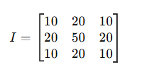  Gaussian Kernel:  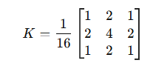  Apply the Gaussian filter for noise reduction. | 10 Marks | L3 | CO2
Or
12. | a. | Explain the importance of Computer vision in healthcare industry. | 10 Marks | L2 | CO3
12. | b. | Track the position of a moving car starting at (x=2,v=1)(x=2, v=1)(x=2,v=1). Use the Kalman Filter to predict its position after 1 second, considering the following equations:  - State Prediction:  x_{k+1}=x_{k}+v_{k}⋅Δt  - Measurement Update:  x_{k+1∣k}=x_{k}+v_{k}⋅Δt=2+1×1=3 | 10 Marks | L3 | CO4
s
13. | a. | Compare different machine learning models for image classification | 10 Marks | L2 | CO1
13. | b. | Given Data:  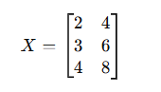  Apply PCA for feature extraction | 10 Marks | L3 | CO3
Or
14. | a. | Explain the commands in MATLAB to do the various operators used in image processing. | 10 Marks | L1 | CO4
14. | b. | Data: (2,4,6,8)(2, 4, 6, 8)(2,4,6,8)  Initial Means: μ1=3,μ2=7  Apply EM algorithm to cluster two Gaussians. | 10 Marks | L3 | CO4

15. | a. | Implement a program in MATLAB to do the edge detection on a given image. | 10 Marks | L2 | CO1
15. | b. | Perform connected component labeling on the binary image:  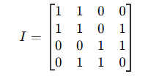 | 10 Marks | L3 | CO2
Or
16. | a. | Explain different types of linear filters. | 10 Marks | L2 | CO3
16. | b. | Perform template matching for a 3x3 image and a 2x2 template:  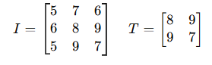 | 10 Marks | L3 | CO2

17. | a. | Explain different types of color models. | 10 Marks | L2 | CO3
17. | b. | Detect a line in a binary edge-detected image using the Hough Transform:  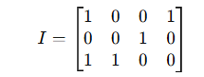 | 10 Marks | L3 | CO4
Or
18. | a. | Explain the process of texture-based classification. | 10 Marks | L2 | CO3
18. | b. | Perform dilation and erosion on a binary image:  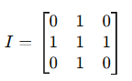  Structuring Element:  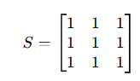 | 10 Marks | L3 | CO3

***** BEST WISHES *****

