Roll No.


PRESIDENCY UNIVERSITY
Bengaluru
End - Term Examinations – JANUARY 2025
Date: 08 / 01/ 2025 Time: 09:30 am –12:30 pm

School: SOCSE | Program: B.Tech -COM/CAI/CEI/CSE/CCS/CIT/CSG/CST/  CBC/CSD/CBD
Course Code: CSE2018 | Course Name: Theory of Computation
Semester: V | Max Marks:100 | Weightage:50%

CO – Levels | CO1 | CO2 | CO3 | CO4
Marks | 24 | 28 | 24 | 24
Instructions:
- Read all questions carefully and answer accordingly.
- Do not write anything on the question paper other than roll number.
Part A
Answer ALL the Questions. Each question carries 2marks. 10Q x 2M=20M
1 | Differentiate Finite Automata with Pushdown Automata. | 2 Marks | L2 | CO1
2 | List any 4 applications of Pushdown Automata. | 2 Marks | L1 | CO1
3 | Define NFA with Tuple representation. | 2 Marks | L2 | CO2
4 | Compute the ε closure of the states q₀, q₁, q₂, q₃ and q₄.  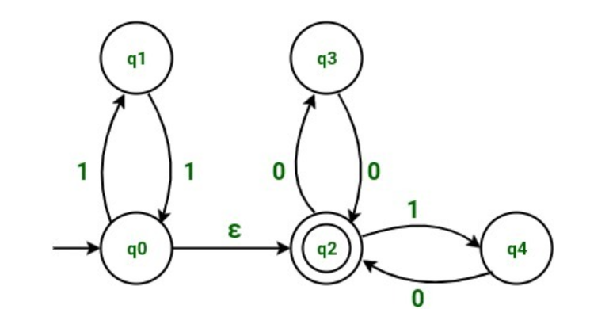 | 2 Marks | L3 | CO2
5 | Define Regular Expression? Give any one Example for Regular Language. | 2 Marks | L2 | CO2
6 | Draw NFA with epsilon for the following Regular Expressionn ( a/ b )* | 2 Marks | L3 | CO2
7 | What is Unit Production? Give an example to eliminate Unit production from the grammar. | 2 Marks | L2 | CO3
8 | Define Derivation. List its types. | 2 Marks | L2 | CO3
9 | Define Turing Machine. | 2 Marks | L2 | CO4
10 | Differentiate input tape of Turing Machine with Pushdown Automata. | 2 Marks | L2 | CO4

Part B
Answer the Questions Total 80 Marks.
11. | a. | (i) Let L1= {a, b, ab} L2= {00, 11} and L3= {a, aa, bb}, Compute the following operations.  1. Concatenation of L1L2.  2. L2 L2^{R}  3. L3*  4. L2⁺  5. L3³  6. Prefixes (a a b a b a b b)  7. Sufixes (a a b a b a b b) |  | 20 Marks | L3 |  | CO1
or
12. | a.  b. | Explain about the following with examples.  1) Alphabet  2) Strings  - Empty Strings  - Length of the string  - Concatenation of two strings  Define and Explain any five operations on Languages with Examples. |  | 10 Marks  10 Marks | L2  L2 |  | CO1  CO1
13. | a.  b.  c.  d. | Construct a DFA which accepts set of all binary strings divisible by 3.  Construct NFA to accept the strings with a’s and b’s such that the string has a substring with ‘ab’.  Convert the Regular Expression (b + (ab))* a into NFA with ε using Thompson’s rule.  Minimize the following DFA using state equivalence method.  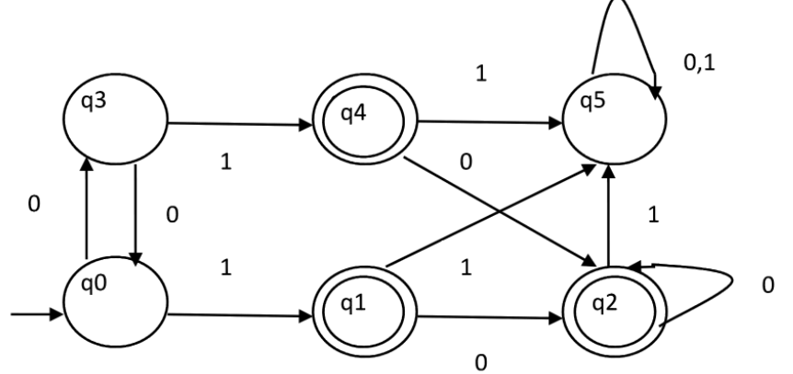 |  | 5 Marks  5 Marks  5 Marks  5 Marks | L3  L3  L3  L3 |  | CO2  CO2  CO2  CO2
or
14. | a. | (i) Convert the given NFA into its equivalent DFA.  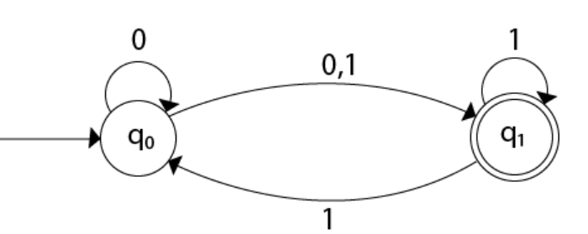  (ii) Convert the given NFA with epsilon into its equivalent DFA.  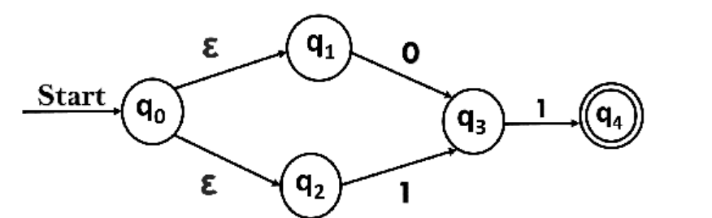 | 10 Marks  10 Marks |  |  | L3  L3 | CO2  CO2

15. | a.  b. | (i) Design a PDA for accepting the language L(G)={w$w^{R}$ : w ϵ {a, b}*}  (ii) Consider the following grammar,  E-> E+T | T  T-> T * F | F  F-> ( E ) | id  Compute the Left most Derivation, Right most Derivation and Parse Tree for the string id * ( id + id ). | 10 Marks  10 Marks | L3  L3 | CO3  CO3
Or
16. | a.  b. | (i)Remove Unit Productions, Null Productions and Useless production rules for the following CFG  S → ASB | XY  A → aAS | a | ε  B → SbS | A | bb | CD  (ii)Convert the given CFG into GNF  S → XA | BB  B → b | SB  X → b  A → a | 10 Marks  10 Marks | L3  L3 | CO3  CO3

17. | a.  b. | Design a Turing Machine to reverse a string over the alphabet {a, b}.  Design a Turing Machine to perform the proper Subtraction of two unary numbers. | 10 Marks  10 Marks | L3  L3 | CO4  CO4
Or
18. | a.  b. | Design a Turing Machine which accepts all strings of the form a^{n}b^{n}c^{n} for n>=1 and rejects all other strings.  Design a Turing Machine to compute the proper addition of two unary numbers. | 10 Marks  10 Marks | L3  L3 | CO4  CO4

***** BEST WISHES *****

