Roll No.


PRESIDENCY UNIVERSITY
Bengaluru
End - Term Examinations – JANUARY 2025
Date: 02 – 01- 2025 Time: 09:30 am – 12:30 pm

School: School of Design | Program: B.Des  Game Design/Product Design
Course Code: DES2159 | Course Name: Intellectual Property Rights
Semester: VII | Max Marks: 100 | Weightage:50%

CO - Levels | CO1 | CO2 | CO3 | CO4 | CO5
Marks | 41 | 42 | 17
Instructions:
- Read all questions carefully and answer accordingly.
- Do not write anything on the question paper other than roll number.
Part A
Answer ALL the Questions. Each question carries 2marks. 10 x 2Marks=20Marks
1 | What is the duration of a trademark? | 2 Marks | Remembering | CO1
2 | What are geographical indications (GI)? | 2 Marks | Remembering | CO1
3 | What is the difference between copyright and patent? | 2 Marks | Remembering | CO1
4 | What is infringement of IPR? | 2 Marks | Remembering | CO1
5 | What is the TRIPS Agreement? | 2 Marks | Remembering | CO1
6 | What is the purpose of the Indian Copyright Act, 1957? | 2 Marks | Remembering | CO1
7 | Which type of IPR can be used for the design below.  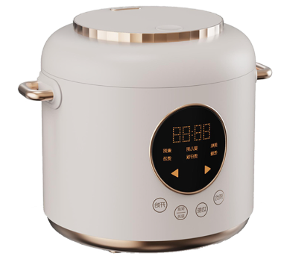 | 2 Marks | Remembering | CO1
8 | A company wants to protect its logo of a company. Identify which type of IPR is suitable for this. | 2 Marks | Understanding | CO2
9 | What types of works are protected by copyright? | 2 Marks | Remembering | CO1
10 | List the types of IPR that can be used for the design below. 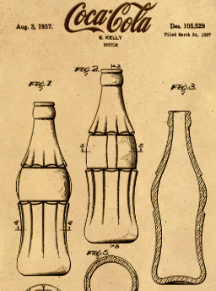 | 2 Marks | Understanding | CO3

Part B
Answer the Questions. Total Marks 80
11. |  | - Define Intellectual Property Rights  (10 Marks)  - Explain IPR’s significance in protecting the creations of the mind.  (15 Marks) | 25 Marks | Understanding | CO1
or
12. |  | - Examine a case where a digital platform (such as YouTube or a social media site) was involved in a copyright violation. (10 Marks)  - What challenges do platforms face in balancing user-generated content with copyright protections?  (15 Marks) | 25 Marks | Understanding | CO1
13. |  | - Describe the role of copyrights in protecting artistic, literary, and musical works.  (10 Marks)  - Why are they important for creators and consumers?  (15 Marks) | 25 Marks | Understanding | CO2
or
14. |  | - Describe in detail about the copyright?  (10 Marks)  - What are the rights granted under copyright law? (10 Marks)  - Give few examples in all the categories of copyrights  (5 Marks) | 25 Marks | Understanding | CO2

15. |  | Discuss the role of trademarks in protecting brand identity and ensuring consumers can distinguish between different products and services. | 15 Marks | Understanding | CO2
Or
16. |  | Match the following Column A and Column B.  List the types of trademarks and explain the trademark infringement. | 15 Marks | Understanding | CO2
  Column A | Column B
  1.Service Mark | 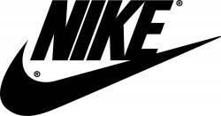  a)
  2. Trademark | b) 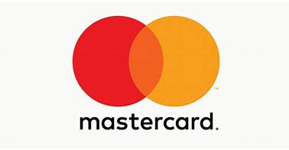
  3. Collective Mark | c) 
  4. Certification | 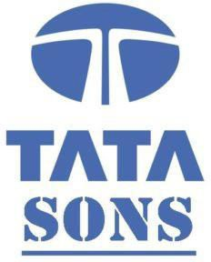  d)

17. |  | - Investigate a real-world example of a patent licensing agreement, discussing the terms and conditions, the negotiation process, and the challenges that both parties faced.  (10 Marks)  - How does licensing affect innovation in the industry?  (5 Marks) | 15 Marks | Applying | CO3
Or
18. |  | - Investigate a case where a company faced the challenge of counterfeit goods entering the market.  (10 Marks)  - Discuss the legal steps taken to combat counterfeiting and the effectiveness of current enforcement mechanisms under IPR laws.  (5 Marks) | 15 Marks | Applying | CO3

***** BEST WISHES *****

