Roll No.


PRESIDENCY UNIVERSITY
Bengaluru
End - Term Examinations – JANUARY 2025
Date: 11 – 01- 2025 Time: 09:30 am –12:30 pm

School: SOE | Program: B.Tech-ECE
Course Code : ECE3082 | Course Name : Data Science for IoT
Semester: VII | Max Marks: 100 | Weightage: 50%

CO - Levels | CO1 | CO2 | CO3
Marks | 26 | 26 | 48
Instructions:
- Read all questions carefully and answer accordingly.
- Do not write anything on the question paper other than roll number.
Part A
Answer ALL the Questions. Each question carries 2marks. 10Q x 2M=20M
1 | An irrigation IoT system measuring moisture in soil every milli-second provides 1000 sample/s. As the soil moisture changes gradually it is required to filter one sample every minute and an average of 10 filtered samples over 10 minute duration is performed to reduce traffic on the network. Recognize the layer in the IoTWF reference model that has such a role. | 2 Marks | L1 | CO1
2 | List the protocols applicable to link layer in TCP/IP model. | 2 Marks | L1 | CO1
3 | The Internet of Things (IoT) ecosystem is growing at a breathtaking pace. List the essential components of IoT. | 2 Marks | L1 | CO1
4 | Identify the type of Data that embodies information that can assume any value within a defined range or interval measured on a continuous scale. | 2 Marks | L1 | CO2
5 | Identify the Big data technology used to clean and transform data into information that can be used to drive business decisions. | 2 Marks | L1 | CO2
6 | Various types of DAQ tools available in the market. State the difference between Wireless vs. Wired DAQ. | 2 Marks | L1 | CO2
7 | ESP32 has sensing technique that can replace mechanical buttons and switches. State the type and number of sensing technique. | 2 Marks | L1 | CO3
8 | State the different serial interfaces available in ESP32 chip. | 2 Marks | L1 | CO3
9 | Compute the duty cycle of PWM in ESP32 to obtain an analog signal output of 2V. | 2 Marks | L1 | CO3
10 | Identify the power mode of ESP32 where WiFi, Bluetooth and CPU is switched off. | 2 Marks | L1 | CO3

Part B
Answer the Questions Total 80 Marks.
11. |  | Presidency University needs a public notification display system. Design a smart display system based on IoT.  - Determine the sensors and actuators required to design the systems. (8 marks)  - Examine the communication API needed for effective design and implementation. (12 marks) | 20 Marks | L2 | CO1
or
12. |  | One architecture component of M2M is the service ecosystem. Explain the four domains of M2M service ecosystem. | 20 Marks | L2 | CO1
13. |  | Big Data describes data that is too large to be managed by traditional databases (RDBMS) and processing tools. Hadoop is used as a tool to handle big data. Explain the main components, architecture and key features of Hadoop. | 20 Marks | L2 | CO2
or
14. |  | Different problems will require different data analytics approaches. Describe the types of data analytics. | 20 Marks | L2 | CO2

15. |  | Fig. 1 illustrates the IoT application in health care  - IoT World Forum Reference Model enables conceptualization of a framework. Decompose the problem and map with IoT World Forum Reference model layers. (14 marks)  - Examine the suitable IoT deployment level for the problem. (6 marks) | 20 Marks | L3 | CO3
Or
16. |  | An ESP32 system is used for controlling servo motor angle of rotation that increases and decreases gradually. The servo motor is connected to GPIO18.  - Sketch the schematic diagram illustrating the interface. (6 marks)  - Write the code to perform the angle control. (14 marks) | 20 Marks | L3 | CO3

17. |  | An ESP32 system is used to measure temperature using LM35 temperature sensor shown in Fig. 2. The GPIO36 (ADC0) of ESP32 is connected to the temperature sensor having a range of -55 deg. C to 150 deg. C and sensitivity 10mV/deg. C.  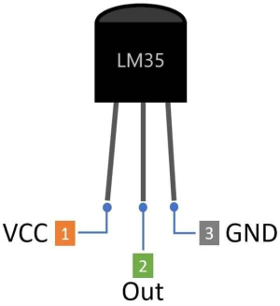  Fig. 2 LM35 pin out  - Compute the ADC resolution of an ESP32. (4 marks)  - Design for input scaling circuit to reduce input loading. (4 marks)  - Compute the digital value for 20 deg C, 35 deg. C. (4 marks)  - Calculate the temperature value from the digital values 278, 545 using conversion formula. (4 marks)  - Draw the schematic diagram illustrating the interface. (4 marks) | 20 Marks | L3 | CO3
Or
18. |  | An ESP32 is interfaced with BME280 sensor module reads temperature, humidity, and pressure. The GPIO 21 and GPIO22 pins of ESP32 support the SDA and SCL signal for I2C respectively. The I2C device address is 0x76.  - Draw the schematic diagram illustrating the interface. (6 marks)  - Write the code to read the temperature, humidity, and pressure every sec. (14 marks) | 20 Marks | L3 | CO3

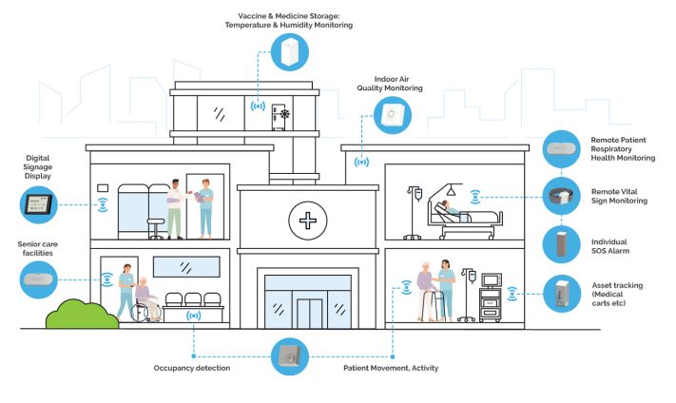
Fig. 1 IoT application in health care

***** BEST WISHES *****

