Roll No.


PRESIDENCY UNIVERSITY
Bengaluru
End - Term Examinations – JANUARY 2025
Date: 08 / 01/ 2025 Time: 09:30 am –12:30 pm

School: School of Engineering | Program: B. Tech – Mechanical Engineering
Course Code: MEC3055 | Course Name: Product Design for Manufacturing Assembly
Semester: V | Max Marks: 100 | Weightage:50%

CO - Levels | CO1 | CO2 | CO3 | CO4
Marks | 26 | 24 | 26 | 24
Instructions:
- Read all questions carefully and answer accordingly.
- Do not write anything on the question paper other than roll number.
Part A
Answer ALL the Questions. Each question carries 2marks. 2Mx10Q=20M
1 | Write the linear functional features for mechanical stud? | 2 Marks | L1 | CO1
2 | Write the linear functional features for pin component | 2 Marks | L1 | CO1
3 | Name standard twist drills | 2 Marks | L1 | CO1
4 | List any 4 design guidelines in turning | 2 Marks | L1 | CO2
5 | What is datum feature? | 2 Marks | L1 | CO2
6 | What is welding design? | 2 Marks | L1 | CO3
7 | Define Standardization in DFM. | 2 Marks | L1 | CO3
8 | What is turning and facing in Machining operation | 2 Marks | L1 | CO3
9 | List the parting line parameters in casting process. | 2 Marks | L1 | CO4
10 | List the various process parameters used in FSW process. | 2 Marks | L1 | CO4
Part B
Answer ALL Questions. Each question carries 20 marks. 4QX20M=80M
11 | 11a | Write a note on die casting defects | 10 Marks | L2 | CO1
11 | 11b | With a neat sketch explain any two design considerations in forging. | 10Marks | L2 | CO1
Or
12 | 12a | With a neat sketch explain any design guidelines in drilling and milling | 10 Marks | L2 | CO1
12 | 12b | List the material selection process in Product design in manufacturing assembly and explain any two steps in detail. | 10Marks | L2 | CO1
13 | 13a | Write a note on drilling entry and runout in design considerations | 10Marks | L2 | CO2
13 | 13b | With a neat sketch explain parting line design and pattern design | 10Marks | L2 | CO2
Or
14 | 14a | With a neat sketch explain causes for distortion and how to minimize the distortion | 10Marks | L2 | CO2
14 | 14b | Write a note on design recommendations for welding. | 10Marks | L2 | CO2
15 | 15a | Write a note on importance of parting line in Casting design | 10 Marks | L2 | CO3
15 | 15b | With a neat sketch explain the destructive tensile test in welding | 10Marks | L2 | CO3
Or
16 | 16a | Explain the working principle of FSW and applications | 10 Marks | L2 | CO3
16 | 16b | Write a note on allowance considerations in casting | 10Marks | L2 | CO3
17 |  | The anchor stud shown in fig 17a is to be manufactured in batches of 200.  - Prepare a suitable operation sequence layout for the stud.  - Show the three possible datum faces for machining the 15 mm wide grove and appropriate dimensional layout for each.  - State the most desire bale datum face and why.  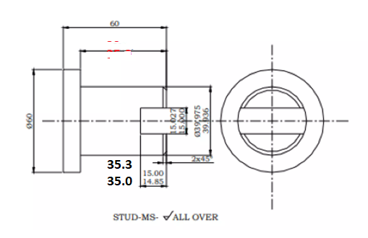 | 20Marks | L3 | CO4
or
18 |  | Re design the following Pin component (detail procedure) two machining process are involved a) Turning ---turn, face and chamfer b) drilling----drill and ream.  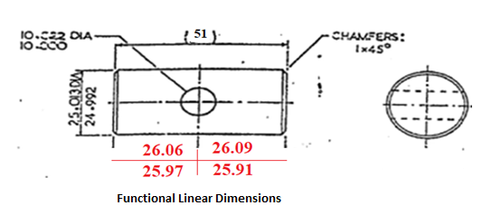 | 20Marks | L3 | CO4

***** BEST WISHES *****

