Roll No
Presidency University
Bengaluru

SCHOOL OF ENGINEERING
ENDTERM EXAMINATION – JUN 2023
Semester: II/IV - 2022
Course Code: KAN2001
Course Name: Thili Kannada
Program & Sem: All Schools
Date: 10-JUN-2023
Time: 01:00 PM – 2:30 PM
Max Marks: 50
Weightage: 25%

Instructions:
- Read the all questions carefully and answer accordingly.
- Question paper consists of 3 parts
- Do not write any matter on the question paper other than roll number.

Part A [Memory Recall Questions]
Answer all the Questions. (5Qx 2M= 10M)

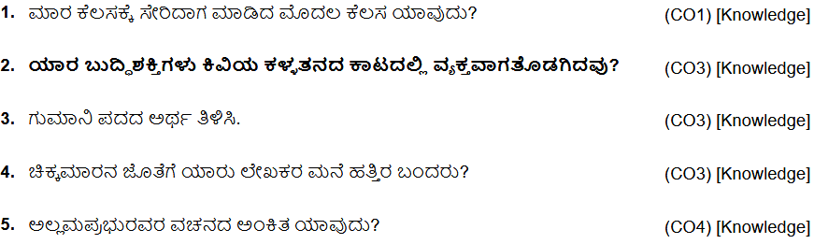
Part B [Thought Provoking Questions]
Answer all the Questions. (3Qx10M=30M)
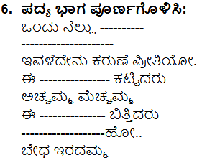

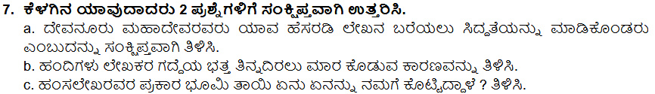

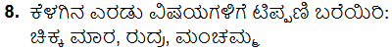

Part C [Problem Solving Questions]
Answer all the Questions. Answer Any One Question. (1Qx10M=10M)

------- +++++ -------

