|  |  |  |  |  |  |  |  |  |  |  |  |  |
| --- | --- | --- | --- | --- | --- | --- | --- | --- | --- | --- | --- | --- |
| Roll No |  |  |  |  |  |  |  |  |  |  |  |  |



**Presidency University**

**Bengaluru**

**SCHOOL OF ENGINEERING**

**MAKE UP EXAMINATION SEP - 2023**

**Course Code**: CSE210

**Course Name**: Operating Systems

**Program**: B. Tech

**Date**: 06.10.2023

**Time**: 01:00 PM - 04:00 PM

**Max Marks**: 100

**Weightage**: 50%

**Instructions:**

1. *Read the all questions carefully and answer accordingly.*
2. *Part A Answers should be compact and precise.*
3. *Answers should be to the point.*
4. *Please fill all the details on the front page of Answer script.*
5. *All Questions are compulsory.*

**Part A [Memory Recall Questions]**

**Answer all the Questions. (10Qx 2M= 20M)**

**1** List out the objectives of operating system? (C.O.No.1) [ Knowledge level]

**2** What is the purpose of system programs/system calls? (C.O.No.1) [ Knowledge level]

**3** Distinguish between batch systems and time sharing systems. (C.O.No.1) [ Knowledge level]

**4** Define scheduler? (C.O.No.2) [ Knowledge level]

**5** What is meant by context switch? (C.O.No.2) [ Knowledge level]

**6** Define Deadlock. (C.O.No.3) [ Knowledge level]

**7** Differentiate between logical and physical addresses. (C.O.No.4) [ Knowledge level]

**8** Define demand paging in memory management. (C.O.No.4) [ Knowledge level]

**9** State the meaning of thrashing? (C.O.No.4) [ Knowledge level]

**10** Outline the various scheduling criteria for CPU scheduling? (C.O.No.3) [ Knowledge level]

**Part B [Thought Provoking Questions]**

**Answer all the Questions. (5Qx7M=35M)**

**11** Considering different memory managementtechniques list out the Main differences between Paging and Segmentation. Describe memory management techniques using Translation Look-aside(**TLB)** Buffer with diagram. (C.O.No.4) [ Comprehensive level]

**12** There are currently 3 memory blocks which are free (in main memory). A new process arrives whose size is slightly smaller than one of the free memory block. Discuss how operating system will allocate the memory block to the process. Justify your answer. (C.O.No.4) [ Comprehensive level]

**13** Illustrate why interrupts are not appropriate for implementing synchronization primitives in multiprocessor systems. (C.O.No.3) [ Comprehensive level]

**14** Elaborate the actions taken by the kernel to context-switch between processes. Draw a neat diagram which depicts context switching. (C.O.No.2) [ Comprehensive level]

**15**

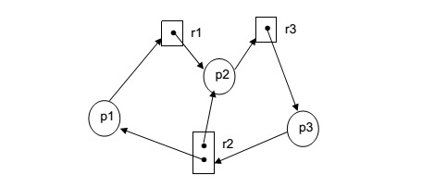

Above RAG depicts the current situation in a system. (C.O.No.3) [ Comprehensive level]

1. Mention the number of request edges and allocation edges. [1]
2. Mention the different resources types and their instances. [1]
3. Mention the number of cycles. [1]
4. Find out whether a deadlock exists or not. If yes, mention the number and names of the processes involved in the deadlock. If no, justify the answer. [4]

.

**Part C [Problem Solving Questions]**

**Answer all the Questions. (3Qx15M=45M)**

**16** Consider the following page reference string: 1, 2, 3, 4, 2, 1, 5, 6, 2, 1, 2, 3, 7, 6, 3, 2, 1, 2, 3, 6. How many page faults would occur for the following replacement algorithms, assuming 3 and 4 frames?

(C.O.No.3) [ Application level]

Remember that all frames are initially empty.

1. LRU replacement [5]
2. FIFO replacement [5]
3. Optimal replacement [5]

**17** Consider the following snapshot of a system: (C.O.No.3) [ Application level]

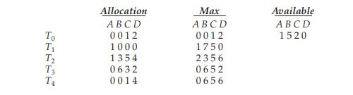

Answer the following questions using the banker’s algorithm:

1. What is the content of the matrix Need? [6]
2. Is the system in a safe state? [3]
3. If a request from thread T1 arrives for (0,4,2,0), can the request be granted immediately? [6]

**18** Consider the following set of processes with the length of CPU- burst time given in milliseconds.

(C.O.No.2) [ Application level]

|  |  |  |  |
| --- | --- | --- | --- |
| PROCESS | BURST TIME | PRIORITY | ARRIVAL TIME |
| P1 | 10 | 3 | 0 |
| P2 | 1 | 1 | 1 |
| P3 | 2 | 3 | 2 |
| P4 | 1 | 4 | 1 |
| P5 | 5 | 2 | 2 |

Draw the grant chart for the execution of these processes and find the average waiting and turnaround time using each of the following methods:

1. SRTFS [5]
2. Preemptive Priority [5]
3. Round Robin with time slice of 2 ms. [5]

.