|  |  |  |  |  |  |  |  |  |  |  |  |  |
| --- | --- | --- | --- | --- | --- | --- | --- | --- | --- | --- | --- | --- |
| Roll No |  |  |  |  |  |  |  |  |  |  |  |  |



**Presidency University**

**Bengaluru**

**SCHOOL OF ENGINEERING**

**MAKE-UP EXAMINATION – SEP 2023**

**Course Code**: CSE227

**Course Name**: Software Engineering and Project Management

**Program**: B. Tech

**Date**: 03.10.2023

**Time**: 9.30AM – 12.30PM

**Max Marks**: 100

**Weightage**: 50%

**Instructions:**

1. *Read the all questions carefully and answer accordingly.*
2. *Draw neat labeled diagrams where necessary*
3. *Write question numbers clearly and legibly with every answer*

**Part A [Memory Recall Questions]**

**Answer all the Questions. Each question carries two mark. (10Qx 2M= 20M)**

|  |  |  |
| --- | --- | --- |
| 1 | List various levels of software testing | [2](C.O.3)[Comprehension] |
| 2 | Expand SDLC | [2](C.O.1) [Comprehension] |
| 3 | Define black box testing with an example | [2](C.O.3)[Comprehension] |
| 4 | Draw an example swimlane diagram | [2](C.O.2)[Comprehension] |
| 5 | Show the strength of agile development | [2](C.O.1) [Comprehension] |
| 6 | Define risk and list types of risk management | [2](C.O.4) [Comprehension] |
| 7 | List any four principles of risk management | [2](C.O.4) [Comprehension] |
| 8 | List steps of waterfall model | [2](C.O.1) [Comprehension] |
| 9 | Mention software process improvement stages | [2](C.O.4) [Comprehension] |
| 10 | Draw a diagram describing extreme programming | [2](C.O.1) [Comprehension] |

**Part B [Thought Provoking Questions]**

**Answer all the Questions. Each question carries eight marks. (4Qx8M=32M)**

11. Triangle Problem accepts three integers – a, b, c as three sides of the triangle .We also define a range for the sides of the triangle as [l, r] where l>0. It returns the type of triangle (Scalene, Isosceles, Equilateral, Not a Triangle) formed by a, b, c.

For a, b, c to form a triangle the following conditions should be satisfied –

a < b+c

b < a+c

c < a+b

If any of these conditions is violated output is Not a Triangle. For Equilateral Triangle all the sides are equal. For Isosceles Triangle exactly one pair of sides is equal. For Scalene Triangle all the sides are different.

Design a test case table that shows the Test Cases for the Triangle Problem.

The range value [l, r] is [1, 100] and nominal value is 50.

[8] (C.O.3) [Comprehension]

12. Find the cylomatic complexity of the given control flow graph and identify independent paths

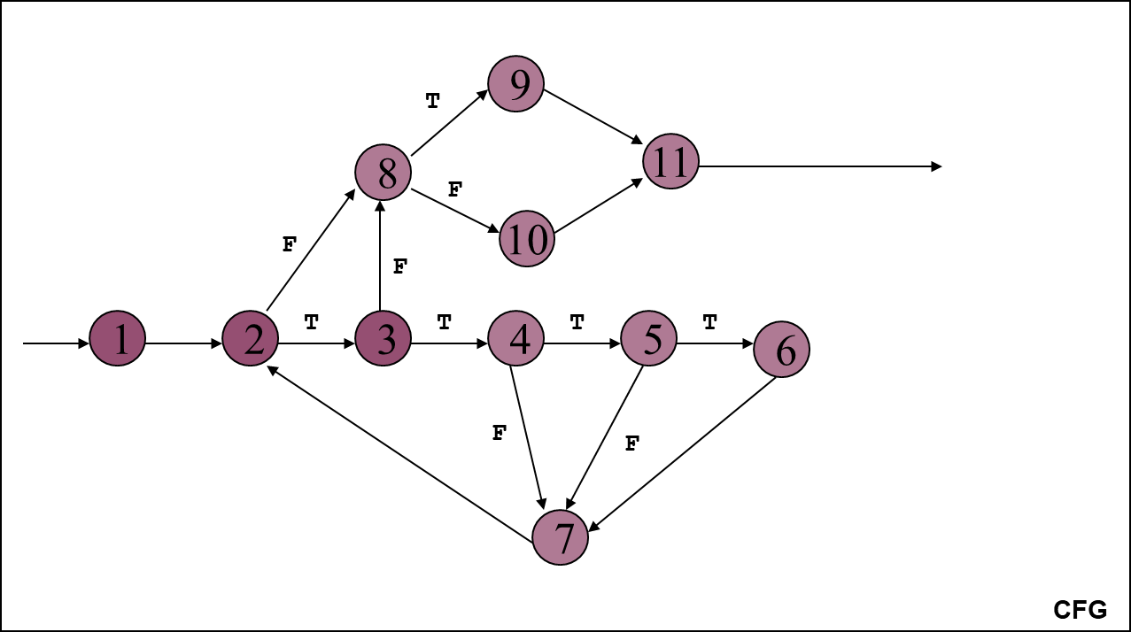

[8] (C.O.3) [Comprehension]

13. “Next Date” is a function consisting of three variables: month (mm), date (dd) and year (yyyy). It returns the date of next day as output. It reads current date as input date.

The conditions are

C1: 1 ≤ month ≤ 12

C2: 1 ≤ day ≤ 31

C3: 1812 ≤ year ≤ 2012

Thus based on valid values, the equivalence classes are:

M1= {month: 1 <= month <= 12}

D1 = {day: 1 <=day<<=31}

Y1= {year: 1812 <= year <= 2012}

And the invalid equivalence classes are:

M2 = {month : month < 1}

M3 = {month : month > 12}

D2 = {day : day < 1}

D3 = {day : day > 31}

Y2 = {year: year < 1812}

Y3 = {year : year > 2012} Design 8 equivalence partitioning test cases for the given description such that 6 are in valid partitions and 2 are from invalid partitions.

[8] (C.O.3) [Comprehension]

14. Our university is planning to develop a student management system that manages, admissions, student forum activities, performance records and such academic as well as nonacademic activities. The requirements are changing almost frequently. Strength of the team working on the project is the technical skill of each team member which is excellent. The team dynamics are also of top level and they communicate among themselves very effectively. Choose a suitable software development model that suits the scenario. Explain the choice with a suitable diagram. Also design a suitable requirement document for the description.

[8] (C.O.1) [Comprehension]

**Part C [Problem Solving Questions]**

**Answer all the Questions. Each question carries 16 marks. (3Qx16M=48M)**

15. Construct the Gantt chart for the data given below

|  |  |  |  |
| --- | --- | --- | --- |
| **Task** | **Length** | **Type\*** | **Dependent on...** |
| A. High level analysis | 1 week | S |  |
| B. Selection of server hosting | 1 day | S | A |
| C. Configuration of server | 2 weeks | S | B |
| D. Detailed analysis of core modules | 2 weeks | S, P to B, C | A |
| E. Detailed analysis of supporting modules | 2 weeks | S, P to F | D |
| F. Development of core modules | 3 weeks | S, P to E | D |
| G. Development of supporting modules | 3 weeks | S, P to H, J | E |
| H. Quality assurance of core modules | 1 week | S, P to G | F |
| I. Quality assurance of supporting modules | 1 week | S | G |
| J. Initial client internal training | 1 day | S, P to G | C,H |
| K. Development and QA of accounting reporting | 1 week | S | E |
| L. Development and QA of management reporting | 1 week | S | E |
| M. Development of Management Information System | 1 week | S | L |
| N. Client internal user training | 1 week | S | I, J, K, M |

[16](C.O.4) [Application]

16. Determine the critical path by scheduling the tasks of the given project

|  |  |  |
| --- | --- | --- |
| Activity | Duration (in weeks) | Precedents |
| A | 6 | – |
| B | 4 | – |
| C | 3 | A |
| D | 4 | B |
| E | 3 | B |
| F | 10 | – |
| G | 3 | E, F |
| H | 2 | C, D |

[16](C.O.4) [Application]

17. **NOTE: there are two sub parts in this question, each carries 8 marks**

a. Calculate the functional point given the values below and complexity adjustment factors are significantly complex products. Assume weighting factors as high.

User input= 55

User output= 35

User Enquiries= 40

User files= 8

External interfaces= 5

b. Consider code for binary search given below and answer the questions that follow based on the code.

[8](C.O.3) [Comprehension]

1. **min = A[0];**
2. **I = 1;**
3. **while (I < N) {**
4. **if (A[I] < min)**
5. **min = A[I];**
6. **I = I + 1;**
7. **}**
8. **print min**
9. Identify nodes
10. Construct a control flow graph of the code.
11. Identify and list independent paths in the CFG.
12. Derive test cases for path testing based on the paths identified.

[Note: Each sub question carries 2 marks]

[8](C.O.3) [Comprehension]