|  |  |  |  |  |  |  |  |  |  |  |  |  |
| --- | --- | --- | --- | --- | --- | --- | --- | --- | --- | --- | --- | --- |
| Roll No |  |  |  |  |  |  |  |  |  |  |  |  |



**Presidency University**

**Bengaluru**

**SCHOOL OF ENGINEERING**

**MAKE UP EXAMINATION SEP 2023**

**Course Code**: CIV 310

**Course Name**: Elements of Earthquake Engineering

**Program** : B.Tech (Civil)

**Date**: 07.10.2023

**Time**: 09:30 AM to 12:30 PM

**Max Marks**: 100

**Weightage**: 50%

**Instructions:**

1. *Read the all questions carefully and answer accordingly*
2. *Question paper consists of 3 parts.*
3. *Scientific and Non-programmable calculators are permitted.*
4. *Data Sheet is attached for reference*

**Part A [Memory Recall Questions]**

**Answer all the Questions. (3Q x 10M = 30M)**

1. What is Plate Tectonic Theory? Explain with neat sketch.

(C.O.No.1) [Knowledge]

2. a) List the various types of seismic waves. (4M)

b) What are the 2 concepts of seismic response control? (6M)

(C.O.No.2) [Knowledge]

3. a) Sketch and explain Focus and Epicentre of an earthquake. (4M)

b) What are the characteristics of strong ground motion? (6M) (C.O.No.1) [Knowledge]

**Part B [Thought Provoking Questions]**

**Answer all the Questions. (3Q x 15M = 45M)**

4. As an intern at the National Centre for Seismology, you have been asked to study all the past earthquakes that occurred in India and classify them. What are all the possible ways to classify earthquakes? (C.O.No.1) [Comprehension]

5. Irregular structures have certain physical discontinuities either in plan or in elevation or both which affect the performance of the structure subjected to seismic loads. During the initial planning of a high-rise residential complex, what are the horizontal and vertical irregularities to be checked?

(C.O.No.3) [Comprehension]

6. A four-storey RCC school building has a plan area of 6m x 6m and the typical storey height is 3m. The building is located in seismic zone IV. The type of soil encountered is medium stiff and it is proposed to design the building with a special moment resisting frame with infill. The intensity of DL is 8 kN/m2 and LL is 3 kN/m2 on all floors. Determine the design seismic loads on each floor of the structure by dynamic analysis. Consider all modes. Determine the seismic forces and shears at different floor levels using static method.

(C.O.No.3) [Application]

**Part C [Problem Solving Questions]**

**Answer the Question. (1Q x 25M = 25M)**

7. A three-storey RCC school building has a plan area of 8m x 8m and the typical storey height is 3.5m. The building is located in seismic zone V. The type of soil encountered is medium stiff and it is proposed to design the building with a special moment resisting frame with infill. The intensity of DL is 10 kN/m2 and LL is 4 kN/m2 on all floors. Determine the design seismic loads on each floor of the structure by dynamic analysis. Consider all modes.

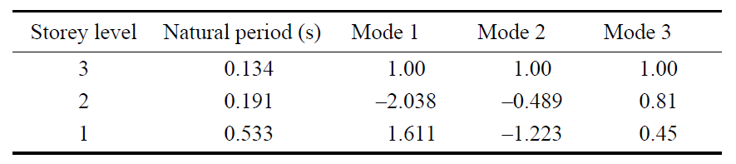

(C.O.No. 3) [Application]

**DATA SHEET**

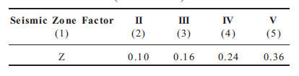

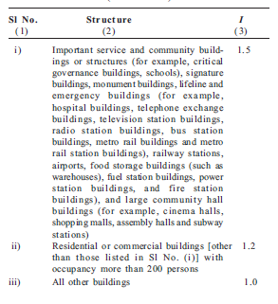

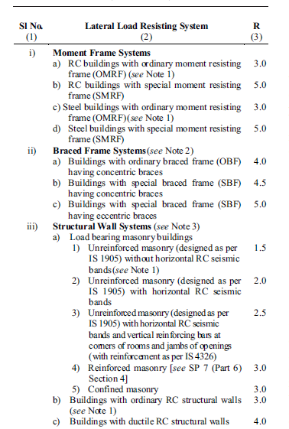

For Static Method

