|  |  |  |  |  |  |  |  |  |  |  |  |  |  |
| --- | --- | --- | --- | --- | --- | --- | --- | --- | --- | --- | --- | --- | --- |
| ROLL NO |  |  |  |  |  |  |  |  |  |  |  |  |  |



**Presidency University**

**Bengaluru**

**SCHOOL OF ENGINEERING**

**MAKE-UP EXAMINATION – SEP 2023**

**Date**: 30-SEP-2023

**Time**: 1.00PM to 4.00PM

**Max Marks**: 100

**Weightage**: 50%

**Course Code** : PET-215

**Course Name:** Natural Gas Engineering

**Program** : B.Tech (Petroleum Engineering)

**Instructions:**

1. ***Read the question carefully and answer all the questions***
2. ***Scientific calculator is allowed***

**Part A [Memory Recall Questions]**

**Answer all the Questions. Each Question carries 5 marks (5Qx5M=25 Marks)**

Q.NO.1 Find the correct answer for the following MCQ

a. Gas hydrates are ice-like crystalline minerals that form when low molecular weight gas combines with water and freezes into a solid. The condition of formation of gas hydrate is _____.

|  |  |
| --- | --- |
| A. low temperature, low pressure | B. low temperature, high pressure |
| C. high temperature, low pressure | D. high temperature, high pressure |

(C.O.NO.5) [Knowledge]

b. An oil/gas separator is a pressure vessel used for separating a well stream into gaseous and liquid components. The function of mist extractor in separator is to remove _____.

|  |  |
| --- | --- |
| A. very fine liquid droplets from gas | B. very fine water droplets from oil |
| C. very fine oil droplets from water | D. None of the above |

(C.O.NO.4) [Knowledge]

C. A separator is a pressure vessel used for separating a well stream into gaseous and liquid components. The main principles of physical separation of gas and liquids in a separator is / are _____.

|  |  |
| --- | --- |
| A. Momentum Change | B. Gravity Settling |
| C. Coalescence | D. All of the above |

(C.O.NO.4) [Knowledge]

d. Centrifugal compressors are particularly suited for compressing large volumes of gas to moderate pressures. A centrifugal compressor works on the principle of _____.

|  |  |
| --- | --- |
| A. conversion of pressure energy into kinetic energy | B. conversion of kinetic energy into pressure energy |
| C. centripetal action | D. generating pressure directly |

(C.O.NO.4) [Knowledge]

e. The capacity of compressor will be highest when its intake temperature is _____.

|  |  |
| --- | --- |
| A. lowest | B. highest |
| C. anything | D. atmospheric |

(C.O.NO.4) [Knowledge]

Q.NO.2 Match the following

|  |  |
| --- | --- |
| a. Cricondenbar | i. Quality lines are equally spaced |
| b. Saturated reservoir | ii. initial point is between critical and cricondentherm |
| c. Ordinary black oil | iii. surface condition, some oil is formed |
| d. Near critical gas reservoir | iv. initial reservoir pressure is equal to bubble-point pressure |
| e. Wet-gas reservoir | v. Maximum pressure above which gas cannot be formed |

Q.NO.3 Fill in the blanks (C.O.NO.3) [Knowledge]

a. Gas-oil ratio for a reservoir is about 10,000 scf/STB and API is 52. The type of reservoir will be _____.

b. . Natural gas commonly including varying amounts of higher alkanes, and sometimes a small percentage of carbon dioxide, nitrogen, hydrogen sulfide, or helium. The main constituent of natural gas is _____.

c. The unit of pseudo reduced pressure is_____.

d. In Wichert-Aziz Correction Method for Nonhydrocarbon Adjustment, B stands for mole fraction of _____

e. In dry gas reservoir, hydrocarbon in the reservoir condition is _____ and hydrocarbon in surface condition is _____.

Q.NO.4 Define the following (C.O.NO.1) [Knowledge]

a. Specific gravity of gas

b. Viscosity of gas

c. Gas dehydration

d. Skin factor

e. Under saturated reservoir

Q.NO.5 What is IPR, TPR and CPR? What is the importance of optimum flow point in IPR and TPR? How you can find the optimum point? (C.O.NO.2) [Knowledge]

**Part B [Thought Provoking Questions]**

**Answer all the Questions. Each Question carries 11 marks. (3Qx11M=33 Marks)**

Q.NO.6 Separators are broadly used in Oil and gas industries to separate different phases. Classify the separator based on their application. Write the advantages and differences between them with neat diagram showing all the components. (C.O.NO 4) [Comprehension]

Q.NO.7 Sweetening process is used to separate H2S and CO2 from natural gas. What are the different Sweetening process? Explain the working principle of Iron-Sponge Sweetening process with all the chemical reactions. (C.O.NO 4) [Comprehension]

Q.NO.8 Different types of hydrocarbon reservoir can be explained based on Bubble point- Dew point curve. Draw a neat diagram of Bubble point- Dew point curve and explain different points. Classify the hydrocarbon reservoir based on that curve. (C.O.NO 1) [Comprehension]

**Part C [Problem Solving Questions]**

**Answer all the Questions. Each Question carries 14 marks. (3Qx14M=42 Marks)**

Q.NO.9 Assuming the overall efficiency is 0.80, calculate the theoretical and brake horsepower required to compress 1 MMcfd of a 0.6- specific gravity natural gas from 100 psia and 800F to 1,600 psia in 2 stages. If intercoolers cool the gas to 800F, what is the heat load on the intercoolers and what is the final gas temperature? Compressibility factor for 1st stage compressor is 0.985 and for 2nd stage is 0.94. Assume specific heat at constant pressure is 10.15 Btu/lb mole 0F.

(C.O.NO 4) [Application]

Q.NO.10 A sour natural gas has a specific gravity of 0.75. The compositional analysis of the gas shows that it contains 10 percent CO2 and 5 percent H2S. Which method will you use to determine the compressibility and density of the gas at 3000 psia and 180°F. (C.O.NO 1) [Application]

Q.NO.11 Suppose that a vertical well produces maximum 2 MMscf/day of 0.71 gas specific gravity gas through a 2 7/8-in tubing set to the top of a gas reservoir at a depth of 10,000 ft. At tubing head, the pressure is 800 psia and the temperature is 1500F; the bottom hole temperature is 2000F. The relative roughness of tubing is about 0.0006. Assume compressibility of the gas is 0.9. Use the following equations. (C.O.NO 3) [Application]

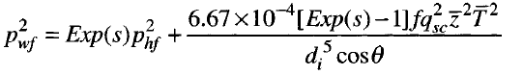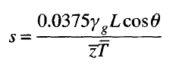

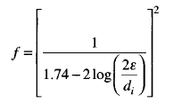

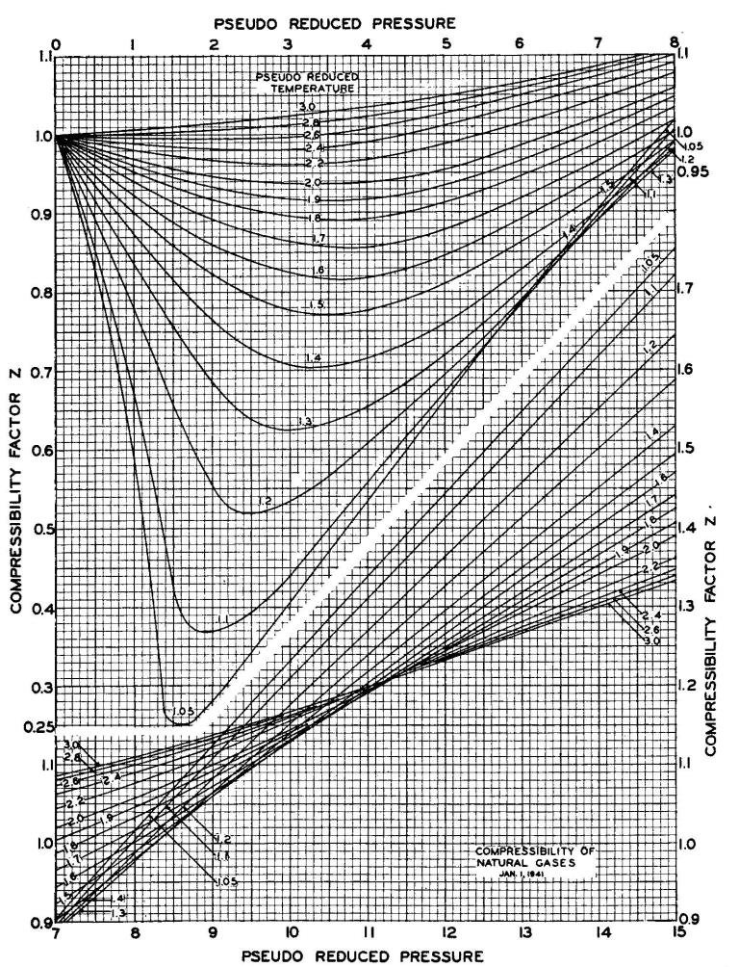

**Fig 1 Compressibility of Natural gas**