|  |  |  |  |  |  |  |  |  |  |  |  |  |
| --- | --- | --- | --- | --- | --- | --- | --- | --- | --- | --- | --- | --- |
| Roll No |  |  |  |  |  |  |  |  |  |  |  |  |

**Presidency University**

**Bengaluru**

**SCHOOL OF ENGINEERING**

**MAKE UP EXAMINATION – SEPTEMBER 2023**

**Course Code**: PET 225

**Course Name**: Advanced Reservoir Engineering and Management

**Program** : B.Tech

**Date**: 01.10.2023

**Time**: 09:30AM to 12:30 PM

**Max Marks**: 100

**Weightage**:50%

**Instructions:**

**(**i) Read the all questions carefully and answer accordingly.

(ii) Question paper consists of three parts: Part A, Part B and Part C

(iii) Attempting all questions is mandatory. Some questions contain multiple parts.

(iv) Use normal graph paper for Part C question, and tie the plotted graph paper inside the answer sheet.

**Part A [Memory Recall Questions]**

**Answer all the Questions. (5Qx 4M = 20M)**

1. Classify the aquifers based on boundary dimensions and in terms of degree of pressure maintenance. Under what conditions a finite acting reservoir will behave as infinite acting reservoir?

(C.O. No.1) [ Knowledge]

2. List the different primary reservoir driving mechanisms. Detail briefly as the presence of which among these mechanisms makes the reservoir as good prospects and weaker prospects for water flooding? (C.O. No.2) [Knowledge]

3. Express mathematically as how does the instantaneous Gas –Oil ratio (GOR) is used to determine the cumulative gas production (Gp) in a reservoir. Use proper illustrations?

(C.O. No.3) [Knowledge]

4. What is water and gas coning, explain briefly through a proper illustration? List the forces affecting the fluid flow distribution around the wellbores and their effect on coning?

(C.O. No.4) [Knowledge]

5. Briefly detail the three different types of Gas-Oil Ratio (GOR) with their mathematical expressions? (C.O. No.3) [Knowledge]

**Part B [Thought Provoking Questions]**

**Answer all the Questions. (2Q x 20M = 40M)**

6. **A.** The measure of the wells ability to produce is called the productivity index. When the pressure of the well below drops below the bubble point pressure, the wells productivity can be defined in the terms of different variables defined by the equation (1)

$J=C(\frac{Kro}{μoBo})$…………………………………..(1)

The variables in the equation 1 affect the productivity index (J) of an oil well in the following manner shown in the Fig 1. You must provide your understanding of how the different variables are changing with increasing pressure. **(C.O.No.3) [Comprehension]**

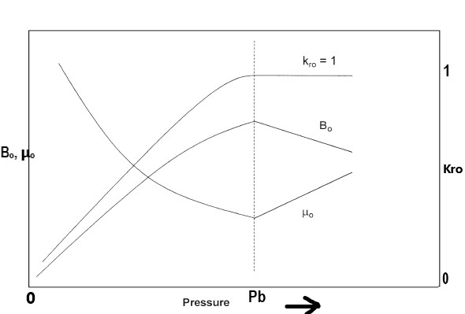

**Fig. 1 Effect of pressure on Bo, μo and Kro**

**B.** Briefy give your insights about the following given terms:

i. Specific Productivity Index (C.O.No.3) [Comprehension]

ii. Critical Production Rate

iii. Stable and Unstable Cone

iv. Residual oil and Connate water saturation

7. Productivity index of a well is an important parameter in terms of well inflow performance. Give your understanding of how does the pressure varies with increasing well flowing time and how does productivity index varies with time. Explain through proper illustrations.

Provide your understanding with proper reasoning, in which flowing regime is the productivity index useful for determining the future performance of wells.

How does the skin factor affects the productivity index? [C.O. No. 3] [Comprehension]

**Part C [Problem Solving Questions]**

**Answer all the Questions. (2Q x 20M = 40M)**

8. **A.** The following production data (in Table 1) are available on a depletion drive reservoir. Using the data in Table 1, Calculate the cumulative gas produced Gp and cumulative gas-oil ratio at each pressure? (C.O. No 3) [Application]

**Table 1: Production data in depletion drive reservoir**

|  |  |  |
| --- | --- | --- |
| **P (psi)** | **GOR (scf/STB)** | **Np (MMSTB)** |
| 2925 **(Pi)** | 1340 | 0 |
| 2600 | 1340 | 1.380 |
| 2400 | 1340 | 2.260 |
| 2100 **(Pb)** | 1340 | 3.445 |
| 1800 | 1936 | 7.240 |
| 1500 | 3584 | 12.029 |
| 1200 | 6230 | 15.321 |

**B.** A volumetric solution gas drive reservoir has an initial water saturation of 40 %. The initial oil formation volume formation factor is 1.5bbl/STB. When 10% of the initial oil was produced, the value of Bo decreased to 1.38. Determine the oil saturation and gas saturation?

(C.O. No 3) [Application]

9. **A.** An oil well is producing from an undersaturated reservoir that is characterized by a bubble point pressure of 2130 psia. The current average reservoir pressure is 3000 psig. Available flow test data show that the well produced 250 STB/day at a stabilized Pwf of 2500 psia. Construct the IPR data and the plot? Use normal graph paper for plotting the IPR curve and use appropriate scale for plotting with clear markings. (C.O. No 3) [Application]

**B. Give your insights on the following reservoir engineering terms**

i. Undersaturated and Saturated Reservoir (C.O. No 3) [Application]

ii. Inflow Performance Relationship (IPR)

iii. Stabilized well flowing pressure