|  |  |  |  |  |  |  |  |  |  |  |  |  |
| --- | --- | --- | --- | --- | --- | --- | --- | --- | --- | --- | --- | --- |
| Roll No |  |  |  |  |  |  |  |  |  |  |  |  |



**Presidency University**

**Bengaluru**

**SCHOOL OF ENGINEERING**

**MAKE-UP EXAMINATION – SEP 2023**

**Date**: 04/OCT/2023

**Time**: 09:30 AM – 12:30 PM

**Max Marks**: 100

**Weightage**: 50%

**Course Code**: PET 304

**Course Name**: Reservoir Geomechanics

**Program & Sem**: B.Tech. (PET) & V

**Instructions:**

1. *Read the all questions carefully and answer accordingly.*
2. *Do not write any matter on the question paper other than roll number.*
3. *All the figures and charts are provided at the end of the question paper. Identify the correct figure / chart for solving the questions.*
4. ***Charts to be used for solving problems are printed herewith. Therefore, submit the Question Paper along with the Answer-script.***

**Part A [Memory Recall Questions]**

**Answer all the Questions. Each question carries 5 marks. (4Qx 5M=20M)**

Q.NO. 1: (a) Discuss “Breakouts”.

(b) List the probable consequences of “Breakouts”. (C.O.No. 1) [Knowledge]

Q.NO. 2: (a) Explain “Stress” and “Strain”.

(b) List down the sources of “Stress” in the crust. (C.O.No. 2) [Knowledge]

Q.NO. 3: (a) Define “Linearly Elastic Material”

(b) Describe the elastic behavior of rocks. (C.O.No. 3) [Knowledge]

Q.NO. 4: Bullet-point the causes of pore pressure generation. (C.O.No. 4) [Knowledge]

**Part B [Thought Provoking Questions]**

**Answer all the Questions. Each question carries 10 marks. (4Qx10M=40M)**

Q.NO. 5: The basis for understanding wellbore stability is understanding the geomechanical model. The geomechanical model begins by defining the principal stress tensor. When the horizontal stress is not equal (a frequent condition) a stress anisotropy is created and wellbore instability can be pronounced as well as direction and deviation sensitive. The pore pressure is a very important parameter in the geomechanical model and can be directly related to the fracture gradient, especially in depleted sands. Rock strength is also a major factor in the calculation of wellbore collapse. When these parameters are known, a geomechanical model can be created. On the basis of the above information, illustrate the possible areas of the oil and gas industry where the knowledge of Geomechanics can be applied.

(C.O.No. 1) [Comprehension]

Q.NO. 6: Field photos of different geological faults are displayed in Figures A through C. Identify the faults and explain all with the block diagrams as per E. M. Anderson’s Stress Classification Scheme.

|  |  |
| --- | --- |
| ***Figure A*** | ***Figure B*** |
|  |  |
| ***Figure C*** | |

(C.O.No. 2) [Comprehension]

Q.NO. 7: Illustrate the rock behavior from Stress – Strain relationship at points A through D as presented in Figure 01.

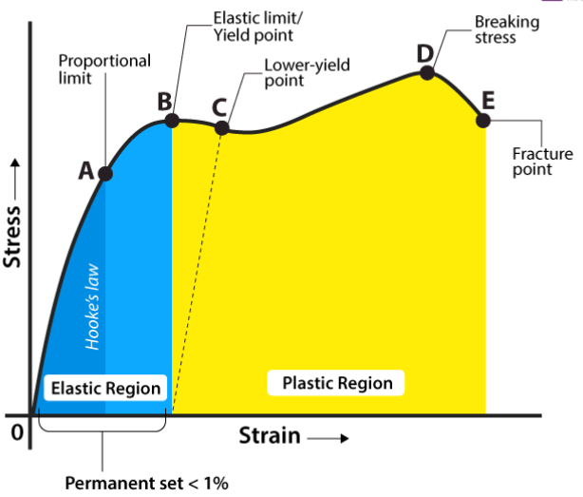

(C.O.No. 3) [Comprehension]

Q.NO. 8: Figure XY shows the variation of pore pressure with depth from observations in the Monte Cristo field along the Texas Gulf coast (after Engelder and Leftwich 1997). The way in which pore pressure varies with depth in this field is similar to what is seen throughout the Gulf of Mexico oil and gas province and many sedimentary basins where overpressure is encountered at depth. Illustrate the importance of Figure XY.

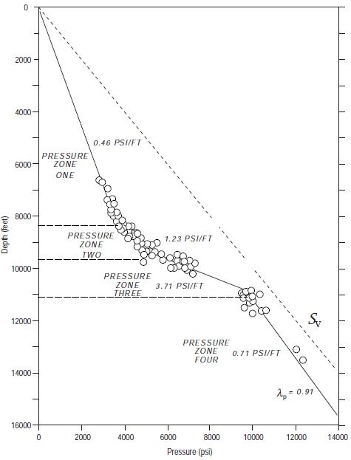

**Figure XY**

(C.O.No. 2) [Comprehension]

**Part C [Problem Solving Questions]**

**Answer all the Questions. Each question carries 20 marks. (2Qx20M=40M)**

Q.NO. 9: Pore Pressure (PP in ppg), Mud Weight (MW in ppg), Modular Dynamic Test (MDT in PPG), Over Burden Gradient (OBG in ppg), Casing Plan (Csg in inch), Fracture Gradient (FG in ppg), Leak Off Test (LOT in ppg), and lithology (mainly shale and sandstone) have been plotted for two offshore vertical wells, i.e., Well PU01 and Well PU02, and displayed the same in Figure 01 and Figure 02 respectively. Analyze the figures, and provide the required information:

(a) Identify the well drilled up to the maximum depth,

(b) Determine the approximate water column depth for both wells,

(c) Pick the well having a bigger safety window (mention the pressure range) at 2000 ft depth,

(d) Delineate the abnormal pressure zones with justification,

(e) Compare both wells and comment on the challenges that might have been faced during the drilling.

|  |  |
| --- | --- |
| **Figure 01** | **Figure 02** |

[2M + 2M + 4M + 6M + 6M] (C.O.No. 2) [Application]

Q.NO. 10: Natural fracture data interpreted from an FMI image log in a vertical well from the Barnett Shale has been presented in Table 1. This image log has been processed using the software GMI Imager, in which fractures were picked as abrupt contrasts in the electrical resistivity image of the borehole wall. Analyze the data presented in Table 1 and answer the followings:

(a) Which of the following strike intervals contains the highest number of fractures?

(i) 0° to 90° (ii) 90° to 180° (iii) 180° to 270° (iv) 270° to 360°

(b) Which of the following dip intervals contains the highest number of fractures?

(i) 0° to 15° (ii) 15° to 30° (iii) 30° to 45° (iv) 45° to 60°

(v) 60° to 75° (vi) 75° to 90°

(c) Which of the following dip direction intervals contains the highest number of fractures?

(i) 0° to 90° (ii) 90° to 180° (iii) 180° to 270° (iv) 270° to 360°

(d) Which of the following aperture intervals contains the highest number of fractures?

(i) 0 mm to 4 mm (ii) 4 mm to 8 mm (iii) Greater than 8 mm

(e) Which of the following aperture intervals contains the highest number of gently dipping fractures of which the dip is less than 45°?

(i) 0 mm to 4 mm (ii) 4 mm to 8 mm (iii) Greater than 8 mm

(f) Which of the following depth intervals contains the highest number of fractures?

(i) Less than 5400 feet (ii) 5400 feet to 5600 feet (iii) 5600 feet to 5800 feet

(iv) 5800 feet to 6000 feet (v) Greater than 6000 feet

(g) Which of the following aperture intervals contains the highest number of nearly north-south striking fractures of which the strike is either between 0° and 15°, or between 75° and 105°, or between 345° and 360°?

(i) 0 mm to 4 mm (ii) 4 mm to 8 mm (iii) Greater than 8 mm

(h) Choose the correct statement:

(i) Fracture Breakdown Pressure (FBP) is the best estimate of the least principal stress (S3) magnitude, even if Instantaneous Shut In Pressure (ISIP) measurement is available.

(ii) Correctly interpreted Instantaneous Shut In Pressure (ISIP) is a reasonable estimate of the least principal stress (S3) magnitude.

**Table 1:**

|  |  |  |  |  |
| --- | --- | --- | --- | --- |
| **Depth (ft)** | **Strike (degree)** | **Dip (degree)** | **Dip Direction (degree)** | **Aperture (millimeter)** |
| 5200.82 | 228.25 | 76.41 | 318.25 | 4.31 |
| 5200.97 | 207.80 | 86.11 | 297.80 | 5.87 |
| 5205.07 | 233.97 | 84.07 | 323.97 | 7.22 |
| 5208.82 | 206.68 | 82.67 | 296.68 | 5.52 |
| 5221.97 | 214.65 | 77.20 | 304.65 | 5.44 |
| 5232.42 | 211.99 | 79.37 | 301.99 | 9.95 |
| 5248.54 | 214.61 | 79.88 | 304.61 | 12.24 |
| 5252.68 | 226.41 | 84.78 | 316.41 | 10.21 |
| 5269.20 | 245.50 | 80.63 | 335.50 | 8.22 |
| 5280.63 | 238.08 | 81.70 | 328.08 | 2.67 |
| 5290.00 | 226.76 | 83.85 | 316.76 | 5.28 |
| 5298.56 | 212.76 | 82.34 | 302.76 | 2.28 |
| 5422.93 | 220.49 | 75.45 | 310.49 | 2.21 |
| 5480.59 | 235.58 | 78.23 | 325.58 | 2.79 |
| 5486.79 | 203.03 | 80.78 | 293.03 | 1.92 |
| 5541.47 | 228.51 | 78.70 | 318.51 | 0.25 |
| 5629.33 | 190.00 | 82.13 | 280.00 | 0.79 |
| 5654.14 | 162.75 | 18.04 | 252.75 | 9.69 |
| 5691.06 | 7.48 | 15.89 | 97.48 | 9.44 |
| 5715.48 | 162.80 | 7.92 | 252.80 | 2.69 |
| 5857.44 | 224.46 | 85.04 | 314.46 | 1.15 |
| 5878.72 | 219.11 | 86.63 | 309.11 | 3.08 |
| 6000.14 | 5.74 | 11.19 | 95.74 | 11.29 |
| 6020.27 | 0.37 | 40.44 | 90.37 | 11.04 |
| 6114.42 | 201.54 | 56.87 | 291.54 | 5.53 |
| 6142.56 | 208.40 | 59.07 | 298.40 | 4.22 |
| 6154.56 | 200.38 | 56.88 | 290.38 | 0.25 |
| 6164.20 | 351.60 | 5.34 | 81.60 | 16.72 |

(C.O.No. 4) [Application]