|  |  |  |  |  |  |  |  |  |  |  |  |  |
| --- | --- | --- | --- | --- | --- | --- | --- | --- | --- | --- | --- | --- |
| Roll No |  |  |  |  |  |  |  |  |  |  |  |  |

**Presidency University**

**Bengaluru**

**SCHOOL OF ENGINEERING**

**MAKEUP EXAMINATION – SEP 2023**

**Course Code**: CIV 209

**Course Name**: Structural Analysis - 2

**Program** : B. Tech

**Date**: 03-10-2023

**Time**: 9.30AM - 04:00 PM

**Max Marks**: 100

**Weightage**: 50%

**Instructions:**

1. *Read the all questions carefully and answer accordingly.*
2. *Question paper consists of 3 parts.*
3. *Scientific and Non-programmable calculators are permitted.*

**Part A [Memory Recall Questions]**

**Answer all the Questions. Each question carries FIVE marks. (4Qx 5M= 20M)**

1. Calculate the Fixed end moments for AB and BC beams loaded as shown in fig. (C.O.No.1) [Knowledge]

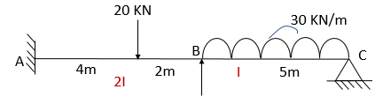

2. Calculate the Rotation factors for the joint B and C for the given frame:

(C.O.No.3) [Knowledge]

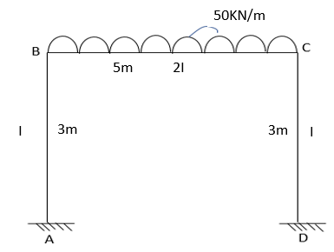

3. Calculate the Maximum Bending moment for the given beam AB:

(C.O.No.2) [Knowledge]

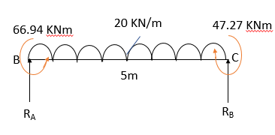

4. Calculate the Distribution factors at joint B for a given continuous beam:

(C.O.No.2) [Knowledge]

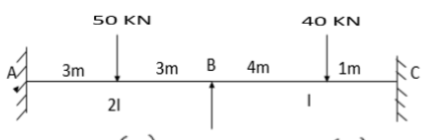

**Part B [Thought Provoking Questions]**

**Answer all the Questions. Each question carries TWENTY marks. (2Qx20M=40M)**

1. The beam BC is supported on elastic columns at rigid joints B and C and restrained at A and D loaded as shown in figure. Analyze the given frame using Moment Distribution method. Determine the Final end moments and show the moments on the frame.

(C.O.No.2) [Application]

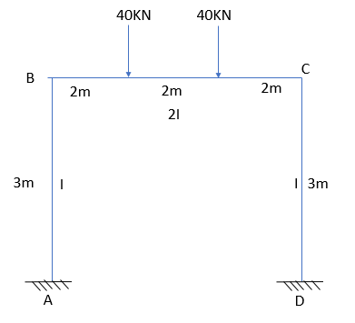

1. A continuous beam ABCD is supported at B and C and ends of the continuous beam are constructed along with supporting elements to achieve the fixity. Analyze the given beam using Kani’s Method. Draw the BMD for the beam and Calculate the maximum positive bending moment for span AB, BC and CD

(C.O.No.3) [Application]

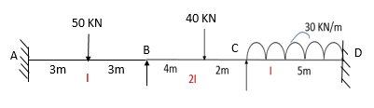

**Part C [Problem Solving Questions]**

**Answer all the Questions. Each question carries TWENTY marks. (2Qx20M=40M)**

1. Analyze the given portal frame using Kani’s method. Draw the BMD for the frame and Calculate the Maximum positive bending moment for the span AB, BC AND CD. (C.O.No.3) [Application]

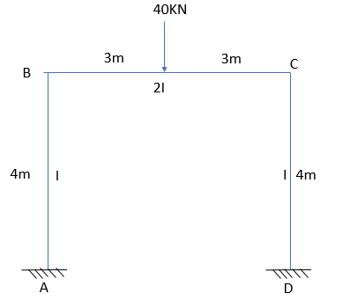

1. Analyze the given beam using **Stiffness Matrix Method** or **Flexibility Matrix method**. Draw the BMD for the beam and Calculate the Maximum positive Bending moment for the span AB and BC. (C.O.No.4) [Application]

