|  |  |  |  |  |  |  |  |  |  |  |  |  |
| --- | --- | --- | --- | --- | --- | --- | --- | --- | --- | --- | --- | --- |
| Roll No |  |  |  |  |  |  |  |  |  |  |  |  |

**Presidency University**

**Bengaluru**

**SCHOOL OF ENGINEERING**

**MAKE UP EXAMINATION – SEPTEMBER 2023**

**Date**: 01.10.2023

**Time**: 9:30AM to 12:30PM

**Max Marks**: 100

**Weightage**: 50%

**Course Code**: CIV 101

**Course Name**: ELEMENTS OF CIVIL ENGINEERING

**Program** : B.TECH

**Instructions:**

1. *Read all the questions carefully and answer accordingly.*
2. *Use of Non-Programmable Scientific Calculator is permitted*

**Part A [Memory Recall Questions]**

**Answer any Nine Questions. (9Qx 2M = 18M)**

1. The branch of civil engineering that deals with the analysis and design of elements of a structure is ________.

a) Geotechnical Engineering b) Structural Engineering

c) Transportation Engineering d) Environmental Engineering (C.O.No.1) [Knowledge]

2. Soils are formed by the process of ____________ of the parent rock.

a) Weathering b) Decomposition

c) Disintegration d) All of the above (C.O.No.1) [Knowledge]

3. Precipitation in the form of fine droplets of water whose size is less than 0.5 mm and intensity is less than 1 mm/hr is known as.

a) Rainfall b) Glaze

c) Sleet d) Drizzle (C.O.No.3) [Knowledge]

4. The layer of aggregate or broken stones packed around and below the sleeper is known as

a) Sleeper b) Ballast

c) Rail d) Subgrade (C.O.No.3) [Knowledge]

5. Paths on the airfield which provide linkages between one part of the airfield and another is known as

a) Runway b) Terminal

c) Taxiway d) Apron (C.O.No.3) [Knowledge]

6. The boundary between pavement and footpath is known as

a) Median b) Camber

c) Kerb d) Shoulder (C.O.No.3) [Knowledge]

7. _________ is the type of bridge with which longest span can be achieved.

a) Beam bridge b) Cable stayed bridge

c) Arch bridge d) Suspension Bridge (C.O.No.1) [Knowledge]

8. Choose the correct sequence of load transfer in Framed structures.

a) Slab-->Column-->Beam-->Footing b) Slab-->Beam-->Column-->Footing

c) Beam-->slab-->Column-->Footing d) None of the above (C.O.No.1) [Knowledge]

9. _________ is a horizontal member in a structure that withstand the loads by flexure.

a) Footing b) Column

c) Truss d) Beam (C.O.No.1) [Knowledge]

**Part B [Thought Provoking Questions]**

**Answer any four Questions. (4Qx10M = 40M)**

10. Mechanics is the area of mathematics and physics concerned with the relationships between force, matter, and motion among physical objects. Forces applied to objects result in displacements, or changes of an object's position relative to its environment. State and briefly explain the principles in mechanics. Also, list the characteristics of a force.

(C.O.No.2) [Comprehension]

11. Law of polygon of forces is used to determine the resultant of coplanar concurrent force system consisting of more than two forces. State and prove Parallelogram law of Forces.

(C.O.No.2) [Comprehension]

1. There are a number of sub-disciplines within the broad field of civil engineering. General civil engineers work closely with surveyors and specialized civil engineers to design grading, drainage, pavement, water supply, sewer service, dams, electric and communications supply. Write short Notes on the following fields in Civil Engineering:

i) Geotechnical Engineering ii) Environmental Engineering

iii) Surveying iv) Transportation Engineering

(C.O.No.1) [Comprehension]

1. There are at least ten different types of forces that exist in the universe and Supports are used in structures to provide stability and strength.

a) Explain the types of forces with a neat figure.

b) List the types of support with their support reactions.

(C.O.No.4) [Comprehension]

**Part C [Problem Solving Questions]**

**Answer any three Questions. (3Qx14M=42M)**

14. Find the support reactions for the beam AB loaded as shown in Figure 29. [14M]

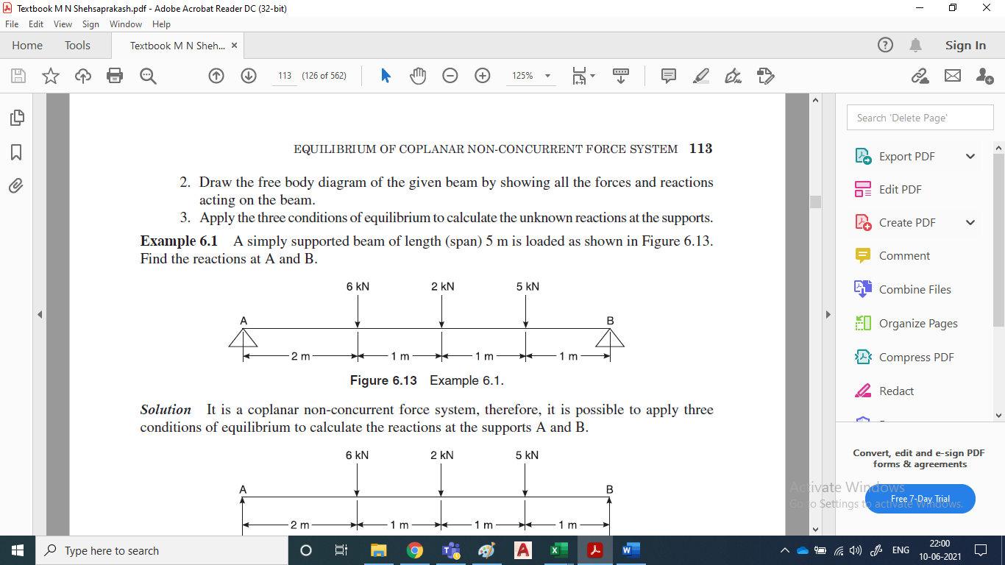

**Fig. 1 (Q14)**

(C.O.NO.4) [Comprehension]

15. Figure 30 shows a rope supporting a load of 10kN at C and another load of ‘P’ at B. If BC is inclined at 45⁰ to horizontal, determine the load P. Also, find the tensile forces developed in different segments of the rope. [14 M]

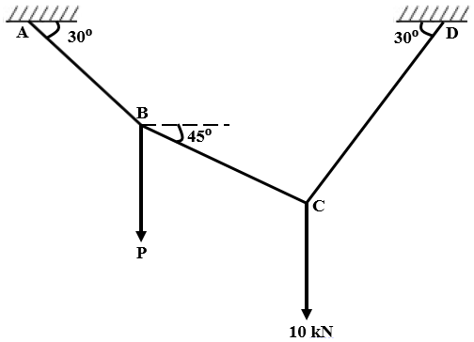

**Fig. 2 (Q15)**

(C.O.NO.4) [Comprehension]

16. Find the magnitude and direction and distance of the resultant from the point ‘A’ for the system of forces shown in Figure 33. [14 M]

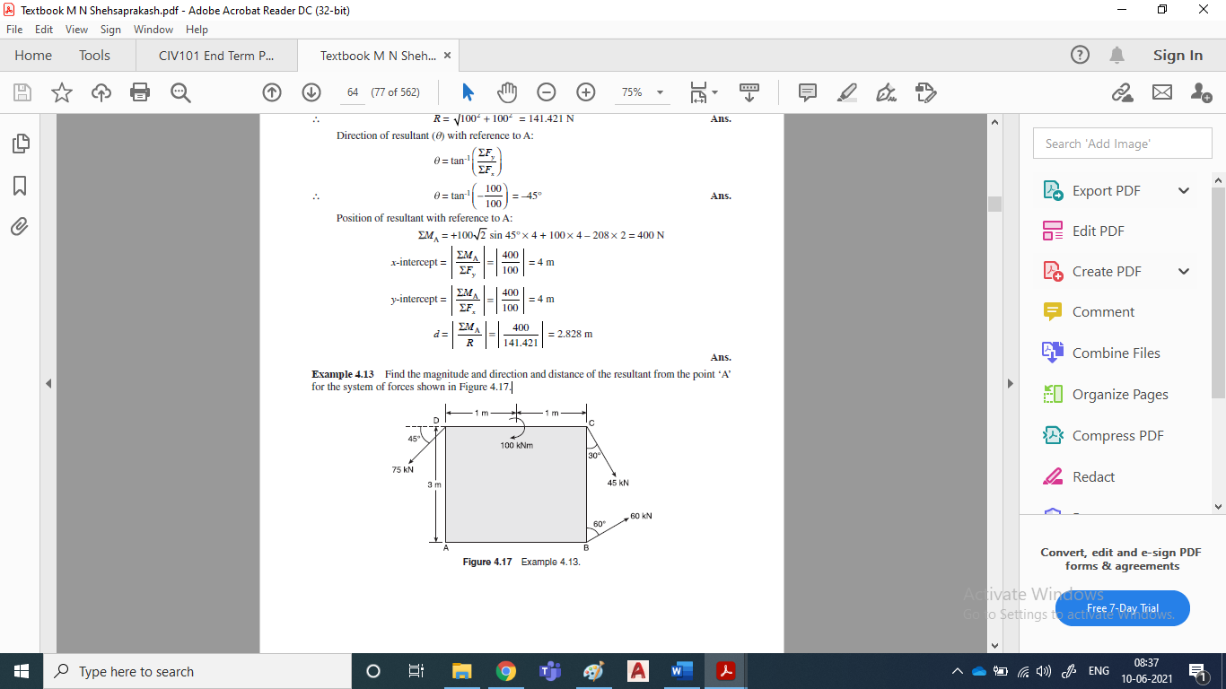

**Fig. 3 (Q16)**

(C.O.NO.3) [Comprehension]