|  |  |  |  |  |  |  |  |  |  |  |  |  |
| --- | --- | --- | --- | --- | --- | --- | --- | --- | --- | --- | --- | --- |
| Roll No |  |  |  |  |  |  |  |  |  |  |  |  |



**Presidency University**

**Bengaluru**

**SCHOOL OF ENGINEERING**

**MAKE UP EXAMINATION – SEPTEMBER 2023**

**Course Code**: MEC 209

**Course Name**: Heat and Mass Transfer

**Program**: B.Tech.MECH

**Date**: 01.10.2023

**Time**: 1.00PM to 4.00PM

**Max Marks**: 100

**Weightage**: 50%

**Instructions:**

1. *Read the all questions carefully and answer accordingly.*
2. *Use of Non-programmable calculator is allowed.*

**Part A [Memory Recall Questions]**

**1. Answer all the Questions. (15Qx 2M= 30M)**

i. A hollow cylinder has length L, inner radius r1 outer radius r2, and thermal conductivity K, the thermal resistance of the cylinder for radial conduction is……… (C.O.1) [Knowledge]

ii. Which of the following is correct regarding one dimensional heat transfer? . . (C.O.1) [Knowledge]

A. Steady – f (x, y, t), Unsteady – f (x) B. Steady – f (y, z), Unsteady – f (y)

C. Steady – f (x, t), Unsteady – f (x) D. None of the above

iii. Which of the statement is correct? . (C.O.1) [Knowledge]

A. The emissivity of black body is Zero.

B. The emissivity of black body is One.

C. The emissivity of black body is not defined.

D. The emissivity of black body is infinity.

iv. Up to the critical radius of insulation, (C.O.1) [Knowledge]

A. adding insulation will increase heat transfer

B adding insulation will decrease heat transfer

C. adding insulation will first increase and then decrease heat transfer

D. None of above

v. Unit of thermal diffusivity is…………. (C.O.1) [Knowledge]

vi. LMTD in case of parallel flow heat exchanger as compared to counter flow heat exchanger is.   (C.O.1) [Knowledge]

A. Higher  B. Lower C. Same D. Depends on area of heat exchanger

vii. The emissive power of a blackbody is P. If its absolute temperature becomes half, the emissive power becomes (C.O.1) [Knowledge]

A. 2P B. 4P C. 8P D. None

viii. For an opaque surface, the absorptivity (α), transmissivity (τ) and reflectivity (ρ) are related by the equation: (C.O.1) [Knowledge]

A. α+ ρ= τ B. α+ ρ+ τ = 0 C. α+ ρ= 1 D. None

ix. Which of the following is a mode of heat transfer. (C.O.1) [Knowledge]

a) Convection b) Radiation c) Conduction d) All of the mentioned

x. Shape factor of any surface depends on temperature of body (True/False) . . (C.O.1) [Knowledge]

xi. Consider the radiation heat exchange inside an annulus between two very long concentric cylinders. The radius of the outer cylinder is $R_{O}$  and that of the inner cylinder is $R_{i}$ . The radiation view factor of the outer cylinder onto itself is………………………… (C.O.1) [Knowledge]

xii. Saturated steam at 90°C condenses on the outside of a tube. Cold fluid enters the tube at 20°C and exits at 50°C. The value of the Log Mean Temperature Difference (LMTD) is _________

(C.O.1) [Knowledge]

xiii. For a heat exchanger, ΔTMAX is the maximum temperature difference and ΔTMIN is the minimum temperature difference between the two fluids. LMTD is the log mean temperature difference. CMIN and CMAX are the minimum and the maximum heat capacity rates. The maximum possible heat transfer (QMAX) between the two fluids is (C.O.1) [Knowledge]

A. CMIN.LMTD

B. CMIN. ΔTMAX

C. CMAX. ΔTMAX

D. CMAX. ΔTMIN

xiv. In a heat exchanger, it is observed that the exit temperature of cold fluid is greater than the the exit temperature of hot fluid. This heat exchanger is………………..

A. a Condenser B. an evaporator C. a Counter flow heat exchanger

D. a Parallel flow heat exchanger [2M](C.O.1) [Knowledge]

xv. Fraction of radiative energy leaving one surface that strikes the other surface is called

A. Radiative flux B. Emissive power of the first surface

C. Re-radiation flux D. None of above

(C.O.1) [Knowledge]

**Part B [Thought Provoking Questions]**

**Answer all the Questions. (4Qx5M=20M)**

2 .Explain effectiveness of heat exchanger with the formula to calculate the effectiveness. . [5M] (C.O.2) [Comprehension]

3. Define Critical Radius of Insulation. Write formula for critical radius of insulation and also draw graph of critical radius of insulation.

[5M] (C.O.2) [Comprehension]

4. Define radiation heat transfer and why radiation shields are placed between two surfaces. Also define emissivity.

[5M] (C.O.2) [Comprehension]

5. Define Irradiation and Radiosity with the help of diagram. Write the formula for total number of surface resistances and space resistances when ‘n’ number of radiation shields placed between two surfaces [5M] (C.O.2) [Comprehension]

**Part C [Problem Solving Questions]**

**Answer all the Questions. (5Qx10M=50M)**

**6**. A metal ball of diameter 60 mm is initially at 220°C. The ball is suddenly cooled by an air jet of 20°C. The heat transfer coefficient is 200 W/m2K. The specific heat, thermal conductivity and density of the metal ball are 400 J/kgK, 400 W/mK and 9000 kg/m3, respectively. [10M] (C.O.3) [Application]

a. Find the ball temperature (in °C) after 90 seconds.

b. Find the time constant of the ball.

**7**. An iron rod (K=41.5W/m-K) of 15mm diameter and 160mm long extends out of a hot surface of temp 150°C into environment at 36°C.The free end of the rod is insulated. If the film heat transfer coefficient is 25W/ $m^{2}$ K, calculate the rate of heat flowing out of the hot surface through the rod and the temp at the insulated end of the rod.

[10M] (C.O.3) [Application]

**8.** Two fluids, A and B exchange heat in a counter-current heat exchanger. Fluid A enters at 420°C and has a mass flow rate of 1 kg/s. Fluid B enters at 20°C and also has a mass flow rate of 1 kg/s, Effectiveness of heat exchanger is 75%. Determine the heat transfer rate and exit temperature of fluid B. (Specific heat of fluid A is 1 kJ/kg K and that of fluid B is 4 kJ/kg-K). [10M] (C.O.3) [Application]

**9.** Define shape factor. Explain shape factor with an example

A solid sphere 1 of radius ′r′ is placed inside a hollow, closed hemispherical surface 2 of radius ′4r′.  Find the shape factor $F_{21}$ . [10M] (C.O.3) [Application]

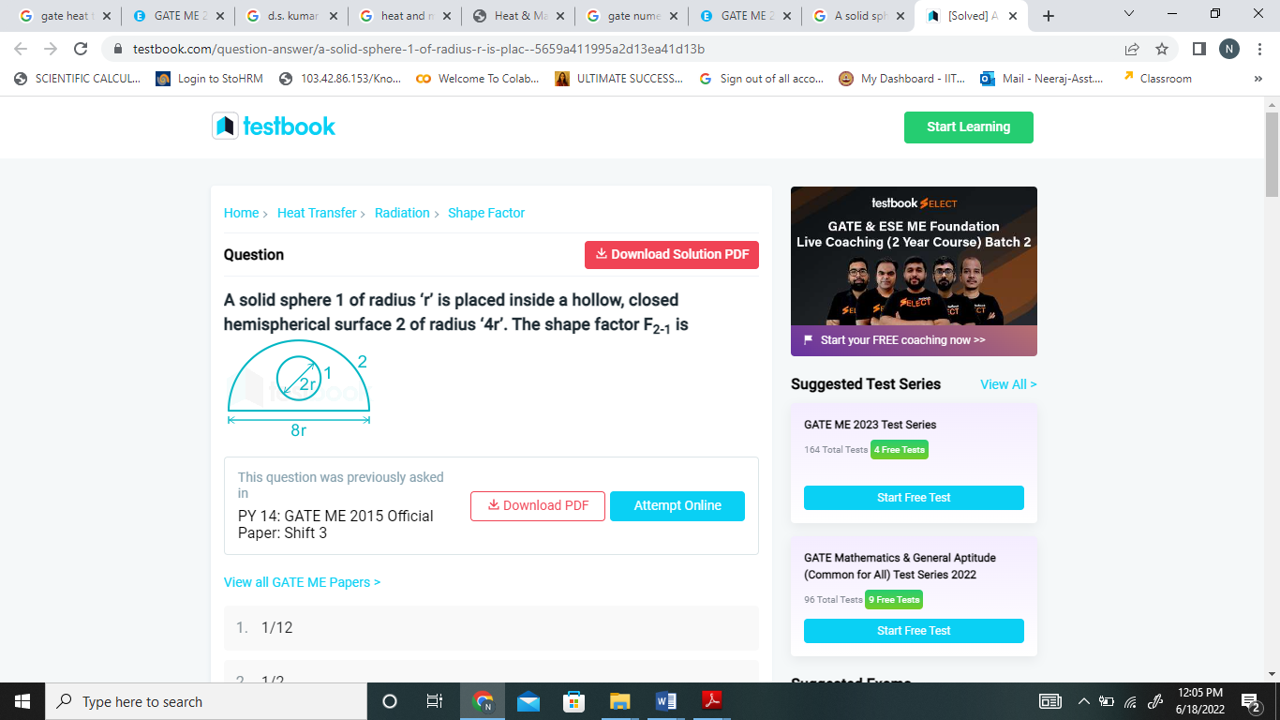

**10.** Two black plates, each one meter square, are placed parallel to each other in such a way that the radiation shape factor for the system is 0.4. If the plates are maintained at 800°C and 400°C respectively, determine the net radiant heat transfer between the plates. Also calculate the net heat exchange if the plate were infinite in size. Stefan Boltzmann constant =5.67× W/m2-K4. [10M] (C.O.3) [Application]