|  |  |  |  |  |  |  |  |  |  |  |  |  |
| --- | --- | --- | --- | --- | --- | --- | --- | --- | --- | --- | --- | --- |
| Roll No |  |  |  |  |  |  |  |  |  |  |  |  |

**Presidency University**

**Bengaluru**

**SCHOOL OF ENGINEERING**

**MAKE UP EXAMINATION – SEP 2023**

**Date**: 06.10.2023

**Time**: 09:30 AM to 12:30 PM

**Max Marks**: 100

**Weightage**: 50 %

**Course Code**: PET 406

**Course Name**: Polymer Technology

**Program** : B.Tech

**Instructions:**

1. *Read the all questions carefully and answer accordingly.*
2. *Question Paper has THREE Parts, i.e. Part A, Part B, and Part C.*

**­­Part A [Memory Recall Questions]**

**Answer all the Questions. (2Qx 10M= 20M)**

**1. Mark the following statements as True or False** (C.O. No. 1, 3) (Knowledge)

i. A polymer is a chain of many small units joined together which are called monomers.

ii. A lot of plastic pollutes our environment.

iii. Degradable plastics break down into tiny pieces called micro plastics.

iv. Cotton is a natural polymer.

v. In general viscosity of gases will increase with increasing temperature.

vi. Thermosetting plastics do have a Tm, and they can have temperature resistance superior to that of thermoplastics.

vii. Crosslinking is one of the most common methods of strengthening polymers and many thermosets have a cross-linked structure.

viii. If shear stress is plotted as a function of a fluid’s deformation rate, an increasing slope will imply fluid is dilantant.

ix. The additive fillers are used to impart colour to the polymer.

x. Viscosity is the proportionality factor that relates the shear stress to the shear strain.

**2. Answer the following questions:** (C.O. No.1, 2) (Knowledge)

**Explain the following terms**

i) Glass transition temperature

ii) Spherulite

iii) Viscoelasticity

iv) Polymer Composite

v) Upper critical solution temperature and lower critical solution temperature.

**Part B [Thought Provoking Questions]**

**Answer all the Questions. (10Qx6M=60M)**

**3.** Some polymers undergo degradation that reduces the average chain length during manufacturing like polyesters. Others, polyethylene for example, crosslink during degradation at high temperature.

1. What would the manufacturer observe in each case scenario?
2. State briefly different types of degradation. (C.O.No.2) (Application)

**4.** Discuss the design characteristics of object obtained by compression moulding. Discuss advantage and disadvantage of compression moulding. (C.O.No.4) (Application)

**5.** Describe using graphical illustrations the difference between a semi-crystalline and amorphous polymer in terms of structure, appearance, melting behavior and glass transition temperature.

(C.O.No.2) (Comprehension)

**6**. Justify the following statement:

1. Plasticizer enhances the flexibility and elongation property when added to polymer
2. A polymer was heated and found to have two melting points in DSC run.

(C.O.No.3) (Comprehension)

**7.** With neat diagram discuss the polymeric materials:

1. Hard and brittile,
2. Hard and strong,
3. Soft and weak and
4. Soft and tough (C.O.No.3) (Application)

**8.** Polymers available can be classified on the basis of synthesis, molecular structure, and chemical family. Discuss different types of polymers based on these classifications along with diagrams wherever required. (C.O.No.1) (Comprehension)

**9**. Polymers undergo degradation when exposed to heat, environment or mechanical stresses. Give your views on the two types of degradation of polymers with examples?

(C.O.No.3) (Comprehension)

**10**. Predict and explain examples the effect, if any, of varying molecular weight, presence of crosslinking, chain stiffness, pendant groups and degree of short-chain branching on thermal properties of polyethylene. (C.O.No.3) (Comprehension)

**11.** Early efforts during the growth of the plastics industry focused on the development of synthetic materials having comparable or superior properties to those of natural polymers. But due to cost effectiveness and environmental impact, industry is moving towards natural polymers. Give your views on the biopolymers or other naturally occurring polymers with examples.

(C.O.No.4) (Application)

**12.** Polymers are large molecules made up of long chains of smaller monomer molecules. The conversion of monomer to polymer is termed as polymerization. Classify different techniques of polymerization with examples. (C.O.No.2) (Comprehension)

**Part C [Problem Solving Questions]**

**Answer both the questions. (2Qx10M=20M)**

**13.** The diagram shows the increase in molecular weight with the percent concentration of polymer.

1. Identify A and B type of polymerization mechanisms.
2. On the basis of the diagram explain the types of polymerization mechanisms including the difference in the formation process with examples.

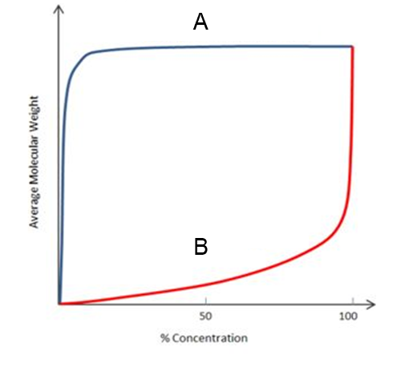 (C.O.No.1) (Application)

**14. (a)** A nylon solution is prepared by step growth reaction. It has three type of polymer molecules based on length.

|  |  |  |
| --- | --- | --- |
| **Species** | **Weight of specie “i” (Wi – gm)** | **Molar weight of specie “i” (Mi)** |
| a | 1 | 10000 |
| b | 2 | 50000 |
| c | 2 | 100000 |

Determine:

i.) Number average molecular weight.

ii.) Weight average molecular weight.

iii.) Polydispercity index. (C.O.No.1) (Application)

**(b)** Calculate the mobility ratio for the fluid used in water flooding project, when if permeability of oil is 0.75D and permeability water is 0.35D, and viscosity of oil is 6cPand water is 1cP. If viscosity is increased by adding polymer to the water to 6cP, calculate the mobility ratio? In which case is the mobility ratio favourable? (C.O.No.4) (Application)