|  |  |  |  |  |  |  |  |  |  |  |  |  |
| --- | --- | --- | --- | --- | --- | --- | --- | --- | --- | --- | --- | --- |
| Roll No |  |  |  |  |  |  |  |  |  |  |  |  |



**Presidency University**

**Bengaluru**

**SCHOOL OF MANAGEMENT**

**MAKE UP EXAMINATION – SEPTEMBER 2023**

**Course Code**: MAH 104

**Course Name**: Strategic Financial Management

**Program** : BCH CMA

**Date**: 01.10.2023

**Time**: 1.00PM to 4.00PM

**Max Marks**: 100 Marks

**Weightage**:50%

**Instructions:**

1. *Read the all questions carefully and answer accordingly.*

**Part A [Memory Recall Questions]**

**Answer all the Questions. (10Qx 3M= 30M)**

1. Gary waits two hours in line to buy a ticket to an NCAA Final Four Tournament. The opportunity cost of buying the $200 ticket is: (C.O.No.2) [Blooms ’level-Knowledge]
   1. Gary's best alternative use of the two hours it took to wait in line.
   2. Gary's best alternative use of both the $200 and the two hours spent in line.
   3. the value of the $200 to the ticket agent.
   4. Gary's best alternative use of the $200.
2. Which of the following is not part of the decision-making process?
   1. Estimate future revenues and costs.
   2. Evaluate all available options.
   3. Incorporate historical revenues and costs.
   4. Identify all available options. (C.O.No 1) [Blooms ’level-Knowledge]
3. Current business segment operations for Whitman, a mass retailer, are presented below.

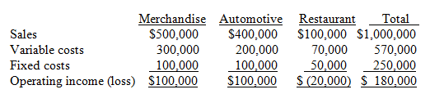

Management is contemplating the discontinuance of the Restaurant segment since "it is losing money." If this segment is discontinued, $30,000 of its fixed costs will be eliminated. In addition, Merchandise and Automotive sales will decrease 5% from their current levels. When considering the decision, Whitman's controller advised that one of the financial aspects Whitman should review is contribution margin. Which one of the following options reflects the current contribution margin ratios for each of Whitman's business segments? (C.O.No.2) [Blooms ’level-Knowledge]

* 1. Merchandising: 40%, Automotive: 50%, Restaurant: 30%.
  2. Merchandising: 60%, Automotive: 50%, Restaurant: 70%.
  3. Merchandising: 40%, Automotive: 50%, Restaurant: 70%.
  4. Merchandising: 60%, Automotive: 50%, Restaurant: 30%.

1. The manufacturing labor cost projections for two different investment proposals are $145,000 and $175,000. These projections are based on the past manufacturing labor rate of $12 per hour and total past manufacturing labor costs of $168,000 (140 hours × 100 workers × $12) for a similar project. In evaluating the proposals, the past labor costs are examples of:

(C.O.No.1) [Blooms ’level-Knowledge]

1. decremental costs.
2. irrelevant costs.
3. relevant costs.

D. incremental costs

1. The manufacturing labor costs for two different investments projects are $270,000 and $310,000. In evaluating the projects, these labor costs are examples of: (C.O.No.1) [Blooms ’level-Knowledge]
   1. opportunity costs.
   2. irrelevant costs.
   3. unavoidable costs.
   4. relevant costs.
2. Cardinal Company needs 20,000 units of a certain part to use in its production cycle. The following information is available: (C.O.No.3) [Blooms ’level-Knowledge]

Cost to Cardinal to make the part:

Direct materials $4

Direct labor $16

Variable overhead $8

Fixed overhead applied $10

Total Cost $38

Cost to buy the part from the Oriole Company $36

If Cardinal buys the part from Oriole instead of making it, 60% of the fixed overhead applied will continue. Cardinal cannot use the released facilities in another manufacturing activity, regardless of what decision is made. In deciding whether to make or buy the part, the total relevant costs to make the part are:

1. $640,000
2. $720,000.
3. $760,000.
4. $560,000
5. Manson Industries incurs unit costs of $8 ($5 variable and $3 fixed) in making an assembly part for its finished product. A supplier offers to make 10,000 of the assembly part at $6 per unit. If the offer is accepted, Manson will save all variable costs but no fixed costs. Which costs are irrelevant in this analysis? (C.O.No.3) [Blooms ’level-Knowledge]
6. $80,000
7. $50,000
8. $30,000
9. $60,000
10. Bryant Company has a factory machine with a book value of $90,000 and a remaining useful life of five years. It can be sold for $30,000. A new machine is available at a cost of $400,000. This machine will have a five-year useful life with no salvage value. The new machine will lower annual variable manufacturing costs from $600,000 to $500,000. Without any regard to tax consequences, which costs are irrelevant in this analysis? (C.O.No.4) [Blooms ’level-Knowledge]
11. $30,000
12. $90,000
13. $400,000
14. $100,000
15. ABC Inc. produces two products. Data regarding these products are presented below. ABC has 1,000 pounds. of raw materials which can be used to produce Products X and Y.

Which one of the alternatives below should ABC accept in order to maximize contribution margin?

(C.O.No.4) [Blooms ’level-Knowledge]

1. 200 units of product X and 50 units of product Y.
2. 250 units of product X.
3. 200 units of product X and 20 units of product Y.
4. 100 units of product Y.
5. The ratio of fixed costs to the unit contribution margin determines:

(C.O.No.3) [Blooms ’level-Knowledge]

1. operating income.
2. profit margin.
3. sales revenues.
4. break-even point.

**Part B [Thought Provoking Questions]**

**Answer all the Questions. (5Qx8M=40M)**

1. Kator Co. is a manufacturer of industrial components. One of their products that is used as a sub-component in auto manufacturing is KB-96. This product has the following financial structure per unit.

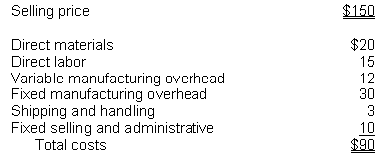

Kator Co. has received a one-time special order for 1,000 KB-96 parts. Assume that Kator is operating at full capacity and the next best alternative use of their capacity on existing equipment is LB-64 that would produce a contribution of $10,000. Calculate the minimum price that is acceptable, using the original data, for this one-time special order. (C.O.No.1) [Blooms ’level-Comprehension]

1. Following are the operating results of the two segments of Parklin Corporation.

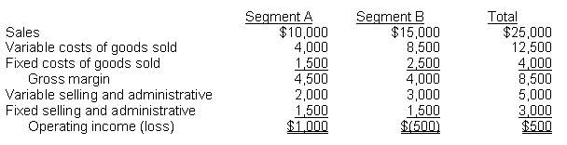

Fixed costs of goods sold are allocated to each segment based on the number of employees. Fixed selling and administrative expenses are allocated equally. If Segment B is eliminated, $1,500 of fixed costs of goods sold would be eliminated. Assuming Segment B is closed, what will be the effect on operating income. (C.O.No.3) [Blooms ’level-Comprehension]

1. Carpets Unlimited produces and sells three lines of carpet: economy grade, standard grade, and deluxe grade. The chief financial officer of the company has prepared the following report on the profitability in the past year. In the report, fixed costs are allocated based on yards of carpet.

|  |  |  |  |  |
| --- | --- | --- | --- | --- |
|  | Economy | Standard | Deluxe | Total |
| Yards of Carpet | 30,000 | 45,000 | 75,000 | 150,000 |
| Sales | $325,000 | $700,000 | $1,525,000 | 2,550.000 |
| Less: Variable costs ( Dyem Yarn, Labor) | $175,000 | $430,000 | $925,000 | 1,540,000 |
| Less: Fixed Costs ( Depreciation, Supervisory salaries) | $162,000 | $243,000 | $405,000 | $810,000 |
| Profit (loss) | $(12,000) | $27,000 | $195,000 | $210,000 |

Upon seeing the report, the president of Carpets Unlimited suggested that the company should consider dropping the economy grade and concentrate on the two other lines.

Assuming all fixed costs are allocated common costs for the entire organization, what would be the impact on the reported profit of the standard grade product line if the economy grade carpet line was dropped? (C.O.No.4) [Blooms ’level-Comprehension]

1. Johnson Company manufactures a variety of shoes, and has received a special one-time-only order directly from a wholesaler. Johnson has sufficient idle capacity to accept the special order to manufacture 15,000 pairs of sneakers at a price of $7.50 per pair. Johnson's normal selling price is $11.50 per pair of sneakers. Variable manufacturing costs are $5.00 per pair and fixed manufacturing costs are $3.00 a pair. Johnson's variable selling expense for its normal line of sneakers is $1.00 per pair. What would the effect on Johnson's operating income be if the company accepted the special order? (C.O.No.2) [Blooms ’level-Comprehension]
2. Cervine Corporation makes motors for various products. Operating data and unit cost information for its products are presented below.

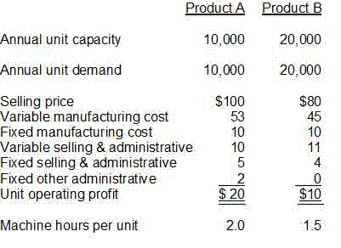

Cervine has 40,000 productive machine hours available. What is the maximum total contribution margin that Cervine can generate in the coming year? (C.O.No.1) [Blooms ’level-Comprehension]

**Part C [Problem Solving Questions]**

**Answer all the Questions. (15Qx2M=30M)**

1. Jones Enterprises manufactures 3 products, A, B, and C. During the month of May, Jones' production, costs, and sales data were

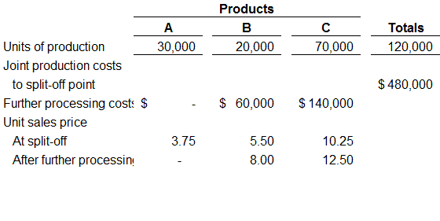

Based on the above information, evaluate the following alternatives and recommend to Jones' management

A) Process Product B further but sell Product C at the split-off point.

B) Process Product C further but sell Product B at the split-off point.

C) Process both Products B and C further.

D) Sell both Product B and Product C at the split-off point

(C.O.No.4) [Blooms ’level Application]

1. A)Define sunk cost and opportunity cost. How are these two types of cost recorded in the accounting records? ( 5 Marks)

B) XGames Inc. manufactures and sells video games. Because the market has become increasingly competitive, the company has decided to cut the selling price of one of its video games from $40 to $30. As a result of lowering the price, the company expects to increase annual sales of this game from 50,000 to 60,000 units. Management wants to earn a 20% target operating income of sales revenues. What is the target operating income per unit and target cost per unit?

(10 Marks)

(C.O.No.3) [Blooms ’level Application]