|  |  |  |  |  |  |  |  |  |  |  |  |  |
| --- | --- | --- | --- | --- | --- | --- | --- | --- | --- | --- | --- | --- |
| Roll No |  |  |  |  |  |  |  |  |  |  |  |  |



**Presidency University**

**Bengaluru**

**SCHOOL OF INFORMATION SCIENCE**

**MAKE UP EXAMINATION – SEPTEMBER 2023**

**Course Code**: BCA209

**Course Name**: Design and Analysis of Algorithms

**Program**: BCA

**Date**:01.10.2023

**Time**: 9.30AM-12.30PM

**Max Marks**: 100

**Weightage**: 50%

**Instructions:**

1. *Read the all questions carefully and answer accordingly.*
2. *PART A and PART B theory based subjective questions.*
3. *PART C Practical based Program write-up and Execution*

**Part A [Memory Recall Questions]**

**Answer all the Questions. (4Qx 5M= 20M)**

1. Calculate the worst-case time complexity to search a key element in given array of elements using brute force algorithm technique.

[5] (C.O.No.1)[Comprehension]

### Write an algorithm string matching using brute force technique.

### [5] (C.O.No.2)[Knowledge]

### Write an algorithm to sort elements using merge sort. [5] (C.O.No.3)[ Knowledge]

### Write Warshall’s algorithm for finding transitive closure. [5] (C.O.No.4) [Knowledge]

**Part B [Problem Solving Questions]**

**Answer all the Questions. (2Qx10M=20M)**

1. Solve the given problem using Dijkstra Algorithm, consider source as “a”.

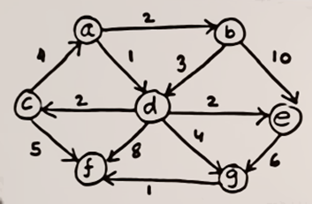

[10] (C.O.No.4) [Application]

1. Solve N Queen problem using backtracking for 4 queens.

[10] (C.O.No.5) [Application]

**Part C [Thought Provoking]**

**Answer all the Questions. (2Qx30M=60M)**

1. Ram wants solve puzzle but his mother wants him to complete math assignment. Help ram to complete both the task by reading a integer number:

a) If number is odd, Ram solves Tower of Hanoi puzzle and display the total number of moves.

b) If number is even, complete the math assignment to find out the factorial of number n.

[30] (C.O.No.2) [Application]

1. Apply dynamic programming and find all pair shortest path for a given directed graph using Floyd’s algorithm.

[30] (C.O.No.4) [Application]