** Presidency University**

**Bengaluru**

**School of Information Science**

**Semester VI**

**MAKE-UP EXAMINATION – SEP 2023**

**Course Title: Software Testing Course Code: BCA 321**

**Date: 01.10.2023 Time: 1.00PM to 4:00 PM**

**Weightage: 50% Total Marks: 100**

**PART B [Thought Provoking Questions]**

**I Answer the following. Each Question Carries 4 Marks.**  (CO2, APPLICATION)

**(5Q X 2M=10 M)**

1. Calculate the Test case preparation productivity if we take 60 hours in preparing 720 test cases.
2. Compute the test design coverage if the total written test cases are mapped to 60% of the requirements gathered which are 180.preparing 720 test cases.
3. Determine the Test case execution productivity if we take 70 hours in executing 920 test cases.
4. Find out test effectiveness if we have found 30 defects in shipping/deployment and 255 defects found in test.
5. Figure out error discovery rate if we have executed 1300 test cases and found 277 defects.

**PART C [Problem Solving Questions] (6Q X 15M=90 M)**

1. Consider the following commission problem scenario:  
   A rifle salesperson in the xyz territory sold rifle locks, stocks, and barrels made by a gunsmith in new York territory. The locks cost $30, stocks cost $40, and  
   barrels cost $50. The salesperson had to sell at least one complete rifle per month and production limits were such that the most the salesperson could sell in a month was 60 locks, 70 stocks, and 80 barrels. After each town visit, the salesperson sent a telegram to the gunsmith with the number of locks, stocks, and barrels sold in that town. At the end of a month, the salesperson sent a very short telegram showing -8 (minus 8) stocks sold. The gunsmith then knew the sales for the month were complete and computed the salesperson's commission as follows: 20% on sales up to (and including) $2000, 10% on the next $500, and 30% on any sales in excess of $2500. The commission program produced a monthly sales report that gave the total number of locks, stocks, and barrels sold, the salesperson's total dollar sales, and, finally, the commission.   
     
   For the above scenario, develop and execute the code (in any programming language). Also write boundary value and decision table test cases

(CO2,APPLICATION)

1. Consider the following next date problem scenario: (CO2, APPLICATION)

Next date is a function consisting of three variables like: month, date and year. It returns the date of next day as output. It reads current date as input date.

The constraints are

C1: 1 <= month <= 12

C2: 1 <= day <= 31

C3: 1947 <=year <= 2021

If any one condition out of c1, c2 or c3 fails, then this function produces an output ""value of month not in the range 1...12"".

Since many combinations of dates can exist, hence we can simply display one message for this function: ""invalid input date"".

A very common and popular problem occurs if the year is a leap year. We have taken into consideration that there are 31 days in a month. But what happens if a month has 30 days or even 29 or 28 days?

For the above scenario, develop and execute the code (in any programming language). Also write boundary value and decision table test cases

1. Design and develop a program in a language of your choice to solve the triangle problem defined as follows: (CO2, APPLICATION)

Accept three integers which are supposed to be the three sides of a triangle and determine if the three values represent an equilateral triangle, isosceles triangle, scalene triangle, or they do not form a triangle at all. Assume that the upper limit for the size of any side is 12. The sides of the triangle must satisfy the following conditions”

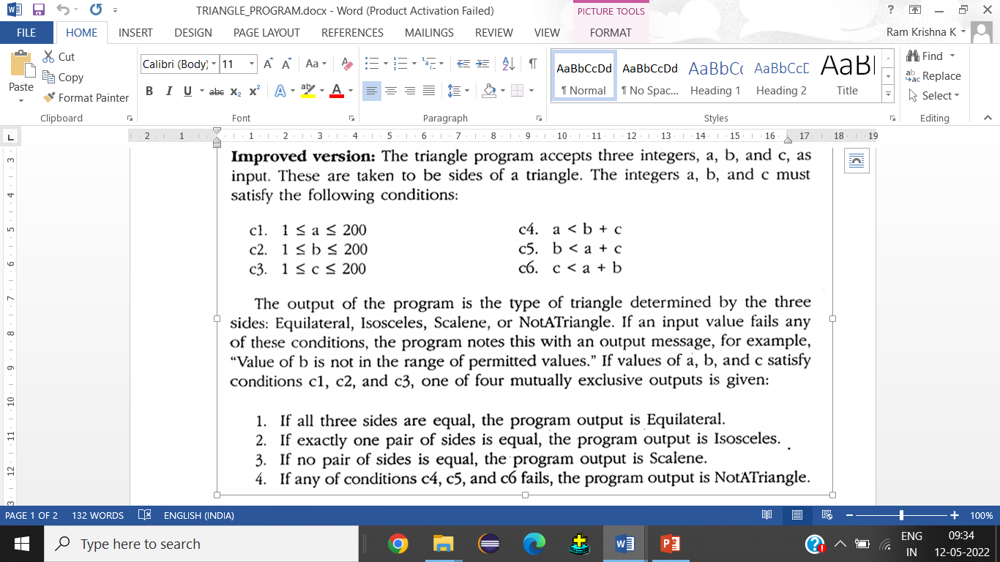

For the above scenario, develop and execute the code (in any programming language). Also write boundary value and decision table test cases.

1. Consider the following binary search problem scenario: (CO2, APPLICATION)

Give the input as an array of 7 numbers which should be multiples of 11. In these numbers search for a key element and display appropriate messages on screen.

For the above scenario, develop and execute code (in any programming language)

Also perform the following

1. Draw the control flow graph

2. Calculate the Cyclomatic Complexity

3. Select a basis set of paths.

4. Generate test cases for each of these paths

1. Consider the following grading problem scenario: (CO2, APPLICATION)

Mr. George is a final year btech student. As part of his assessments he has appeared for all the assessments and has obtained a certain cgpa. He would like to know his final grade based on the cgpa that he obtained. If cgpa is greater than equal to 9 then grade is outstanding. If cgpa is greater than equal to 8 then grade is excellent. If cgpa is greater than equal to 6 then grade is good. If cgpa is greater than equal to 5 then grade is pass. If cgpa is less than 5 then grade is fail.

For the above scenario, develop and execute code (in any programming language)

Also perform the following

1. Draw the control flow graph

2. Calculate the cyclomatic complexity

3. Select a basis set of paths.

4. Generate test cases for each of these paths

1. Consider the following prime number identification problem scenario

(CO2, APPLICATION)

Given input number should be checked if it’s a prime number

For the above scenario, develop and execute code (in any programming language)

Also perform the following

1. Draw the control flow graph

2. Calculate the Cyclomatic Complexity

3. Select a basis set of paths.

4. Generate test cases for each of these paths