|  |  |  |  |  |  |  |  |  |  |  |  |  |
| --- | --- | --- | --- | --- | --- | --- | --- | --- | --- | --- | --- | --- |
| Roll No |  |  |  |  |  |  |  |  |  |  |  |  |



**Presidency University**

**Bengaluru**

**SCHOOL OF ENGINEERING**

**MAKE-UP EXAMINATION JULY 2024**

**Course Code**:CSE3006

**Course Name**: Artificial Intelligence & Neural Networks

**Program & Sem:** BTECH

**Date**:15 JULY 2024

**Time**: 1:30PM to 4:30 PM

**Max Marks**:100

**Weightage**:50%

**Instructions:**

1. *Read the all questionscarefully and answer accordingly.*
2. *No choice of questions in any part. All questions are mandatory.*
3. *All the problems are to be solved in detail to fetch full marks.*

**Part A [Memory Recall Questions]**

**Answer all the Questions. Each question carries six marks. (5Qx 6M=30M)**

1. Describe in brief the working of Turing Test. (C.O.No.1) [KNOWLEDGE]

2. Differentiate supervised and unsupervised learning with an example for each . (C.O.No.4) [KNOWLEDGE]

3. Implement OR and AND gates with necessary weights and bias using an Artificial neuron model (C.O.No.4) [KNOWLEDGE]

4. Compare Simplex and Goal based agents. (C.O.No.1) [KNOWLEDGE]

5. Define the terms: a. proposition b. Quantifiers and its types.[4m]

Also, check and reason out which of the following statements is a proposition.

i. All birds can fly in the sky [1m]

ii. A flight from America to Africa is delayed by 5 hours. [1m](C.O.No.1) [KNOWLEDGE]

**Part B [Thought Provoking Questions]**

**Answer all the Questions. Each question carries ten marks. (4Qx10M=40M)**

6. Explain in detail any 3 activation functions. (C.O.No.4) [COMPREHENSION]

7. Define Conditional probability and Bayes Theorem. Apply the Bayes theorem to solve the following problem.

*“A bag I contains 4 white and 6 black balls while another Bag II contains 4 white and 3 black balls. One ball is drawn at random from one of the bags, and it is found to be black. Find the probability that it was drawn from Bag I.”* (C.O.No.2)[COMPREHENSION] 8. Explain how the Network of Mc Culloch Pitt’s neuron model works with a sequence of 3 neurons with proper diagram and formulae. (C.O.No.4)[COMPREHENSION] 9. Explain the structures of both Biological and Artificial neurons with diagram for both. (C.O.No.3) [COMPREHENSION]

**Part C [Problem Solving Questions]**

**Answer all the Questions. Each question carries fifteen marks. (2Qx15M=30M)**

10. Explain Alpha-Beta Pruning. Also, apply the same to determine the score at the root node for the following tree. (Note: Alpha and Beta values at each node to be specified in the final tree) [15](C.O.No. 2) [APPLICATION]

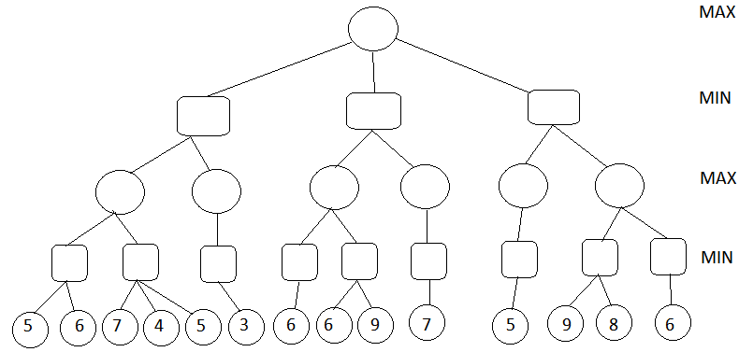

11. a. Show that the “Law of Hypothetical syllogism” leads to tautology by constructing truth table. [7m](C.O.No.1) [APPLICATION]

b. Write the following statements in FOL form: [8M](C.O.No.2) [APPLICATION]

1. Some prime numbers are not divisible by 2
2. Everyone likes everyone
3. All meals at the Red Lion costs 3 Pounds
4. All things in the bag are blue