|  |  |  |  |  |  |  |  |  |  |  |  |  |
| --- | --- | --- | --- | --- | --- | --- | --- | --- | --- | --- | --- | --- |
| Roll No |  |  |  |  |  |  |  |  |  |  |  |  |



**Presidency University**

**Bengaluru**

**SCHOOL OF COMPUTER SCINCE AND ENGINEERING**

**MAKEUP EXAMINATION JULY 2024**

**Semester**: VI&VII

**Course Code**: CSE3010

**Course Name**: Deep Learning Techniques

**Program & Sem**: Makeup

**Date**: 02 July 2024

**Time**: 1:30Pm to 4:30pm

**Max Marks**: 100

**Weightage**:50%

**Instructions:**

1. *Read the all questions carefully and answer accordingly.*

**Part A [Memory Recall Questions]**

**Answer all the Questions. Each question carries 4 marks. (6Qx 4M= 24M)**

1. Write any four differences between deep learning and machine learning.

(C.O.No.1) [Knowledge]

2. Explain the four hyper parameters related to the Autoencoder. (C.O.No.3) [Knowledge]

3. Explain weight initialization techniques. (C.O.No.1) [Knowledge]

4. Discuss in brief Boltzmann machine and Restricted Boltzmann Machine.

(C.O.No.3) [Knowledge]

5. Explain Types of RNN with application for each type. (C.O.No.2) [Knowledge]

6. Write a note on Hopfield Neural network. (C.O.No.3) [Knowledge]

**Part B [Thought Provoking Questions]**

**Answer all the Questions. Each question carries 8 marks. (5Qx8M=40M)**

7. An essay written in language ‘A’ has to be translated to language ‘B’. Identify a suitable deep learning model for the same. The model should be capable of handling long short term memory. Answer the following questions.

1. Which deep learning model is suitable for this language translation?
2. Explain the architecture of this model with a neat diagram.

(C.O.No.2) [Comprehension] 8. A physician needs to compress the medical reports of his/her patients which are MRI images. Identify the unsupervised deep learning model that will help the physician to get a compressed representation of his/her patient’s reports. Answer all the following with respect to that model.

1. With a neat diagram explain the architecture of the proposed image compression model
2. Name the three properties of this model.
3. List the various types of this model. (C.O.No.3) [Comprehension]

9. Ms. Shreshta would like to develop a deep learning model for face recognition in unconstrained environment. But she does not have sufficient training dataset. She wants to generate more number of training images from the existing face images. (C.O.No.3) [Comprehension]

a. Suggest her the suitable deep learning model to generate new data

b. Discuss the architecture of this model with a neat diagram.

10. Given MNIST dataset, the task is to design a deep learning model to classify the handwritten digits.

a. Identify the activation function to be used in the hidden layers and the output layer. Discuss them in detail.

b. Identify the suitable loss function and explain in detail. (C.O.No.1) [Comprehension]

11. Optimization algorithms in deep learning allow neural networks to learn faster and achieve better performance. Differentiate the three types of gradient based optimization techniques used in back propagation. (C.O.No.1) [Comprehension]

**Part C [Problem Solving Questions]**

**Answer all the Questions. Each question carries 12 marks. (3Qx12M=36M)**

12. Apply the filter on the given input image and perform convolution operation with stride 1. Show the resulting feature matrix. Also, demonstrate result after applying Relu activation function. Then apply average pooling of window size 2X2 with stride 1 and show the final result after flattening.

|  |  |  |  |  |  |  |
| --- | --- | --- | --- | --- | --- | --- |
| Input image | | | | | | |
| 3 | 4 | 0 | 5 | 7 | 6 | 2 |
| 2 | 1 | 8 | 6 | 2 | 9 | 1 |
| 8 | 9 | 6 | 2 | 8 | 4 | 5 |
| 4 | 7 | 6 | 3 | 2 | 9 | 1 |
| 0 | 5 | 3 | 7 | 5 | 7 | 0 |
| 3 | 2 | 5 | 1 | 6 | 3 | 9 |
| 5 | 3 | 6 | 7 | 5 | 0 | 8 |

|  |  |  |
| --- | --- | --- |
| Filter | | |
| 1 | 0 | -1 |
| 1 | 0 | -1 |
| 1 | 0 | -1 |

(C.O.No.2) [Application]

13. Construct KSOM on the input 111, 110 and 010.

Number of clusters are 2

Learning rate: 0.5

Initial weight matrix: 0.1 0.2

0.3 0.4

0.5 0.6

Find the cluster to which the pattern 001 belongs to. (C.O.No.3) [Application]

14. Following artificial neural network is trained to recognize the XOR function. Using the weights, bias and the **step function (Z) as the activation function** in hidden and output layers, complete the truth table of the XOR function for each of the four input cases.

Note: consider each of the below case as input and calculate the output of the given neural network.

[x1=1, x2=1

X1=1, X2=0

X1=0, X2=1

X1=0, X2=0]

Step function: if Z>=0, output=1 else 0

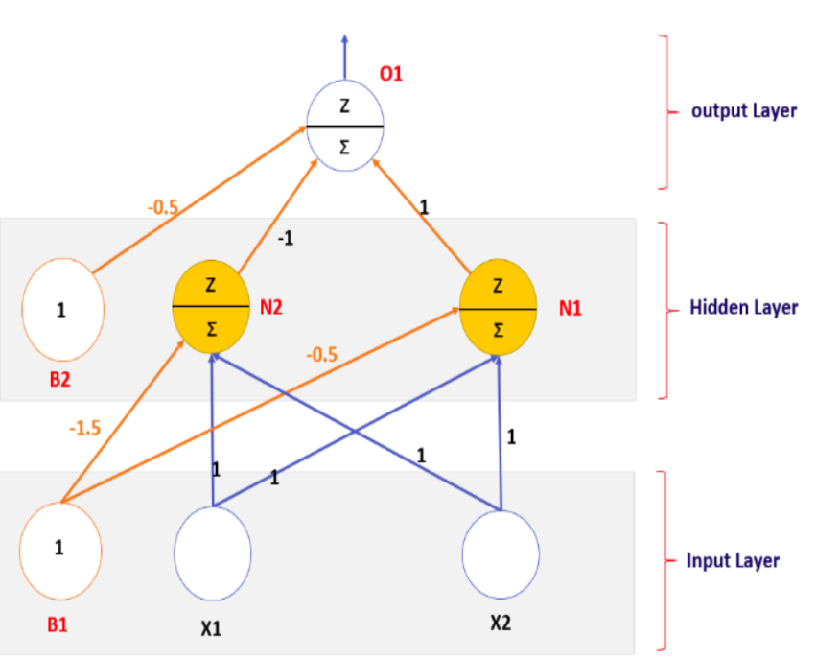

(C.O.No.1) [Application]