|  |  |  |  |  |  |  |  |  |  |  |  |  |
| --- | --- | --- | --- | --- | --- | --- | --- | --- | --- | --- | --- | --- |
| Roll No |  |  |  |  |  |  |  |  |  |  |  |  |



**Presidency University**

**Bengaluru**

**SCHOOL OF ENGINEERING**

**MAKE-UP EXAMINATION JULY 2024**

**Course Code**: CSE5012

**Course Name**: AI in Cloud Computing

**Program & Sem**: MTech

**Date**: 04 JULY 2024

**Time**: 01.30 PM to 04.30 PM

**Max Marks**: 100

**Weightage**: 50%

**Instructions:**

1. *Read all questions carefully and answer accordingly.*
2. *All questions are compulsory*

**Part A [Memory Recall Questions]**

**Answer all the Questions. Each question carries TEN marks. (4Qx 10M= 40M)**

1. How is AI changing cloud service? Explain (CO1) [Knowledge]
2. Explain the 5 stages of FASTUS (CO2) [Knowledge]
3. Outline the two approaches generally used while developing a chatbot (CO3) [Knowledge]
4. Explain the features and functionalities offered by the following AI platforms?
5. Google Cloud Platform b) Microsoft Azure AI (CO4) [Knowledge]

**Part B [Thought Provoking Questions]**

**Answer all the Questions. Each question carries TEN marks. (4Qx 10M= 40M)**

1. A robot is used to provide tours to museum visitors. Given a map of the museum, starting location and orientation which method would you chose to find a path to the goal position? Justify your answer. (Assume all obstacles are known and are static in nature)

(CO2) [Comprehension]

1. I need to design a chatbot that monitors data and intent, and can also initiate conversations. Which type of chatbot do I choose to design? Why? (CO3) [Comprehension]
2. A JAVA application “virtual travel booking agent” is to be developed and deployed on Oracle Cloud. Illustrate how this can be done. (CO4) [Comprehension]

**Part C [Problem Solving Questions]**

**Answer all the Questions. Each question carries TEN marks. (3Qx10M=30M)**

1. 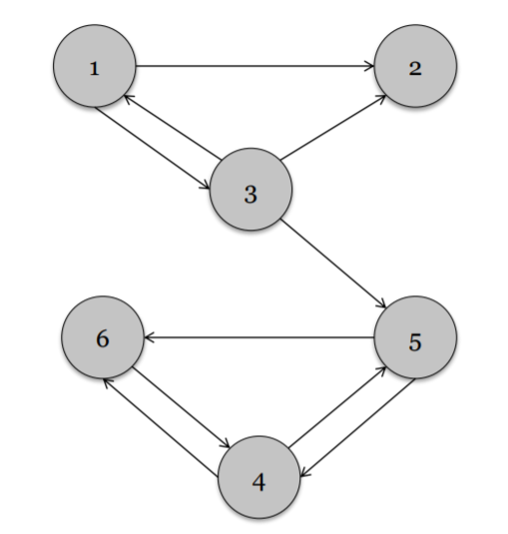Outline page rank algorithm. Use this algorithm to evaluate the given network and rank the nodes. Perform 3 iterations.

(CO2) [Application]

1. Depict the overall process in creating a bot using the development of an educational chatbot as an example**.** (CO3) [Application]