|  |  |  |  |  |  |  |  |  |  |  |  |
| --- | --- | --- | --- | --- | --- | --- | --- | --- | --- | --- | --- |
| Roll No |  |  |  |  |  |  |  |  |  |  |  |

PRESIDENCY UNIVERSITY BENGALURU

SCHOOL OF ENGINEERING SET-B

MAKEUP EXAMINATION - JULY 2024

|  |  |
| --- | --- |
| **Course Code : ECE2007** | **Date :** **04-07-2024** |
| **Course Name :** **Digital Design** | **Time : 1.30pm to 4.30pm** |
| **Program : B.Tech. Electronics and Communication Engineering** | **Max Marks : 100** |
|  | **Weightage : 50%** |

**Instructions:**

1. *Read all questions carefully and answer accordingly.*
2. *Question paper consists of 3 parts.*
3. *Scientific and non-programmable calculator are permitted.*
4. *Do not write any information on the question paper other than Roll Number.*

**PART A**

**Answer any 5 questions out of 7 questions 5Q X 2M = 10M**

1. Identify and draw the logic gate which produces a high output when both inputs are equal.

(CO1) [Knowledge]

1. Write the truth table for the Boolean function F= (A + (A . B)). (CO1) [Knowledge]
2. A Half adder is an arithmetic circuit that adds two binary digits. It uses ______ gate and _________ gates if its output is sum and carry. (CO2) [Knowledge]
3. A 16:1 multiplexer has _____ inputs, _____ output and ______ selection lines. (CO2) [Knowledge]
4. The outputs of a comparator irrespective of number of bits are _____ and _____ and ____.

(CO2) [Knowledge]

1. Which of the following input combinations is not allowed in an SR flip-flop? (CO3) [Knowledge]
2. T-flip flop is modified version of ________ Flip flop. In T- flip flop, for what input combinations it produces no change state? (CO3) [Knowledge]

**PART B**

**Answer any 5 questions out of 7 questions 5Q X 10M = 50M**

1. Prove the given expression by using Boolean Algebraic Simplification **A'B(D'+C'D)+B(A+A'CD)=B** name the laws used for simplification. (CO1) [Comprehension]
2. Combinational circuits are a class of digital circuits where the output depends only on the present input. Different gates are used to implement a combinational circuit. Universal gates (NAND and NOR) gates are used due to its advantages. The digital circuit shown below is an example of a combinational circuit. For the given circuit, draw the truth table. From the truth table, write the Boolean Expression using input variables in both canonical SOP and canonical POS. (CO1) [Comprehension]

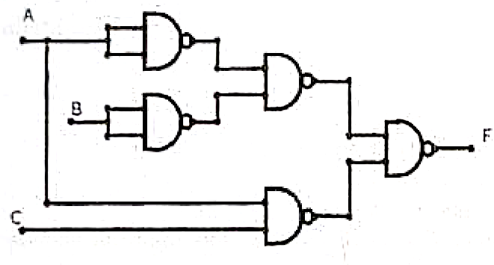

1. The half adder and half subtractor are basic building blocks that can be used to construct come complex arithmetic circuits. Design half adder circuit using minimum number of NAND gates. (CO2) [Comprehension]
2. In Boolean algebra, circuit minimization is the problem of obtaining the smallest logic circuit that represents a given Boolean function or truth table. Mr.Ben is provided with Boolean function

**F=Σm(0,1,4,7,9,13,15)** and minimum number of NAND gates. For designing the Boolean function into digital circuits, he has to simplify the function using K-map. After his simplification

(i) How many PRODUCT term are present in his function, further

(ii) How many number of TWO input NAND gates are needed for the implementation of this circuit. (CO2) [Comprehension]

1. The owner of a house installed a smart security system to protect his house from intruders. The security system has three sensors: Door sensor (D), Window sensor (W) and Motion sensor (M). The objective is to activate the alarm system (output=1) under any of the following conditions:

(i) If either the door or the window is open, regardless of the motion

(ii) If a motion is detected inside the house, regardless of the door or window status.

Design a digital system and implement using basic gates to determine when to activate the home's security alarm based on inputs from the sensors. The design must include truth table, simplified Boolean expression using K-maps and Implementation using basic gates. (CO2) [Comprehension]

1. JK-flip flop is a controlled bi-stable latch where the clock signal is the control signal. Thus, the output has two stable states based on the inputs. Draw the logic symbol and circuit diagram with the appropriate JK-flip flop truth table. Derive the characteristic equation of JK-flip flop. (CO3) [Comprehension]
2. ﻿ A de-multiplexer (or demux) is a digital logic device that takes a single input signal and routes it to one of several output lines, based on the values of its selection inputs. Design a 1x8 demux using only 1x2 demux with proper naming of the input, output and select lines. Total how many 1x2 demux is used for the design? (CO2) [Comprehension]

**PART C**

**Answer any 2 questions out of 3 questions 2Q X 20M = 40M**

1. Given SOP Boolean expression is **F = (W' X' Y' Z')+(W Y' Z')+(X' Y Z')+(W' X Y Z) +(X Y' Z)** Using K-Map find the simplified POS expression and implement using NOR gate only. (CO2) [Comprehension]
2. The basic function of a comparator is to compare the magnitudes of two binary quantities to determine the relationship of those quantities. Design a 2-Bit comparator using basic gates with the help of truth table and obtain the logical expression for each case with the help of simplification method (K-map). (CO2) [Comprehension]
3. Ravi wants to start the race with the up-count of 3 bits. To facilitate Ravi, design and develop logic diagram of 3-bit synchronous up-counter using only JK-flip flop. (CO3) [Comprehension]

* Write excitation table of Flip Flop.
* Draw the state transition diagram and circuit state table.
* Find a simplified equation using K-map and draw the circuit diagram.