|  |  |  |  |  |  |  |  |  |  |  |  |  |
| --- | --- | --- | --- | --- | --- | --- | --- | --- | --- | --- | --- | --- |
| Roll No |  |  |  |  |  |  |  |  |  |  |  |  |



**Presidency University**

**Bengaluru**

**SCHOOL OF ENGINEERING**

**MAKEUP EXAMINATION JULY 2024**

**Course Code**: ECE 2008

**Course Name**: Signals and Systems

**Program** : B.Tech (ECE)

**Date**: 22-07-2024

**Time**: 9.30am to 12.30pm

**Max Marks**: 100

**Weightage**: 50%

**Instructions:**

1. *Read the all questions carefully and answer accordingly.*

**Part A [Memory Recall Questions]**

**Answer all the Questions. (10Qx2M= 20M)**

Q.NO. 1. A Fourier series is a summation of harmonically related sinusoidal functions, also known as components or harmonics. For which time of continuous time signals, does Fourier series exist? (C.O 1) [Knowledge]

a) Periodic continuous time signals

b) Aperiodic continuous time signals

c) Both Periodic and Aperiodic continuous time signals

d) None of the mentioned

Q.NO. 2. Consider a discrete time system with input x[n] and output y[n]. The input –output relationship for this system is y[n] = x[n] x [n-2]. Is the system memoryless? (CO 1) [Knowledge]

a) Memoryless

b) With memory

c) Both memoryless and with memory

d) None of the above

Q.NO. 3. The Region of Convergence is the area in the pole/zero plot of the transfer function in which the function exists. The Region of Convergence for Laplace Transform of a left sided signal lies on the (CO 1) [Knowledge]

a) Left side

b) Right side

c) Both

d) Cannot be determined

Q.NO. 4. A system can be causal and non-causal depending upon its dependence on input signals. Check whether the system y (t) = (3t + 5) x (t) is causal or not. (CO 1) [Knowledge]

a) Causal

b) Non Causal

c) Both causal and non-causal

d) Cannot be determined

Q.NO. 5. A Fourier transform is a mathematical transform that decomposes functions into frequency components, which are represented by the output of the transform as a function of frequency. For which type of continuous time signals, does Fourier Transform exist?

(CO 1) [Knowledge]

a) Periodic continuous time signals

b) Aperiodic continuous time signals

c) Both Periodic and Aperiodic continuous time signals

d) None of the mentioned

Q.NO. 6. In signal processing and control theory, the impulse response, or impulse response function, of a dynamic system is its output when presented with a brief input signal, called an impulse. Step response of LTI System given as $e^{-3t}u\left(t\right)$, find its impulse response.

(CO-1)[Knowledge]

Q.NO. 7. A time-variant system is a system whose output response depends on moment of observation as well as moment of input signal application. Check whether the system y (t) = (cos 3t) x (t) is time variant or not. (CO-1)[Knowledge]

Q.NO. 8. The Fourier transform of a function is a complex-valued function representing the complex sinusoids that comprise the original function. What is the expression for continuous time Fourier Transform of x (t-3)? (CO-1)[Knowledge]

Q.NO. 9. Convolution is a mathematical way of combining two signals to form a third signal. What is the result of the convolution between two signals 𝛿 (𝑡-2) and 𝛿 (𝑡+5)? (CO-1)[Knowledge]

Q.NO. 10. A system is said to be a linear system if it obeys the principle of homogeneity and principle of superposition. Whether the system $\frac{dx(t)}{dt}$ is linear or not? (CO-1)[Knowledge]

**Part B [Thought Provoking Questions]**

**Answer all the Questions. Each question carries ten marks. (4Qx10M=40M)**

Q.NO. 11. x[n]= {4,3,2,1,2,3,4}. Sketch the following signals.

(CO-2)[Comprehension]

a) $x[-n-1]$

b) $x[-2n]$

c) $x[3n+2]$

d) $x[-n+1]$

Q.NO. 12. In mathematics and signal processing, the Z-transform converts a discrete-time signal, which is a sequence of real or complex numbers, into a complex frequency-domain (z-domain or z-plane) representation.

$${x\left(n\right)=a}^{n}u[n], a>0$$

$${x\left(n\right)=-a}^{n}u[-n-1], a>0$$

(CO-4)[Comprehension]

Q.NO. 13. John needs to perform convolution graphically for which he needs to perform some basic operations on signals. His teacher advised him to practice the basic operations on signal x(t) given below before using it for convolution. Help him to identify the below given operations and sketch the following: (CO-2)[Comprehension]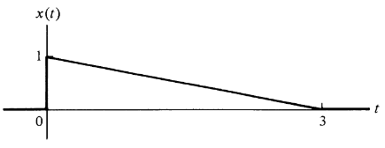

a) x (-t)

b) x (t+2)

c) x (2t+2)

d) x (1-3t)

Q.NO. 14. The Laplace transform, named after its discoverer Pierre-Simon Laplace, is an integral transform that converts a function of a real variable to a function of a complex variables. Find the Laplace Transform of the following signal and also draw the region of convergence (ROC)

$${x\left(t\right)=3e}^{-2t}u\left(t\right)- {2e}^{-2t}u\left(t\right)$$

(CO-2)[Comprehension]

**Part C [Problem Solving Questions]**

**Answer all the Questions. Each question carries ten marks. (4Qx10M=40M)**

Q.NO.15. A Fourier transform (FT) is a mathematical transform that decomposes functions into frequency components, which are represented by the output of the transform as a function of frequency. x (t) is a rectangular pulse as shown in fig below. Find Fourier Transform X[jw]. Also draw the graphs for X[jw]. (CO-4)[Application]

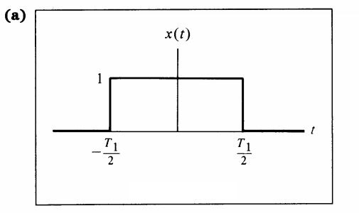

Q.NO.16. In mathematics and signal processing, the Z-transform converts a discrete-time signal, which is a sequence of real or complex numbers, into a complex frequency-domain (z-domain or z-plane) representation. Find the Z- Transform of the following sequence and also draw the region of convergence. (CO-4)[Application]

$$x \left[n\right]=u \left[n+1\right]-u \left[n-2\right]$$

Q.NO.17. In mathematics, the Laplace transform, is an integral transform that converts a function of a real variable to a function of a complex variable s. Determine the Laplace Transform and Region of convergence of the following time function. (CO-4)[Application]

(a) ${x\left(t\right)=e}^{-at}u\left(t\right), a>0$

(b) ${x\left(t\right)=e}^{-at}u\left(t\right), a <0$

Q.NO.18.The Z-transform (ZT) is a mathematical tool which is used to convert the difference equations in time domain into the algebraic equations in z-domain. Find the Z-transform (ZT) of the following signal and also draw the region of convergence (ROC)

(CO-4)[Application]

