|  |  |  |  |  |  |  |  |  |  |  |  |  |
| --- | --- | --- | --- | --- | --- | --- | --- | --- | --- | --- | --- | --- |
| Roll No |  |  |  |  |  |  |  |  |  |  |  |  |

**Presidency University**

**Bengaluru**

**SCHOOL OF ENGINEERING**

**MAKE UP EXAMINATION JULY 2024**

**Date**: 22/07/2024

**Time**: 1:30 PM – 4:30 PM

**Max Marks**: 100

**Weightage**: 50%

**Course Code**: ECE2001

**Course Name**: Analog Electronics

**Program** : B. Tech

**Instructions:**

1. *Read the all questions carefully and answer accordingly.*
2. *Draw diagrams wherever necessary.*
3. *Use of non-programmable scientific calculator is permitted.*
4. *Total Question is 17.*

**Part A [Memory Recall Questions]**

**Answer all the Questions. Each question carries Two marks.**

**2M x 10Q=20M**

1. Under thermal equilibrium, the product of the free negative and positive concentration is a constant independent of the amount of .............................. doping and this relationship, called the mass action low and is given by np =....................... (CO1)
2. The voltages at V1 and V2 of the arrangement shown in Fig. given below, will be respectively. (CO1)

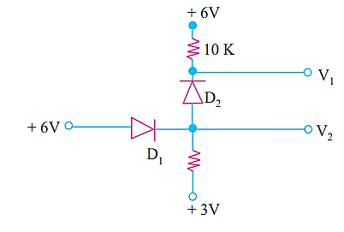

1. I allow the current to pass through me in only one direction. Identify me. (CO1)
2. I am the electrical circuit which may be used to translate the signal to a different DC level. Identify the circuit. (CO2)
3. Name the circuit in electronics, that is designed to prevent a signal from exceeding a predetermined reference voltage level. (CO2)
4. I am three-legged device with holes as the majority carrier. I am controlled by the current applied at the one of the legs. Identify the device. (CO2)
5. The Figure shows the transfer characteristics curve of a JFET. Write the equation for the drain current. (CO3)

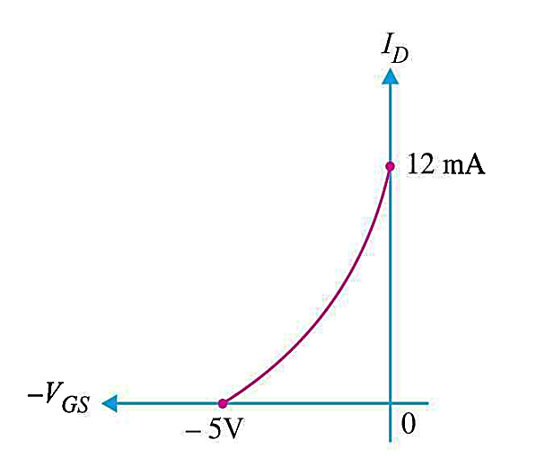

1. BJT is the current controlled device whereas the FET is the voltage controlled device. Why and explain your answer. (CO3)
2. The resultant gain of the negative feedback amplifier is independent of transistor parameters and supply voltage variations. Justify it. (CO4)
3. According to Barkhausen criterion there are two essential conditions for a circuit to maintain oscillations. Mention them. (CO4)

**Part B [Thought Provoking Questions]**

**Answer all the Questions. Each question carries Ten marks.**

**10M x 4Q=40M**

1. (a) A negative-feedback amplifier is an electronic amplifier that subtracts a fraction of its output from its input so that negative feedback opposes the original signal. Design a voltage amplifier and describe the effects of negative feedback on this amplifier. (CO4) (**5 Marks**)

(b) Consider the parameters of voltage- to- voltage converter without feedback such as voltage gain A=-100, input impedance Ri=10K and output impedance Ro=20K. Design a negative feedback voltage-to-voltage converter with the feedback factor β = -0.5. and calculate voltage gain, input impedance and output impedance. (CO4) (**5 Marks**)

1. Transistor biasing is needed for faithful amplification. Mention the different types of transistor biasing. Draw the circuit of a BJT in potential divider bias configuration. Derive the expression for Q point voltage and current and draw the load line. (CO2) (10 **Marks)**
2. A voltage regulator converts an unregulated dc voltage into a constant regulated dc voltage A voltage regulator is a system designed to automatically maintain a constant voltage. For the circuit shown in Fig. given below, find (i) the output voltage (ii) the voltage drop across series resistance (iii) the current through zener diode. (CO1) (10 Marks)

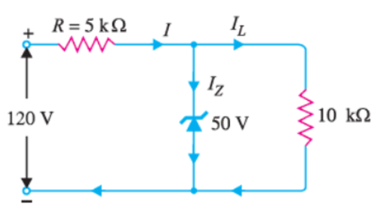

1. The field-effect transistor (FET) is a type of [transistor](https://en.wikipedia.org/wiki/Transistor) that uses an [electric field](https://en.wikipedia.org/wiki/Electric_field) to control the flow of [current](https://en.wikipedia.org/wiki/Electric_current) in a [semiconductor](https://en.wikipedia.org/wiki/Semiconductor). FETs ([JFETs](https://en.wikipedia.org/wiki/JFET) or [MOSFETs](https://en.wikipedia.org/wiki/MOSFET)) are devices with three terminals: source, gate, and drain. (CO3)

(a) With the help of a neat diagram explain the operation of an n-channel D-MOSFET. (6 Marks)

(b) A D-MOSFET has a drain current of 6mA. If IDSS = 12mA and VP = 3V find VGS. (4 Marks)

**Part C [Problem Solving Questions]**

**Answer all the Questions. Each question carries Twenty marks.**

**20M x 2Q=40M**

1. (a) The circuit shown below shows the base resistor transistor circuit. The device has the characteristics also shown below. Determine Vcc, Rc and RB.

(CO2) (10 Marks)

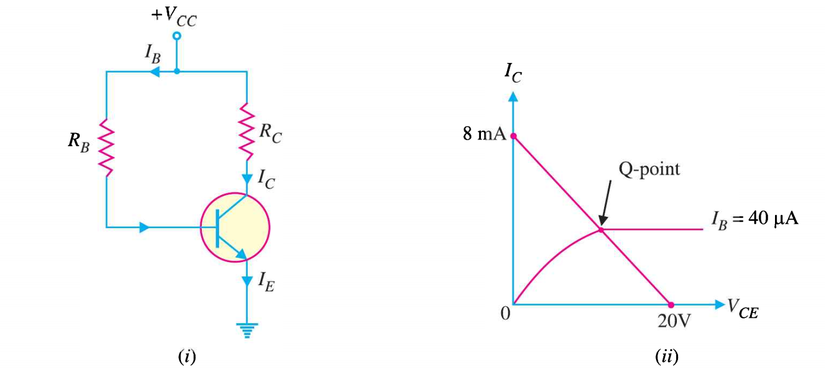

(b) A RF oscillator is a type of harmonic oscillator. The oscillation frequency for a RF Oscillator is determined by an LC oscillator (i.e. a circuit consisting of capacitors and inductors). It is typically tuned to produce waves in the radio frequency band which is why they are also known as RF oscillators. Draw the circuit of Hartley oscillator and explain its working. Derive an expression for frequency oscillation of Hartley oscillator. (CO4) (10 Marks)

1. (a) In practical applications, the output of a single state amplifier is usually insufficient, though it is a voltage or power amplifier. Hence, they are replaced by multi-stage transistor amplifiers. In Multi-stage amplifiers, the output of first stage is coupled to the input of next stage using a coupling device. These coupling devices can usually be a capacitor or a transformer. This process of joining two amplifier stages using a coupling device can be called as Cascading. Draw the circuit diagram of two stage Common Emitter RC Coupled Amplifier Explain the working of Common Emitter RC Coupled Amplifier. Explain the use of different capacitors used in the RC coupled amplifier.

(CO2) (10Marks)

(b) Using the given drain characteristic of JFET. Draw the transfer characteristic of JFET and write the equation of drain current. (CO3) (5 Marks)

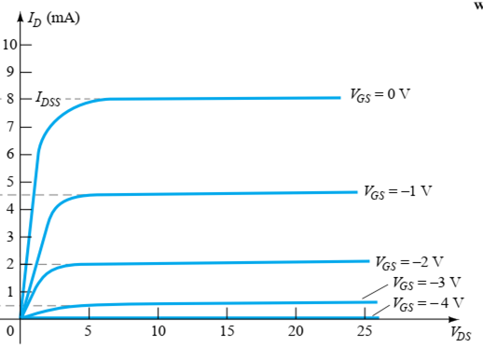

(c) A half wave rectifier uses a transformer of turn ratio 2:1. The load resistance is 500 Ω. If the Primary voltage (rms) is 220 V, find dc output voltage, efficiency, peak inverse voltage. (CO1) (5 Marks)