|  |  |  |  |  |  |  |  |  |  |  |  |  |
| --- | --- | --- | --- | --- | --- | --- | --- | --- | --- | --- | --- | --- |
| Roll No |  |  |  |  |  |  |  |  |  |  |  |  |



**Presidency University**

**Bengaluru**

**SCHOOL OF ENGINEERING**

**Make-up Examinations July 2024**

**Date**: 02/JULY/2024

**Time**: 01:30pm – 04:30pm

**Max Marks**: 100

**Weightage**: 50%

**Odd Semester**: III

**Course Code**: ECE2003

**Course Name**: SIGNALS AND SYSTEMS

**Department: ECE**

**Instructions:**

1. *Read the all questions carefully and answer accordingly.*
2. *Do not write any matter on the question paper other than roll number.*

**PART A**

**Answer any SIX Questions. Each question carries 10 marks. (6Qx 10M= 60M)**

1. A signal could be an analog quantity that means it is defined with respect to the time. For the given signal, x(n)=[ 1, 2, 3, 4]. Draw (i) x(n) (ii) x(n-1) (iii)x(n+2) (iv)x(n/2) (v) x(3n).

(CO:1 BL: Knowledge)

1. Human voice is an example of analog signals. Find whether the given signal, x(t)=t is (i) odd or even (ii) periodic or aperiodic (iii) Energy or power.

(CO:1 BL: Knowledge)

1. The techniques such as error detection and correction, encoding, and decoding uses basic signals and system principle. Find whether the given system, y(t)=tx(t) is (i) static or dynamic (ii) Causal or non-causal (iii) linear or non-linear (iv) time variant or time invariant (v) stable or unstable.

(CO:1 BL: Knowledge)

1. Techniques such as MRI, CT scans, and ultrasound imaging uses signal processing for image reconstruction and enhancement. Find Fourier series for the given signal x(t) in the figure given below.

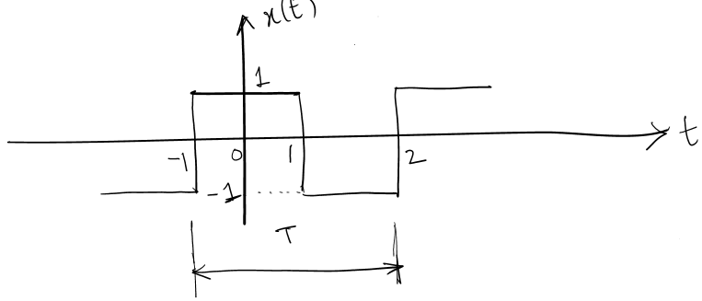



(CO:2 BL: Application)

1. Signals can be audio, video, sensor data, images, and many other types of data. Find the Fourier series for the following signals

$x_{1}\left(t\right)=sinωt+cos2ωt$

$x_{2}\left(t\right)=1+coswt$

(CO:2 BL: Application)

1. Digital signal processing (DSP) is a subfield of signal processing that deals specifically with the representation and manipulation of signals in a digital format. Write any two properties of Fourier series and prove it.

(CO:2 BL: Comprehension)

1. Signal processing techniques are used in control systems to stabilize and optimize the performance of systems by processing feedback signals from sensors and actuators. Find the initial and final value theorem for the following signals.

$X\left(S\right)=\frac{3}{S^{2}+5S-1}$

$X\left(S\right)=\frac{S-1}{S(S+1)}$

(CO:3 BL: Application)

1. Signal processing techniques are used in financial engineering to analyze and interpret financial data and to develop predictive models for financial markets. Find the z-transform for the following

(i) ${ X}_{1}\left(n\right)=\{2,3,5,9,10\}$

(ii) $X_{2}\left(n\right)=\{8,4,6,7,8\}$

Find the convolution of these two sequences using z-transform.

(CO:3 BL: Application)

**PART B**

**Answer any TWO Questions. Each question carries 20 marks. (2Qx 20M= 40M)**

1. Signal acquisition is the first step in signal processing is to acquire the input signal. Find the convolution for the given sequences, $x_{1}\left(n\right)=\{1, 2,3,4,5,6\}$ and $x_{2}\left(n\right)=\{1, 1,1,1,1,1\}$.

(CO:1 BL: Application)

1. The input signal will be represented in a suitable form for processing. Find the Fourier transform for the rectangular signal shown in figure.

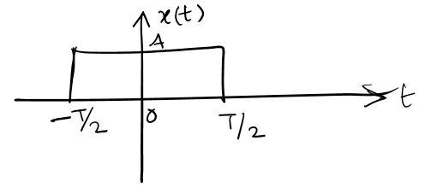

(CO:2 BL: Application)

1. Many signals and systems change over time, and modeling and analyzing these time-varying systems can be challenging. Find the inverse z-transform for the given signal.

$X\left(z\right)=\frac{5z^{-1}}{(1-2z^{-1})(1-3z^{-1})}$; $\left|z\right|>3$

(CO:3 BL: Application)