|  |  |  |  |  |  |  |  |  |  |  |  |  |
| --- | --- | --- | --- | --- | --- | --- | --- | --- | --- | --- | --- | --- |
| Roll No |  |  |  |  |  |  |  |  |  |  |  |  |



**Presidency University**

**Bengaluru**

**SCHOOL OF INFORMATION SCIENCE**

**Makeup -Term Examinations, July 2024**

**Date**: 08/July/2024

**Time**: 09:30am – 12:30pm

**Max Marks**: 100

**Weightage**: 50%

**Odd Semester**: III / IV

**Course Code**: ECE 2004

**Course Name**: Network Theory

**Department:** ECE

**Instructions:**

1. *Read the all questions carefully and answer accordingly.*
2. *Do not write any matter on the question paper other than roll number.*

**PART A**

**Answer any SIX Questions. Each question carries 10 marks. (6Qx 10M= 60M)**

1. **The equivalent resistance** represents the total resistance that could replace the entire circuit between points A and B without changing the overall current or voltage characteristics___.

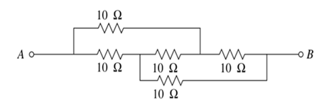

1. In the context of mesh analysis for electrical circuits, imagine a circuit with multiple loops formed by interconnected resistors and other components. Each loop has a current flowing through it, and mesh analysis involves applying Kirchhoff's Voltage Law (KVL) to write equations for the voltage drops across each component in the loop. **Calculate the current across 2Ω resistor using mesh analysis.**

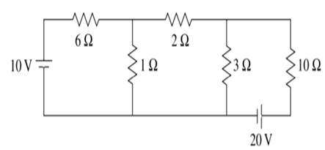

1. Superposition theorem states that in any linear, bilateral network where more than one source is present, the response across any element in the circuit is the sum of the responses obtained from each source considered separately. **Find out the value of ‘v’ using Superposition theorem.**

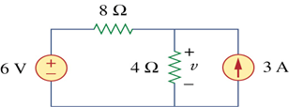

1. A Wheatstone bridge ABCD is arranged as follows AB is equals to 20 ohm BC is equal to 50 ohm and CD is equals to 60 ohm and DA is equals to 80 ohm. A  20 volt battery of internal resistance 25 ohm is connected between points A and C with A being positive. A galvanometer of resistance 40 ohm is connected between B and D. **Find Galvanometer current.**
2. The ABCD parameters, also known as transmission parameters, are another set of parameters commonly used in the analysis of two-port networks in electronics. **Derive the 4 equations for A,B,C and D and also draw the circuit diagram.**
3. Hybrid parameters (also known as h parameters) are known as ‘hybrid’ parameters as they use Z and  Y parameter , voltage ratio, and current ratios to represent the relationship between voltage and current in atwo port network**. Find h11, h12, h21, and h22**

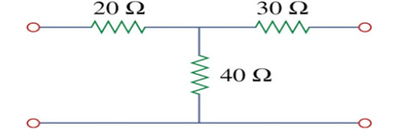

1. Nodal analysis relies on Kirchhoff's current law (KCL) to write equations based on the sum of currents entering and leaving each node. **Utilizing nodal analysis (or the node-voltage method), determine the voltages at nodes 1 and 2 in the electrical circuit**. The approach involves identifying the currents at each node and formulating equations to solve for the desired node voltages.

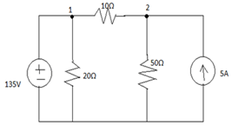

1. Mesh analysis involves writing and solving equations based on the loop currents, Kirchhoff's voltage law, and the resistances in the circuit. Using the mesh analysis method, **determine the current flowing in each of the three loops in a planar electrical circuit.**

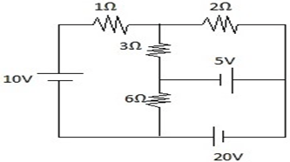

**PART B**

**Answer any TWO Questions. Each question carries 20 marks. (2Qx 20M= 40M)**

1. Thevenin's Theorem and Norton’s Theorems are fundamental principles in electrical circuit analysis that simplifies the analysis of complex linear circuits.
2. Find out Thevenin’s equivalent circuit for the given network.
3. Find out Norton’s equivalent circuit for the given network.

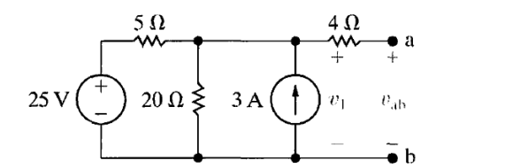

1. The Z parameters, or impedance parameters, of a two-port network are represented by a 2×2 impedance matrix. This matrix is also known as the open-circuit parameter consisting of Z11, Z12, Z21 & Z22.
2. Derive the 4 equations for the same and also draw the circuit diagram.
3. Identify and find the impedance parameters or Z parameters for the circuit shown below and also find out Z11, Z12, Z21 & Z22 .What is the matrix form of Z-parameters?  
   
4. Admittance is the reciprocal of impedance, and it is a measure of how easily a circuit allows the flow of current. Admittance Parameters are denoted by Y11, Y12, Y21, and Y22.
5. Derive the 4 equations for the same and also draw the circuit diagram.
6. Identify and find the Admittance or Y Parameters Y11, Y12, Y21, and Y22 for the circuit shown below