|  |  |  |  |  |  |  |  |  |  |  |  |  |  |
| --- | --- | --- | --- | --- | --- | --- | --- | --- | --- | --- | --- | --- | --- |
| Roll No. |  |  |  |  |  |  |  |  |  |  |  |  |  |

**Presidency University Bengaluru**

**SCHOOL OF ENGINEERING**

**MAKE UP EXAMINATION- JULY 2024**

**Date**: 10.07.2024

**Time**: 9:30 AM to 12:30 PM

**Max Marks**: 100

**Weightage**: 50%

**Semester**: IV & VI Sem

**Course Code**: ECE3029

**Course Name**: Digital Image Processing

**Program &Sem**: B.Tech & (2020 & 2021 Batch)

**Instructions:**

1. ***Read the question properly and answer accordingly***
2. ***Question paper consists of 3 parts***
3. ***Scientific and Non-programmable calculators are permitted***

**PART-A**

**Answer any FOUR Questions. Each question carries 5 marks. (4Qx5M=20M)**

Q1. For a continuous image f(x,y), define what is Quantization. Number of Bits to store image is denoted by the formula _____? [CO.1 Knowledge Level]

Q2. Power Law Transformation is used for enhancing images for different type of display devices. The process used to correct power law response phenomena is called as_______? Express the general form of log transformation. [CO.2 Knowledge Level]

Q3. What is the Resolution of the 1024 x 1024 image ? If an image with L = 23 ,identify the Number Intensity Levels the image contains. [CO.1 Knowledge Level]

Q4. What are the elements of an Image called as? In cathode ray tube (CRT) devices, if γ (gamma) = 2.5, the display system would produce images that are __________ in appearance.

[CO.2 Knowledge Level]

Q5. The purpose of a color model is to facilitate the hardware or applications where color manipulation is a goal. Which of the following color models are used for color printing? What do you mean by the term pixel depth? [CO.4 Knowledge Level]

Q6. Erosion and Dilation are two primitive operation used in morphological image processing. Briefly explain the Erosion and Dilation with suitable example [CO.3 Knowledge Level]

**PART-B**

**Answer any FIVE Questions. Each question carries 10 marks. (5Qx10M=50M)**

Q7. Define Digital Image Processing? List the key stages in Digital Image Processing?

[CO.1 Comprehension Level]

Q8. Define bit plane slicing. For a given image, perform bit plane slicing.



[CO.2 Comprehension Level]

Q9. For a 3 bit 4*4 size image f(x,y) given below, perform the following operations

Intensity level slicing with background and without background. The range of interest of intensity values is r1=3 and r2=5.

$$f\left(x,y\right)=$$

[CO.2 Comprehension Level]

Q10. Consider a triangle with vertices (0,0),(1,0),(1,1). This triangle is rotated 90 degrees clockwise, draw the original location of this triangle and also the new transformed figure with coordinates. (CO.3) [Comprehensive Level]

Q11. Let p and q are two pixels at co-ordinates (10,15) and (15,25) respectively.

Compute: i) Euclidean distance ii) Chessboard distance and iii) City Block distance.

[CO.3 Comprehensive Level]

Q12. In image processing and image recognition, pixel connectivity is the way in which pixels in 2-dimensional images relate to their neighbors. An image segment is shown in figure below where V= {94, 95, 96, 97} be the set of gray level values used to define connectivity in the image. Compute

(i) 4-adjacency between p and q

(ii) 8- adjacency between p and q

(iii) De distances between p and q

(iv) D4 distances between p and q

(v) D8 distances between p and q

[CO.2 Comprehension Level]

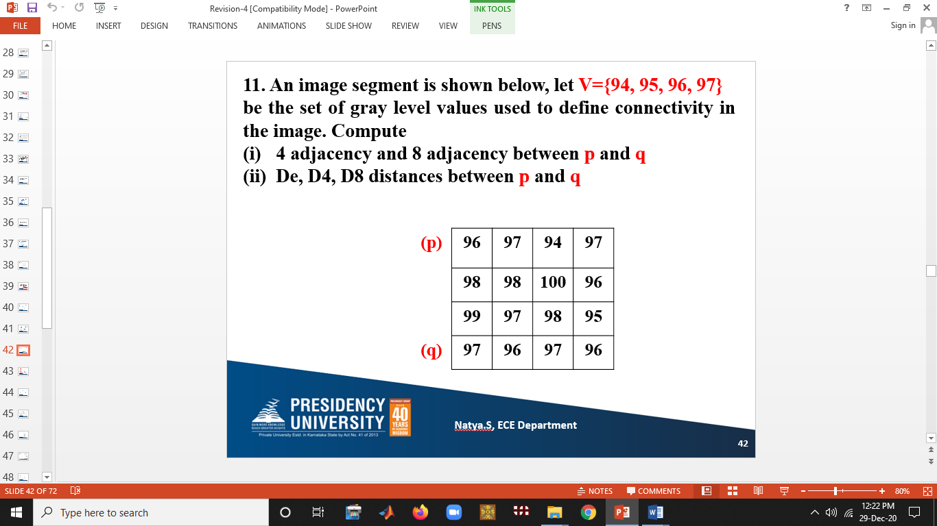

Q13. In Digital Image Processing, there are various Set and Logical Operations. While dealing with Binary Images the Foreground (1-Valued) and Background(0-Valued) sets of Pixels, we refer Union, Intersection and Compliment (Set Operations) as the OR, AND and NOT Logical Operations respectively. Considering the two Regions (Sets) A and B as shown in figure, Perform the following Logical Operations. Given that:



1. NOT ( A)
2. (A) AND (B)
3. (A) OR (B)

[CO.3 Comprehension Level]

**PART-C**

**Answer any TWO Questions. Each question carries 15 marks. (2Qx15M =30M)**

Q14. a) There are various Mathematical Tools used in Digital Image Processing. As we know that images can be viewed equivalently as Matrices, we can perform various Array and Matrix Operations on Images. Accordingly, perform Arithmetic Operations between Images, such as Addition F1+F2, Subtraction( F2-F1), Multiplication F1.*F2 . (7M)

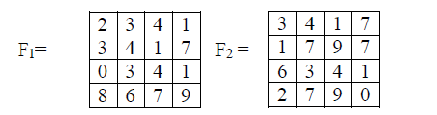

(C.O.2) [Comprehensive Level]

b) Given f1 = $\left[\begin{matrix}0 & 2 \\ 2 & 3\end{matrix}\right]$, f2 = $\left[\begin{matrix}6 & 5 \\ 4 & 7\end{matrix}\right]$, a1=1 a2=-1 and H= max. Determine

weather it is a Linear operation or non-Linear operation. (8M) (C.O.3) [Comprehensive Level]

Q15. Huffman Coding is a Lossless data Compression algorithm. In this algorithm Variable-Length Code is assigned to different source input characters. The code length is related to how frequently characters are used. Most frequent characters have the smallest codes and longer codes for least frequent characters. Let us generate the Huffman Code for an information Source producing a sequence of Alphabets “A to G” with respective probabilities as shown in the table below.

|  |  |  |  |  |  |  |  |
| --- | --- | --- | --- | --- | --- | --- | --- |
| Alphabets | S1 | S2 | S3 | S4 | S5 | S6 | S7 |
| Probabilities | 0.4 | 0.2 | 0.1 | 0.1 | 0.1 | 0.05 | 0.05 |

Accordingly,

1. The Huffman Code of the Alphabet “S1” is = ____
2. The Huffman Code of the Alphabet “S3” is = ____
3. The Huffman Code of the Alphabet “S5” is = ____
4. The Huffman Code of the Alphabet “S7” is = ____

The Average Length L , will be _______ (C.O.4) [Comprehensive Level]

Q16. Segmentation subdivides an image into its constituent regions or objects and is for non-trivial images and one of the most difficult tasks in image processing. Its accuracy determines the eventual success of failure of the computerized analysis. To extract basic features such as points, edges and lines by abrupt changes in intensity can be detected using derivatives. An image strip ‘x’ a section of horizontal intensity profile given below taken from a glass building of a mall, identify the cracks by using 1st and 2nd derivative method.

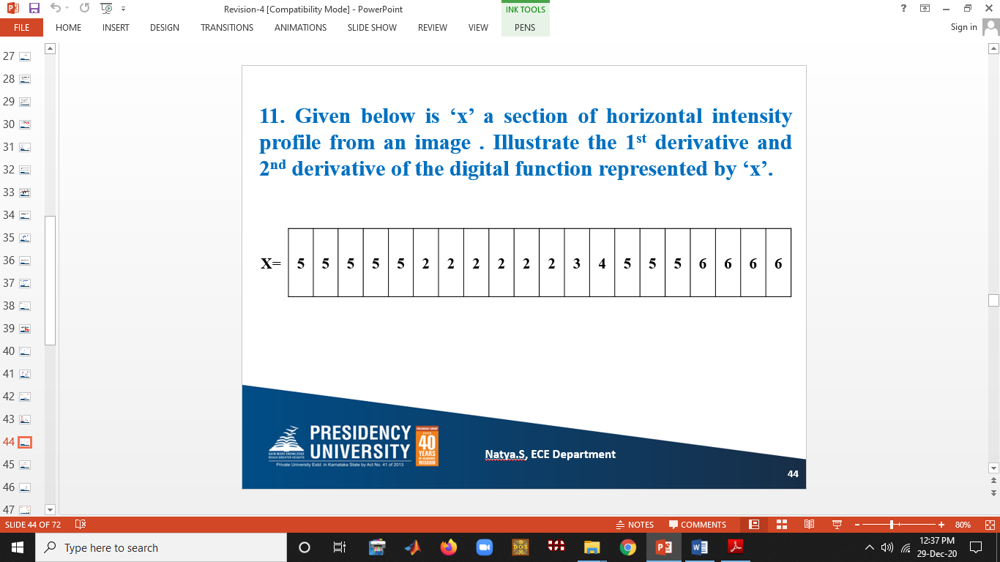

(C.O.4)[Comprehensive Level]

Q17. Erosion and Dilation are the two Fundamental operations in Morphological Image Processing from which all the other morphological operations are based. They were originally defined for Binary Images, later being extended to grayscale images and subsequently to complete lattice. Dilation adds pixels to the boundaries of objects in an image while erosion removes pixels on object boundaries. Accordingly, Consider a Binary image A, and the structuring elements B1 and B2 given below and perform the following morphological operations.

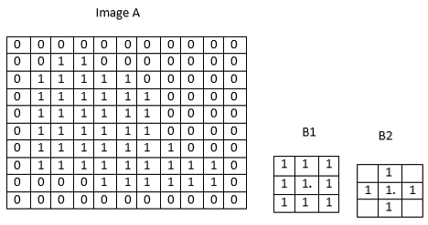

1. A erosion B1.
2. A erosion B2
3. A dilation B1
4. A dilation B2

(C.O.3)[Comprehensive Level]