|  |  |  |  |  |  |  |  |  |  |  |  |
| --- | --- | --- | --- | --- | --- | --- | --- | --- | --- | --- | --- |
| Roll No |  |  |  |  |  |  |  |  |  |  |  |



**Semester :** 4

**Course Code :** ECE3007

PRESIDENCY UNIVERSITY BENGALURU

SCHOOL OF ENGINEERING

**MAKE UP EXAMINATION – JULY 2024**

**Date :** 18-07-2024

**Time :** 9.30AM - 12.30PM

**Course Name :** Control Systems

**Program :** B.Tech. Electronics and Communication Engineering

**Max Marks :** 100

**Weightage :** 50%

**Instructions:**

1. *Read all questions carefully and answer accordingly.*
2. *Question paper consists of 3 parts.*
3. *Scientific and non-programmable calculator are permitted.*

**PART A**

**ANSWER ALL THE FIVE QUESTIONSQ 5 X 2 = 10M**

* 1. Define rise time and peak time of a second order system

(CO4,CO1,CO3,CO2) [Knowledge]

* 1. Suppose you are analyzing a system with open loop transfer function



It is known that s = -1 is a point on the root locus. What will be the corresponding value of K ?

(CO4,CO1,CO3,CO2) [Knowledge]

* 1. Analogous systems are two physically different systems, which can be modelled using similar differential equations. Consider a mechanical system which contains mass of 4 kg, spring with spring constant 5 N/m and a frictional element with constant 10 Ns/m. If the equivalent electrical network is drawn using force voltage analogy, the value of the resistor will be H

(CO2,CO4,CO1,CO3) [Knowledge]

* 1. Bode plot is a very important tool for frequency response analysis of a system. For an open loop system with a zero at origin with multiplicity 2, the slope of the gain plot will be dB/decade and the angle will be

(CO4,CO1,CO3,CO2) [Knowledge]

* 1. Mr. Abrar is analyzing a system and found that the poles of the system are located at  and

. Identify the damping associated with the system. Draw the pole zero plot.

(CO1,CO5,CO4,CO2,CO3) [Knowledge]

**PART B**

**ANSWER ALL THE TWO QUESTIONS 2 X 15 = 30M**

* 1. The output response of a system is the sum of two responses: the forced response and the natural response. Given the system in Figure, find the following
     1. The closed-loop transfer function
     2. The system type and Kp, Kv, and Ka
     3. The steady-state error for an input of 5u(t)
     4. The steady-state error for an input of 5tu(t)

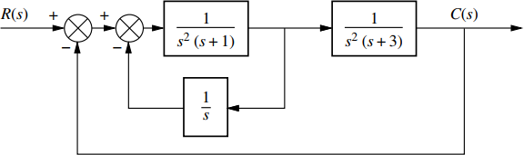

(CO2) [Comprehension]

* 1. Mr. Abrar is analyzing a series RLC circuit. He applied a dc voltage of 15 V to the circuit . He took the voltage across the capacitor as the output voltage. He observed that the voltage across the capacitor was as below.

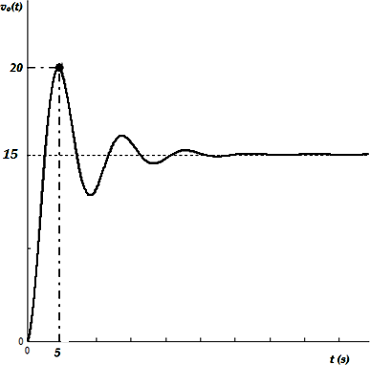

Estimate the values of the resistor, capacitor and inductor he used for his experiment. Also evaluate the settling time in this case.

(CO2,CO1) [Comprehension]

**PART C**

**ANSWER ALL THE THREE QUESTIONS 3 X 20 = 60M**

* 1. Mr. Vivek designed a filter using operational amplifier which has a transfer function



Bode plot can be used to find out the behavior of a certain system for different frequencies. Draw the Bode plot (both Gain and Phase plot) and hence state what type of filter(High Pass, Low Pass, Band Pass, or Band Stop) is this?

(CO3) [Application]

* 1. Dr. Praise is analyzing a system with the following open loop transfer function

He wants to design a controller for the system to meeting some specifications. He is planning to use Root Locus as his design method. Obtain the root locus plot. Draw neatly. The specifications are as below

Specification 1 : System should be STABLE Specification 2 : System should be underdamped.

Help him by finding the value of K which meets the above specifications. Show that part of the root locus will be a circle.

(CO3) [Application]

* 1. A project trainee working in ISRO is studying a control system. He comes up with the space model shown below. He meets his professor and shows the result. the professor asks him to evaluate the model by verifyingthe controllability and observability. Help the trainee to reach his goal

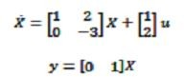

(CO4) [Application]

**\*\*\*\*\***