|  |  |  |  |  |  |  |  |  |  |  |  |  |
| --- | --- | --- | --- | --- | --- | --- | --- | --- | --- | --- | --- | --- |
| Roll No |  |  |  |  |  |  |  |  |  |  |  |  |



**Presidency University**

**Bengaluru**

**SCHOOL OF ENGINEERING**

**MAKE UP EXAMINATION- JUL 2024**

**Semester**: I

**Course Code**: CIV1003

**Course Name**: Elements of Engineering Mechanics

**Program:** B.Tech

**Date**: 08 - July - 20241

**Time**: 09:30 AM – 12:30PM

**Max Marks**: 100

**Weightage**: 50%

**Instructions:**

1. *Read the all questions carefully and answer accordingly.*
2. *Do not write any matter on the question paper other than roll number.*
3. *Scientific Calculators are permitted.*

**Part A [Memory Recall Questions]**

**Answer Any 3 Questions. Each question carries FIVE marks. (3Qx 5M= 15M)**

1. Define Concurrent force systems and Non-concurrent force systems along with diagrams. (C.O.No.1) [Knowledge]

2. Two cables are connected at A and B as shown in the figure. Determine the forces in the cables CA and CB if a 30 kN force is applied at a point C. (C.O.No.2) [Knowledge]

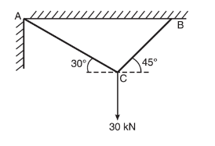

3. Define a Moment and Couple with example. (C.O.No.1) [Knowledge]

4. Find the moment of the force F = 600 N about A. (C.O.No.3) [Knowledge]

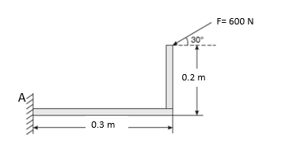

**Part B [Thought Provoking Questions]**

**Answer any 3 Questions. Each question carries FIFTEEN marks. (3Qx15M=45M)**

5. Determine the resultant of the force system shown in figure below.

(C.O.No.1)[Comprehension]

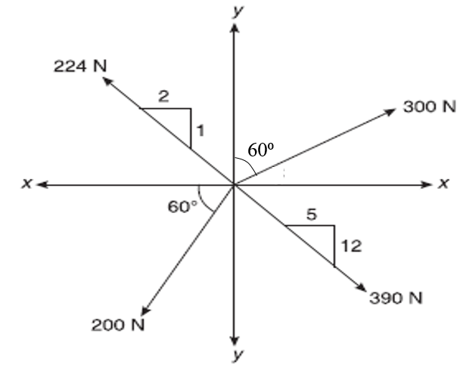

6. For the non-concurrent coplanar system shown in Figure 4.5, determine the magnitude, direction and position of the resultant force with reference to A. (C.O.No.1)[Comprehension]

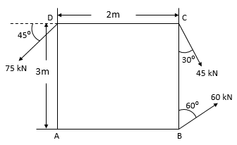

7. A string ABCD attached to two fixed points A and D has two equal weights 500 N attached to it at B and C (Figure 5.15). The weights rest with portions AB and CD inclined at angles of 30° and 60° respectively with the vertical. Find the tensions in the portions AB, BC, and CD of the string. The inclination of BC with vertical is 120°. (C.O.No.2) [Comprehension]

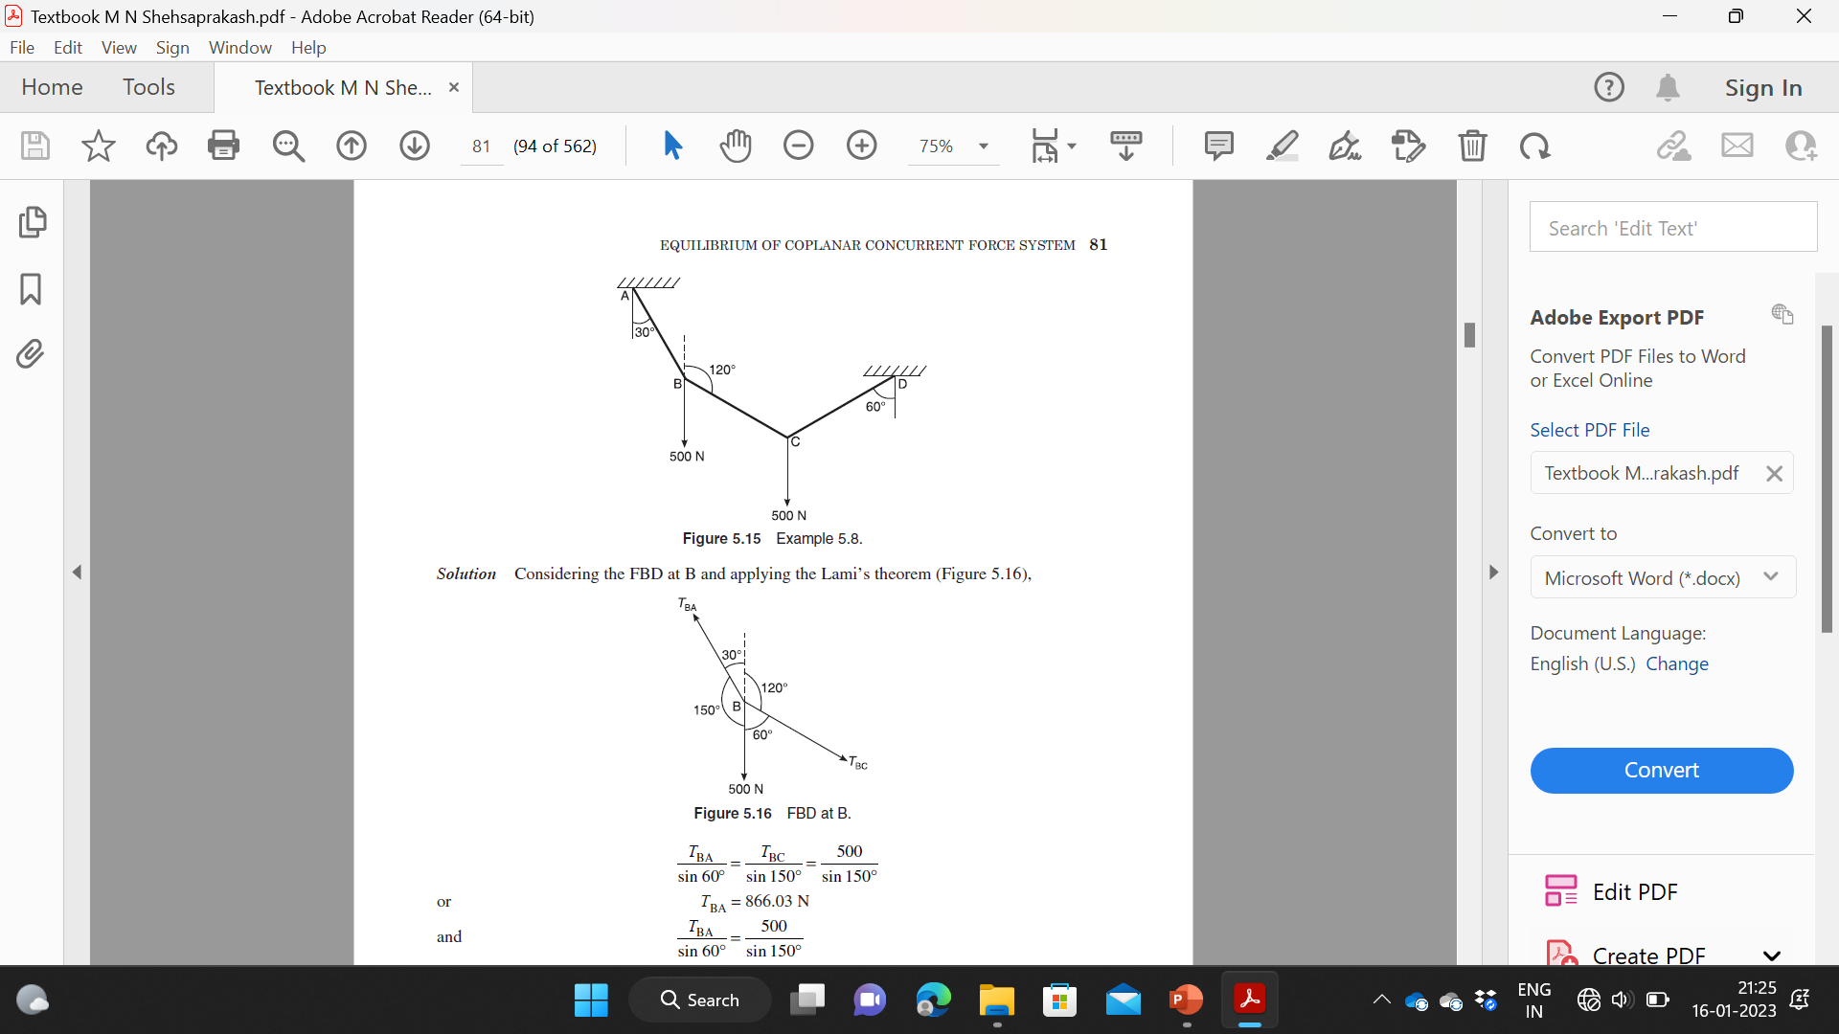

8. A block of mass 20 kg placed on an inclined plane as shown in figure. is subjected to a force P that is parallel to the plane. Taking the inclination of plane with respect to horizontal as 30°and the coefficient of friction as 0.24, determine the value of P for impending motion of the block up the plane and down the plane. (C.O.No.3) [Comprehension]

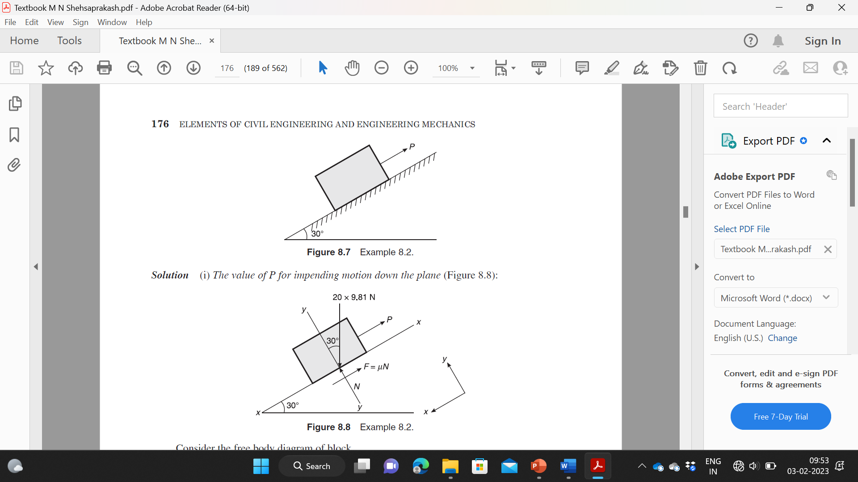

**Part C [Problem Solving Questions]**

**Answer Any 2 Questions. Each question carries TWENTY marks. (2Qx20M=40M)**

9. Calculate the support reactions for a beam loaded and supported as shown in the figure (C.O.No.2) [Application]

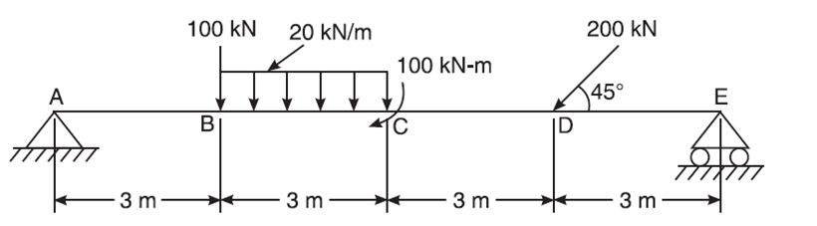

10. Figure shows the I-section of following dimensions. Determine the Centroid of the section at the horizontal and vertical axes, passing through the centroid of section. (C.O.No.3) [Application]

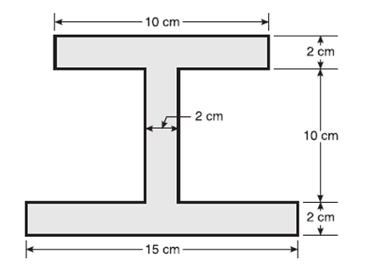

11. Determine the centroid of the section, shown in figure. (C.O.No.3) [Application]

