|  |  |  |  |  |  |  |  |  |  |  |  |  |
| --- | --- | --- | --- | --- | --- | --- | --- | --- | --- | --- | --- | --- |
| Roll No |  |  |  |  |  |  |  |  |  |  |  |  |



**Presidency University**

**Bengaluru**

**SCHOOL OF ENGINEERING**

**MAKE UP EXAMINATION JULY 2024**

**Date**: 1st July 2024

**Time**: 9:30AM to 12:30PM

**Max Marks**: 100

**Weightage**: 50%

(2019 Batch)

**Semester:** I

**Course Code**: CIV101

**Course Name**: ELEMENTS OF CIVIL ENGINEERING

**Program:** B.TECH.

**Instructions:**

1. *Read all the questions carefully and answer accordingly.*
2. *Use of Non-Programmable Scientific Calculator is permitted*

**Part A [Memory Recall Questions]**

**Answer all the Questions. Each Question carries 02 marks. (12Qx 2M = 24M)**

1. The branch of civil engineering that deals with Supply of water, Treatment of water and sewage is _______.

a) Geotechnical Engineering b) Structural Engineering

c) Transportation Engineering d) Environmental Engineering (C.O.No.1) [Knowledge]

2. Soils are formed by the process of ____________ of the parent rock.

a) Weathering b) Decomposition

c) Disintegration d) All of the above (C.O.No.1) [Knowledge]

3. State whether the following statement is true or false. Load bearing structures are more resistant to Earthquake than framed structures.

a) True b) False

c) Cannot say d) Data given is insufficient (C.O.No.1) [Knowledge]

4. Mat or Raft foundations are useful in reducing the __________ settlements of building on non-homogeneous soils, where there is a large variation in the loads on individual columns.

a) Differential b) Uniform

c) Combined d) None of the above (C.O.No.1) [Knowledge]

5. The layer of aggregate or broken stones packed around and below the sleeper is known as

a) Sleeper b) Ballast

c) Rail d) Subgrade (C.O.No.3) [Knowledge]

6. Paths on the airfield which provide linkages between one part of the airfield and another is known as

a) Runway b) Terminal

c) Taxiway d) Apron (C.O.No.3) [Knowledge]

7. With respect to the phase diagram of soil, a partially saturated soil consists of ____________.

a) Air voids, Water and soil solids b) Only air voids and soil solids

c) Only water and soil solids d) None of the above (C.O.No.1) [Knowledge]

8. Which of the following type of foundation is a deep foundation?

a) Strip Foundation b) Caisson Foundation

c) Raft Foundation d) Combined foundation (C.O.No.1) [Knowledge]

9. _________ is the type of bridge with which longest span can be achieved.

a) Beam bridge b) Cable stayed bridge

c) Arch bridge d) Suspension Bridge (C.O.No.1) [Knowledge]

10. Choose the correct sequence of load transfer in Framed structures.

a) Slab-->Column-->Beam-->Footing b) Slab-->Beam-->Column-->Footing

c) Beam-->slab-->Column-->Footing d) None of the above (C.O.No.1) [Knowledge]

11. ________ is a component of the bridge which transmits forces from super structure to sub structure while permitting angular and linear movement between parts.

a) Girder b) Bearing

c) Pier d) Abutment (C.O.No.1) [Knowledge]

12. Which of the following is the correct order of geological cycle for formation of soil from rocks.

a) Weathering -->Deposition-->Transportation-->Upheaval

b) Weathering -->Deposition-->Upheaval-->Transportation

c) Weathering -->Transportation-->Deposition-->Upheaval

d) None of the above (C.O.No.1) [Knowledge]

**Part B [Thought Provoking Questions]**

**Answer any four Questions. Each Question carries 10 marks. (4Qx10M = 40M)**

13. State and prove Parallelogram law of Forces. (C.O.No.2) [Comprehension]

a) List out the factors affecting the choice/type of foundation. [4M]

b) List the various components of a building and write the functions of any two components. [6M]

(C.O.No.1) [Comprehension]

14. Write short Notes on the following fields of Civil Engineering:

i) Geotechnical Engineering ii) Environmental Engineering

iii) Surveying iv) Transportation Engineering

(C.O.No.1) [Comprehension]

15. State and prove Lami’s theorem. (C.O.No.4) [Comprehension]

16. Explain the various components of a bridge with the help of a neat sketch.

(C.O.No.1) [Comprehension]

17. Explain the various system of forces.

(C.O.No.2) [Comprehension]

18. Determine the magnitude and direction of resultant of the force system acting on a particle as shown in the figure below. (C.O.NO.3) [Comprehension]

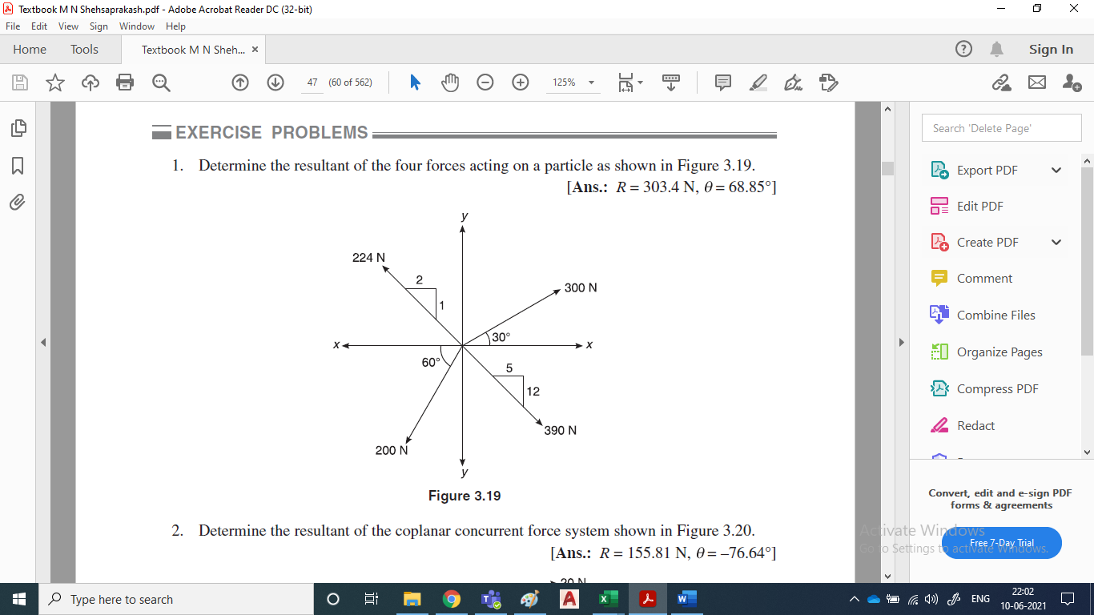

**Part C [Problem Solving Questions]**

**Answer any three Questions. Each Question carries 12 marks. (3Qx12M=36M)**

19. a) Explain the types of forces with a neat figure. [6 M]

b) List the types of support with their support reactions. [6 M]

(C.O.NO.3) [Application]

20. Find the support reactions for the beam AB loaded as shown in the figure below.

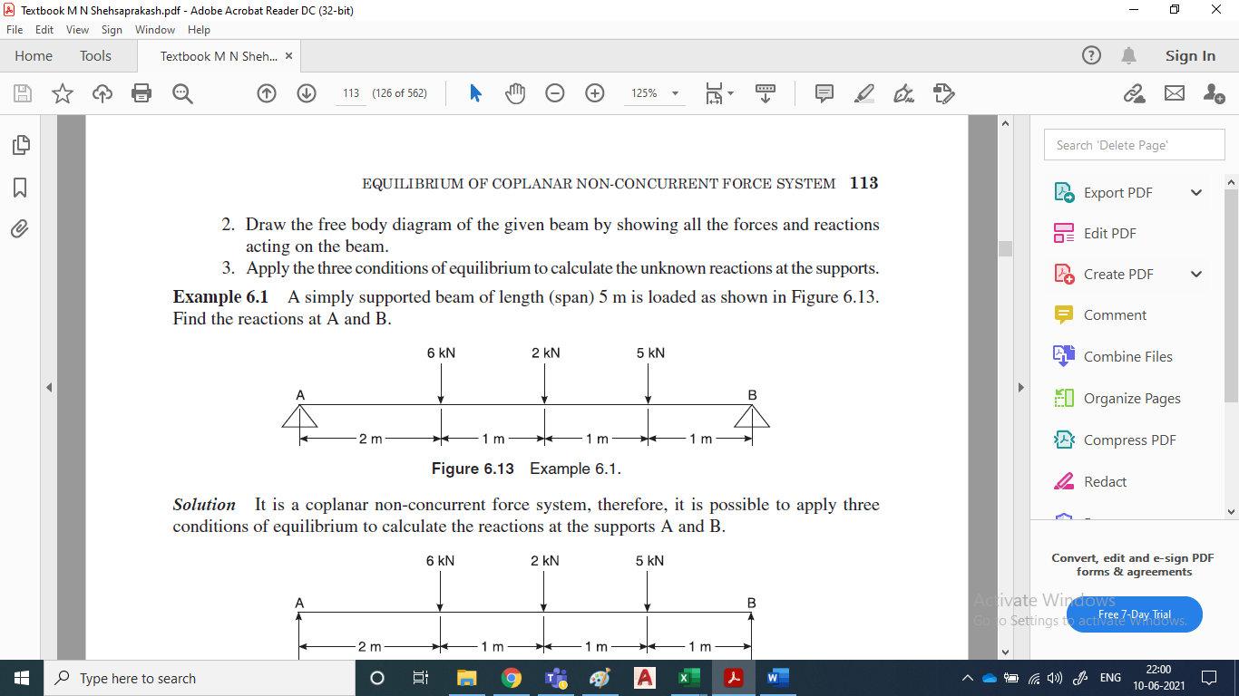

(C.O.NO.4) [Application]

21. Find the magnitude and direction and distance of the resultant from the point ‘A’ for the system of forces shown in the figure below.

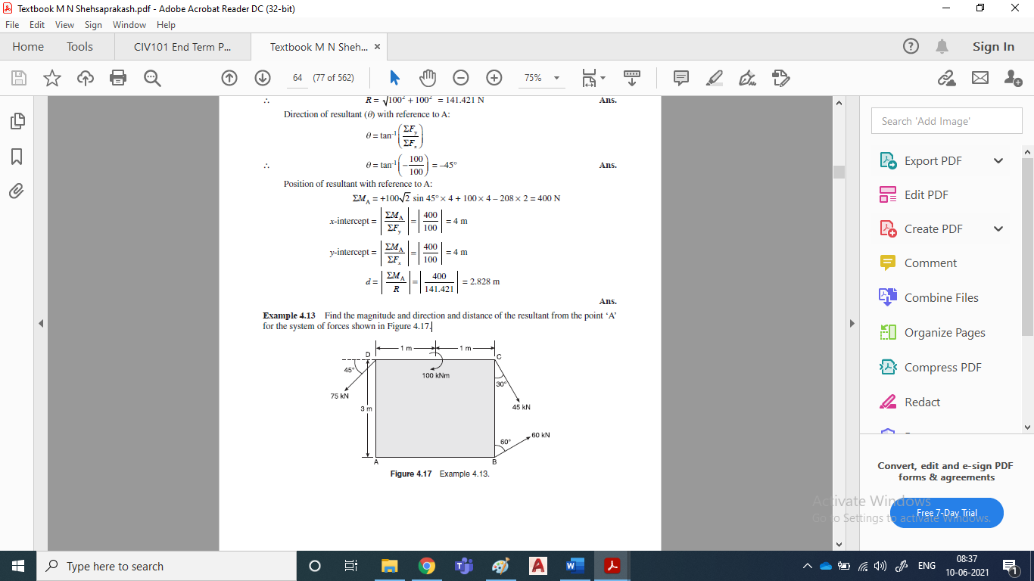

(C.O.NO.3) [Application]

22. The four coplanar forces acting at a point are as shown in Figure. One of the forces is unknown

and its magnitude is as shown by ‘F’. The resultant is 500 N and is along x-axis. Determine the

force ‘F’ and its inclination.



(C.O.NO.3) [Application]

23. Figure 30 shows a rope supporting a load of 10kN at C and another load of ‘P’ at B. If BC is inclined at 45⁰ to horizontal, determine the load P. Also, find the tensile forces developed in different segments of the rope.

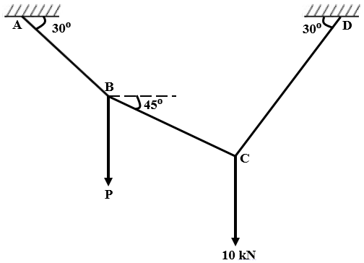

(C.O.NO.4) [Application]