**PRESIDENCY UNIVERSITY BENGALURU**

**SCHOOL OF ENGINEERING**

**MAKEUP EXAMINATION**

**Semester: 1 SEM**

**Course Code: KAN 1001**

**Course Name: KALI KANNADA**

**Date: 10 JULY 2024**

**Time: 9:30am-12:30pm**

**Max Marks: 100**

**Weightage: 50%**

**Instructions:**

1. ***Read the question properly and answer accordingly.***
2. ***Question paper consists of 3 parts.***

***.***

## Part A - Memory Recall

***Read the following questions and choose the right option*****(25Qx1M=25M)**

1. There are 13 vowels in kannada varnamale. Here the word **vowels** in kannada means?
2. There are Consonants in “KANNADA VARNAMALE”?
3. “We are students of Class 10th.” Here **Class** in kannada means?
4. “Wash your hands regularly” here **hand** in kannada means?
5. I : naanu :: We :
6. “They are best friends.” here the word **They** means ?
7. What is the meaning of thatha and ajji?
8. Verb : :: Adverb : kriya visheshaNa?
9. If a male teacher is called as “Shikshaka” in kannada what is a female teacher called?
10. The Consonants **pa, ba, ma** is pronounced with the help of
11. “He studies at Presidency University.” here the pronoun **He** in kannada means?
12. If a female lecturer is called as upanyasaki in kannada then what is a male lecturer called?
13. Presidency University has the biggest campus. Here the word **Big** in kannada means?
14. Adjective in kannada
15. “Look Up” Here the word “Up” in kannada
16. “haLadi & gulaabi” these are examples under ?
17. In × out
18. The conjunction “**AND**” in kannada is?
19. The word “ayoooo” in means
20. Bird : pakshi :: animal :
21. If elder brother is aNNa what does elder sister means?
22. “One has to go when he sees green light” here **green** in kannada?
23. If vegetables are called tarakari, what are colours called ?
24. “Wash your hands regularly” here **hand** in kannada means?
25. He : avanu :: She :

## Part B – Thought Provoking

***Match the following*** **(10Qx1M=10M)**

1. Nine hasiru
2. Swara kappu
3. Green yellow
4. Seven ondhu
5. hraswa swara avargeeya vyanjana
6. haLadi gulaabi
7. Unclassified consonants ombhattu
8. One vowel
9. Black eLu
10. Pink short vowel

***Translate the following sentences to English*** **(10Qx2M=20M)**

1. idu nanna kai
2. avaLu nanna thangi
3. ivaru nanna shikshakaru
4. sebu oLLeya haNNu
5. gubbacchi chikka pakshi
6. Bengaluru nanna nagara
7. idu kappu baNNa kaage
8. naanu BE vidyarthi
9. mysore sundara nagara
10. ninna hesaru yenu?

*Find kannada tarakari, haNNu, praNi, pakshi from the box and categorize accordingly*. **(1Qx10M=10M)**

## http://guqbms.inpods.com:57953/api/v1/downloadFile?fileId=25295&tenantid=13

*Fill in the blanks***(10Qx1M=10M)**

## 

## 

1. kempu : baNNa :: ondhu : _______
2. Noun: Bangalore:: Pronoun : _________
3. White : biLi :: Black :_________
4. He : avanu :: She :
5. Bird : pakshi :: animal :
6. I : naanu :: We :
7. why : yaake :: who : _____
8. koLi : pakshi :: simha : ______
9. raja : king :: raNi : ______
10. This : idu :: That : ______

## Part C – Problem Solving Questions

***Form five simple sentences using the below given words*** **(5Qx2M=10M)**

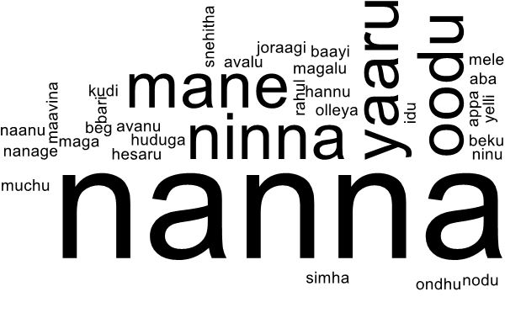

***Translate the following Kannada conversation to English*****(1Qx5M=5M)**

**John : namaskara sir.**

**Sir : namaskara, ninna hesaru yenu?**

**John : Sir nanna hesaru john. naanu Law vidyarthi.**

**Sir : John ninna taragathi yaavudu?**

**John : Sir naanu BA LLB 2 taragathi vidyarthi**

***Read the following passage and answer to the following questions in the given space* (5Qx2M=10M)**

This year we went to Ooty for during our summer vacations. We went up the hill on a train. The hillside was beautiful, with wildflowers, tall trees, and little rushing streams. We stayed for a week or seven days in Ooty in a tourist lodge. The first day we went boating in Ooty Lake. I, too, used the oars for some time. Another day, we visited the Botanical Gardens where the annual flower show was being held. Beautiful and rare varieties of flowers. Pink and red roses. Rare varieties of fruits like Apples, Custard apples, and a variety of black grapes were on display. I went horse riding one day. We also visited the Mukurti Dam, Pykara Dam, and other dams nearby. We climbed the Doddabeta Peak which is the highest peak in the Nilgiris. We were taken around a tea garden which was more than ten acres, where we sampled their tea. The trip to Ooty was really memorable.

1. Find three pronouns from the passage and translate them into Kannada
2. Find three Adjectives from the passage and translate it into Kannada
3. Find three Fruits from the passage and translate it into Kannada
4. Find three Colours from the passage and translate it into Kannada
5. Find three numbers from the passage and translate it into Kannada