**PRESIDENCY UNIVERSITY BENGALURU**

**SCHOOL OF COMMERCE**

**MAKEUP EXAMINATION**

**Semester: 2 Sem (AY 2023-24)**

**Course Code: KAN 1002**

**Course Name: SARALA KANNADA**

**Program: BA /BCOM /BBA**

**Date: 4 JULY 2024**

**Time: 9:30 AM -12:30 PM**

**Max Marks: 100**

**Weightage: 50%**

**Instructions:**

1. ***Read the question properly and answer accordingly.***
2. ***Question paper consists of 3 parts.***

***.***

## Part A - Memory Recall

***Read the following questions and choose the right option*****(25Qx1M=25M)**

1. He × She
2. “He is my father’s younger brother”, here the word **Father’s Younger brother** in kannada means?
3. Noun : naamapada :: pronoun : ______________
4. “Lion” in kannada is .”
5. One : ________ :: Two : eraDu
6. doDDappa × doDDamma
7. “Your hairs are black” here the word **hairs n black** in kannada means?
8. Big × Small
9. If Brinjals are called badane kaayi what are Green Chilly called?
10. White × Black _________
11. Bird : pakshi :: animal :

1. This is the example for present tense
2. boy × girl
3. “haNNugaLu” is a ______________ word.
4. nimma collegena hesaru yenu?
5. How many Genders are there in kannada?
6. Son × Daughter

1. "How" means ____________
2. “nanna mathru bhashe kannada “ translated to english
3. Masculine Gender : pullinga :: Feminine Gender : ___________
4. santhoshadinda means __________
5. Vidyarthini is a ________________
6. “haLadi & gulaabi” these are examples under ?
7. In × out
8. The word “ayoooo” in means

***Write 2 kannada examples for each category*** **(10Qx2M=20M)**

|  |  |
| --- | --- |
| **naamapada/noun** |  |
| **baNNa/colour** |  |
| **sthri linga/Feminine gender** |  |
| **Interrogative words** |  |
| **Pullinga/ Masculine** |  |
| **udgaara/ Interjection** |  |
| **kriya pada/ Adverbs** |  |
| **haNNu/ Fruit** |  |
| **prani/ Animal** |  |
| **tarakaari/ Vegetable** |  |

## Part B – Thought Provoking

***Match the following and write down the right answers in the given space*****(10Qx1M=10M)**

### **SIX neeli**

### **RED hattu**

1. **SEVEN gulaabi**
2. **BLUE ombhattu**

### **EIGHT hasiru**

### **PINK aaru**

1. **NINE kempu**
2. **YELLOW eLu**

### **TEN haLadi**

### **GREEN entu**

***Translate the following and write down the right answers in the given space*****(10Qx2M=20M)**

# Who Are You?

1. **What is your name?**
2. **Who is he?**

# Which is your state?

# In and out

# Good Morning sir

# Walk everyday

1. **He is eating**

# I went

1. **He will run**

## Part C – Problem Solving Questions

***Form five simple sentences using the below given words*** **(5Qx2M=10M)**

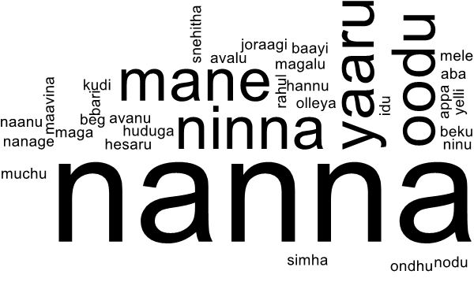

***Translate the following Kannada conversation to English*****(1Qx5M=5M)**

**John : namaskara sir.**

**Sir : namaskara, ninna hesaru yenu?**

**John : Sir nanna hesaru john. naanu Law vidyarthi.**

**Sir : John ninna taragathi yaavudu?**

**John : Sir naanu BA LLB 2 taragathi vidyarthi**

***Read the following passage and answer to the following questions in the given space* (5Qx2M=10M)**

### Namaskaara sir. nanna hesaru Ramesh/Rajani. naanu Law vidyarthi/vidyarthini. naanu Presidency vishwaviyalaya dalli oodutthidene. nanna rajya Maharastra. nanna mathru bhashe marathi. avana hesaru Santhosh. avanu nanna snehitha. avara hesaru Mohan. avaru nanna English shikshakaru. naanu prathi dina vishwavidyalayakke hoguttene.

1. How is Ramesh/Rajani greeting their sir?
2. The word hoguttene in the passage is in which tense?
3. The word ooduttidene in the passage is in which tense?
4. Translate the word **“mathru bhashe”** to English and find the word **“Friend”** in the passage?
5. List 2 Noun and 2 Pronoun from the passage?