Roll No



PRESIDENCY UNIVERSITY BENGALURU

Semester : Semester V & VII
Course Code : CSE3005

SCHOOL OF ENGINEERING
MAKE UP EXAMINATIONJULY 2024
Date : 01-07-2024
Time : 9:30AM - 12:30 PM

Course Name :Applied Artificial Intelligence
Program : B.Tech.
Max Marks : 100
Weightage : 50%

Instructions:
- Read all questions carefully and answer accordingly.
- Question paper consists of 3 parts.
- Scientific and non-programmable calculator are permitted.
- Do not write any information on the question paper other than Roll Number.

PART A
ANSWER ALL THE QUESTIONS 5 X 2M = 10M
- Mentioned the search algorithm that is used to traverse tbe game tree for pruning nodes in alpha-beta pruning.
(CO1) [Knowledge]
- Consider 3 cells (A, B, and C) in a grid, such that they have sector numbers , , and respectively. If A is connected to B and C is also connected to B, write down the values of:

1.

  - , and

3.

(CO1) [Knowledge]

- Mention the term which describes the set of rules for writing a valid statement in propositional logic.
(CO1) [Knowledge]

- Mentioned the search algorithm that is used to create the distance map.

- Expand CNF, and mention what each set of disjunctions in the CNF is called.
(CO2) [Knowledge] (CO2) [Knowledge]

PART B
ANSWER ALL THE QUESTIONS 5 X 10M = 50M

- Explain why we traverse the tree in DFS for alpha beta pruning, as opposed to BFS.
(CO1) [Comprehension]

- Solve the N queens problem with N = 5. Your answer must contain the final allotment of the row numbers for each of the 5 queens. You must also draw a diagram (5x5 board) of the same.
(CO2) [Comprehension]
- Consider the following situation: "Alice likes mathematics and she also likes literature. If someone likes mathematics, then they also like algebra. If someone likes algebra and also likes physics, then they will graduate.Alice likes physics, but neither chemistry nor history. If someone will graduate, their GPA is more than 4." For each of the following terms, classify them as either coonstant, variable, predicate, or function. In case it is a predicate or function, define the predicate / function:

  - algebra
  - Alice
  - chemistry
  - GPA
  - graduate
  - history
  - likes
  - literature
  - mathematics
  - physics

(CO3) [Comprehension]
- Consider the Bayesian Network shown here:
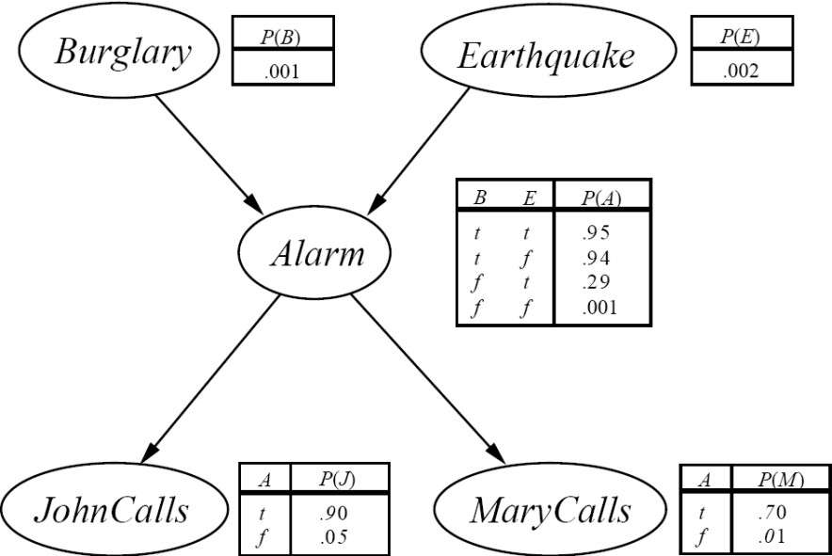

Calculate the probability that a burglary has taken place, given that you DO NOT get a call from either John or Mary, that your Alarm is ringing.
(CO4) [Comprehension]
- Consider a situation of the water jug problem, where we have a 3 litres jug and a 9 litres jug. Describe all the different ways to measure out integral volumes of water, from 1 litre to 12 litres. In case no method is possible, write “No solution possible”.
(CO2) [Comprehension]

PART C

ANSWER ALL THE QUESTIONS 2 X 20M = 40M

- For the given map, calculate the distance to R from the node A, using Greedy Best-First Search, as well as A* Search. Are the distances the same?
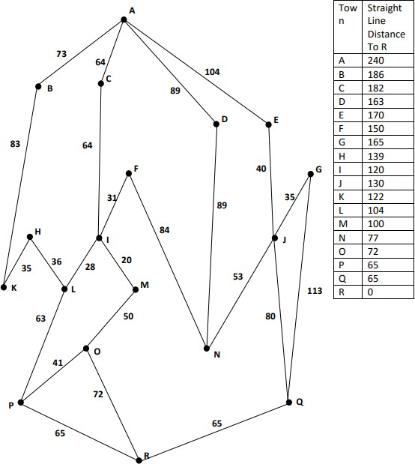

(CO2) [Application]
- Consider the coloured ball choosing problem, where we have 100 red balls, 100 green balls and 100 blue balls. Each of the balls are in one of 3 urns, namely Urn1, Urn2 and Urn3, such that all 3 urns have 100 balls. The distribution of the balls in the urns are as follows:
 | Urn1 | Urn2 | Urn3
Red | 30 | 10 | 60
Green | 50 | 40 | 10
Blue | 20 | 50 | 30
Now, we pick a series of balls from the urns, one at a time, and replace them back in the urns. The probabilities of choosing the ith Urn, given that we chose the (i-1)th Urn are given below (including the initial probabilities which are NOT 1/3):
 | Urn1 | Urn2 | Urn3
$(START) | 0.25 | 0.5 | 0.25
Urn1 | 0.1 | 0.4 | 0.5
Urn2 | 0.6 | 0.2 | 0.2
Urn3 | 0.3 | 0.4 | 0.3
For the observation sequence "B R B G B", find the sequnce of urns that are chosen which give us this probability.
(CO4) [Application]

