|  |  |  |  |  |  |  |  |  |  |  |  |  |
| --- | --- | --- | --- | --- | --- | --- | --- | --- | --- | --- | --- | --- |
| Roll No |  |  |  |  |  |  |  |  |  |  |  |  |



**Presidency University**

**Bengaluru**

**SCHOOL OF ENGINEERING**

**MAKE-UP EXAMINATION JULY 2024**

**Semester**: V

**Course Code**: MEC4040

**Course Name**: Manufacturing Engineering

**Program:** B. Tech

**Date**: 01-07-2024

**Time**: 1:30 PM to 4:30 PM

**Max Marks**: 100

**Weightage**: 50%

**Instructions:**

1. *Read the all questions carefully and answer accordingly.*

**Part A [Memory Recall Questions]**

**Answer any FIVE questions. Each question carries TWO marks. (5Qx 2M= 10M)**

1. What is positive rake angle. For which type materials positive rake angles are preferred. ( CO.No.01) [Knowledge]

2. Give any two examples for multi-point cutting tools used in manufacturing.

( CO.No.01) [Knowledge]

3. What are the important properties that cutting tool material should possess for effective cutting.

( CO.No.02) [Knowledge]

4. What are the functions of cutting fluids? ( CO.No.02) [Knowledge]

5. List out the advantages of Transfer moulding. ( CO.No.03) [Knowledge]

6. What is Powder metallurgy? ( CO.No.04) [Knowledge]

7. What are the advantages of CNC machines? ( CO.No.05) [Knowledge]

**Part B**

**Answer any SIX questions. Each question carries TEN marks. (6Qx 10M= 60M)**

8. Chips are generated when tool comes in contact with rotating work piece. Explain the chip formation process in continuous, discontinuous and build up edge chip. ( CO.No.01) [Comprehension]

9. Explain the variables that affecting tool life in metal cutting process. ( CO.No.01) [Comprehension]

10. Cutting fluids are used for lubricating and cooling purpose in metal cutting operation. Explain the characteristics of cutting fluids in metal cutting operation. ( CO.No.02) [Comprehension]

11. With neat sketch explain the compression moulding process in plastic with advantages and limitations. ( CO.No.03) [Comprehension]

12. What is blow moulding? Explain the blow moulding in plastics with its applications.

( CO.No.03) [Comprehension]

13. 5S is the workplace organization methodology that uses five Japanese words. Explain the 5S used by Japanese company to improve the production rate. ( CO.No.04) [Comprehension]

14. With the simple diagram explain the production of metal powder by Gas and water atomization process. ( CO.No.04) [Comprehension]

**Part C**

**Answer any TWO Questions. Each question carries FIFTEEN marks. (2Qx15M=30M)**

15**.** The tool's life was discovered to be 1 hr 40 minutes at a spindle speed of 40 rpm when it was used to machine a mild steel work piece. If a tool needs to run at a speed that is 23% faster than the initial cutting speed, calculate the tool life. Calculate the cutting speed as well if the tool needs to last 165 minutes. Assume n=0.22 Taylor's exponent. (C.O.No.1) [Application]

16. Write a program using milling cutter with diameter 50 mm spindle speed 1000 rpm and feed 0.05 mm/min depth of cut 2mm in absolute system. (C.O.No.5) [Application]

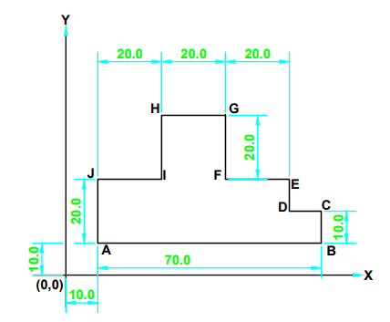

17. Write a program using milling cutter with diameter 10mm spindle speed 1000 rpm and feed 0.05 depth of cut 2mm in incremental system. (C.O.No.5) [Application]

