|  |  |  |  |  |  |  |  |  |  |  |  |
| --- | --- | --- | --- | --- | --- | --- | --- | --- | --- | --- | --- |
| Roll No |  |  |  |  |  |  |  |  |  |  |  |

PRESIDENCY UNIVERSITY BENGALURU

SCHOOL OF ENGINEERING

**MAKE-UP EXAMINATION - JULY 2024**

**Semester :** Semester IV

**Course Code :** CIV2013

**Course Name :** Sem IV - CIV2013 - Analysis of Determinate Structures

**Program :** B.Tech. Civil Engineering

**Date :** 01 JULY 2024

**Time :** 09.30am to 12.30pm

**Max Marks :** 100

**Weightage :** 50%

**Instructions:**

1. *Read all questions carefully and answer accordingly.*
2. *Question paper consists of 3 parts.*
3. *Scientific and non-programmable calculator are permitted.*
4. *Do not write any information on the question paper other than Roll Number.*

# PART A

## Answer any 10 10*2=20

* 1. Calculate the degree of indeterminacy of a Fixed beam loaded as shown in figure below.

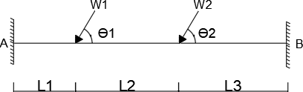

(CO1) [Knowledge]

* 1. Calculate the total degree of indeterminacy of fixed beam loaded as shown in figure below.

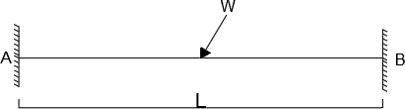

(CO1) [Knowledge]

* 1. Calculate the total degree of indeterminacy of the propped cantilever beam loaded as shown.

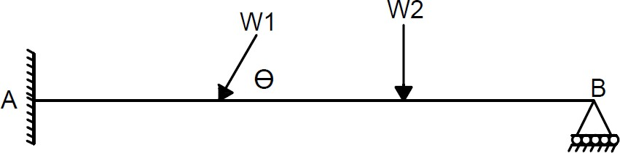

(CO1) [Knowledge]

* 1. Calculate the degree of indeterminacy of a Fixed beam loaded as shown in the figure below.

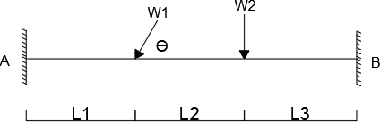

* 1. Calculate degree of indeterminacy of a continuous beam loaded as shown in the figure.

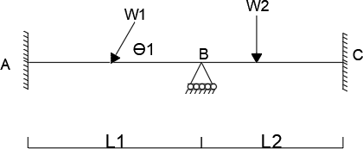

(CO1) [Knowledge]

* 1. Calculate degree of indeterminacy of a simply supported beam loaded as shown in figure below.

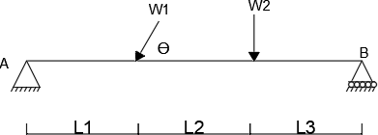

(CO1) [Knowledge]

* 1. Calculate the degree of indeterminacy of a cantilever beam loaded as shown in the figure.

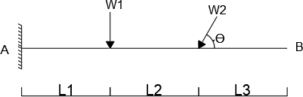

(CO1) [Knowledge]

* 1. Calculate the degree of indeterminacy of a simply supported beam loaded as shown in the figure below.

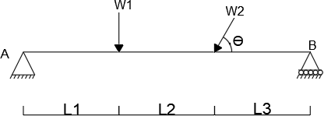

(CO1) [Knowledge]

* 1. Calculate total degree of indeterminacy of a fixed beam loaded as shown in figure below.

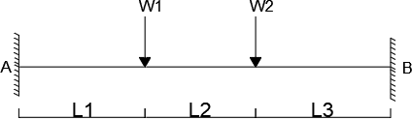

(CO1) [Knowledge]

* 1. Calculate the total degree of indeterminacy of the continuous beam loaded as shown.

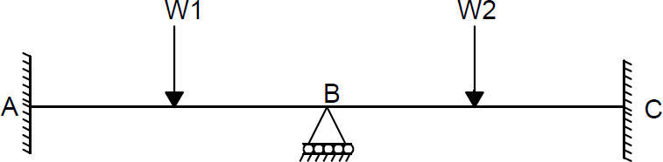

* 1. Calculate the total degree of indeterminacy of a fixed beam loaded as shown.

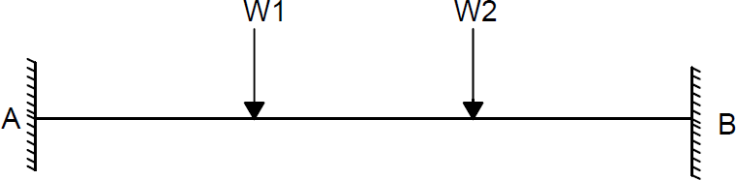

* 1. Calculate the degree of indeterminacy of a cantilever beam loaded as shown.

(CO1) [Knowledge]

(CO1) [Knowledge]

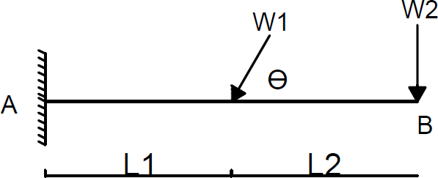

* 1. Calculate the Kinematic degree of indeterminacy of a continuous beam as shown.

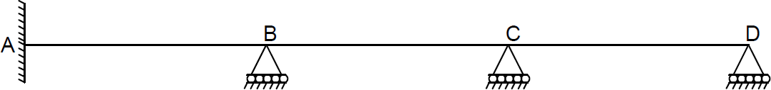

* 1. Calculate the Kinematic degree of indeterminacy of a truss as shown.

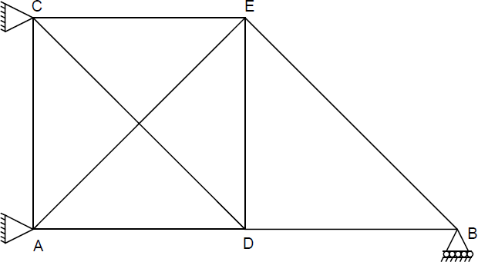

(CO1) [Knowledge]

(CO1) [Knowledge]

# PART B

## Answer any 4 4*8=32

* 1. The three hinged symmetrical parabolic arch of span 40m and rise of 10m and subjected to UDL of magnitude 25 kN/m on left half of the span. Calculate the support reactions and draw the BMD.

(CO2) [Comprehension]

* 1. The three hinged symmetrical parabolic arch of span 50m, rise of 10m and subjected to UDL of magnitude 30 kN/m on left half of the arch. Calculate the support reactions and draw the BMD.

(CO2) [Comprehension]

* 1. Calculate the maximum slope and deflection for cantilever beam loaded as shown in the figure by moment area method. Take EI = 10X kNm².

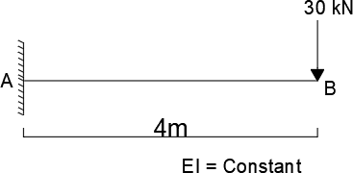

(CO3) [Comprehension]

* 1. Calculate maximum slope and deflection for simply supported beam loaded as shown in the figure by conjugate beam method. Take EI = 10X kNm².

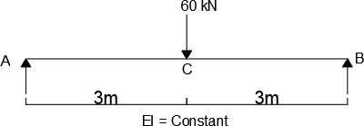

(CO3) [Comprehension]

* 1. Calculate the maximum slope and deflection for simply supported beam loaded as shown in figure by moment area method. Take EI = 8X kNm².

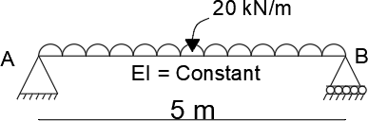

* 1. Calculate the maximum slope and deflection for simply supported beam loaded as shown in the fig by conjugate beam method. Take EI = 10X  kNm².

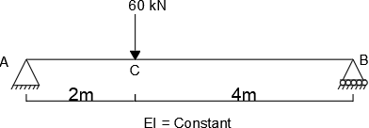

(CO3) [Comprehension]

# PART C

## Answer any 4 4*12=48

* 1. The three hinged symmetrical parabolic arch of span 50m, rise of 10m and subjected to point load of magnitude 400 kN at distance 12.5 m from the left support. Calculate the support reactions and draw the BMD also calculate the normal thrust and radial shear at a distance 15 m from the left support.

(CO2) [Application]

* 1. The three hinged symmetrical parabolic arch of span 50m and rise of 10m and subjected to UDL of magnitude 20 kN/m on left half of the span. Calculate the support reactions and draw the BMD. Also calculate normal thrust and radial shear at distance 12.5m from the left support.

(CO2) [Application]

* 1. Analyze a fixed beam loaded as shown in the figure by the consistent deformation method and draw the BMD and SFD. Take EI = Constant.

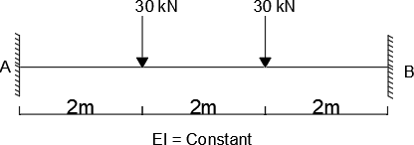

(CO4) [Application]

* 1. Analyze the fixed beam loaded as shown in the figure by consistent deformation method and draw BMD and SFD. Take EI = Constant.

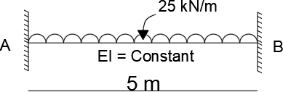

(CO4) [Application]

* 1. Analyze the propped cantilever beam loaded as shown in the figure by consistent deformation method and draw the BMD and SFD. Take the value EI = Constant.

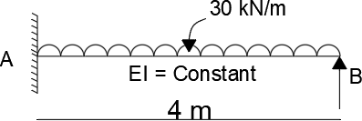

(CO4) [Application]

* 1. Analyze the propped cantilever beam loaded as shown in the figure by consistent deformation method and draw the BMD and SFD. Take EI = Constant.

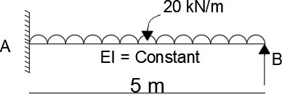

(CO4) [Application]