|  |  |  |  |  |  |  |  |  |  |  |  |
| --- | --- | --- | --- | --- | --- | --- | --- | --- | --- | --- | --- |
| Roll No |  |  |  |  |  |  |  |  |  |  |  |

PRESIDENCY UNIVERSITY BENGALURU

SCHOOL OF ENGINEERING

**MAKE UP EXAMINATION - JULY 2024**

**Semester :** Semester V -

**Course Code :** MGT2013

**Course Name :** - Project Management

**Program :** B.Tech. Mechanical Engineering

**Date :** July 8, 2024

**Time :** 01:30 PM - 04:30 PM

**Max Marks :** 100

**Weightage :** 50%

**Instructions:**

1. *Read all questions carefully and answer accordingly.*
2. *Question paper consists of 3 parts.*
3. *Scientific and non-programmable calculator are permitted.*
4. *Do not write any information on the question paper other than Roll Number.*

**PART A**

**ANSWER ALL THE QUESTIONS 5 X 2M = 10M**

* 1. Define the term: "Portfolio Management" with a suitable example.
  2. Recognize five (5) benefits of Waterfall Methodology.
  3. List the essential factors affecting the qualities of estimation of a project.
  4. List the steps in creating an AOA network diagram.
  5. Recall the six (6) components of a Gantt Chart.

(CO1) [Knowledge] (CO1) [Knowledge] (CO2) [Knowledge] (CO3) [Knowledge] (CO4) [Knowledge]

**PART B**

**ANSWER ALL THE QUESTIONS 5 X 10M = 50M**

* 1. Explain the common mistakes made by project teams when defining Project Scope, with suitable examples.

(CO2) [Comprehension]

* 1. Explain with suitable examples, why project crashing is useful for faster execution of project.

(CO3) [Comprehension]

* 1. Critical Path Analysis helps the Project Manager to better manage a project. With reference ot this context, explain the benefits and limitations of critical path analysis, with suitable examples.

(CO3) [Comprehension]

* 1. Project closure is the last phase of the project management where everything comes to an end. Referring to this context, discuss the seven (7) steps of project closure.

(CO4) [Comprehension]

* 1. Risks can be positive and negative, as well. Each time a risk occurs, it has to be addressed with a proper risk response. Regarding this context, answer the following questions:
     1. Explain five (5) negative risk responses, with suitable examples
     2. Explain five (5) positive risk responses, with suitable examples

(CO4) [Comprehension]

**PART C**

**ANSWER ALL THE QUESTIONS 2 X 20M = 40M**

* 1. 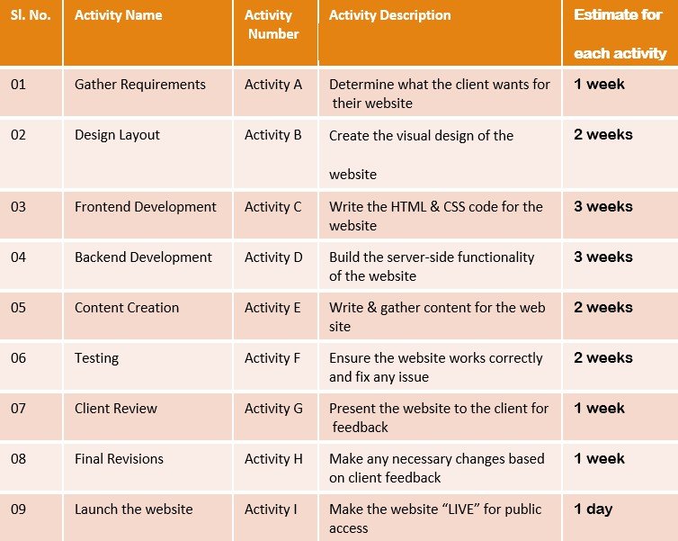You are the Project Manager to design and develop a website for a Digital Marketing company. From the activity chart shown below, answer the following questions:
     1. Draw both AOA and AON diagrams with the durations for each activity for the above chart
     2. Explain the dependencies of each activity on others

(CO3) [Application]

* 1. A Gantt chart illustrates the timeline of a project and its tasks. With reference to this context, answer the following questions:
     1. Demonstrate the uses of Gantt Chart
     2. Show the pros and cons of Gantt Chart

(CO4) [Application]