|  |  |  |  |  |  |  |  |  |  |  |  |
| --- | --- | --- | --- | --- | --- | --- | --- | --- | --- | --- | --- |
| Roll No |  |  |  |  |  |  |  |  |  |  |  |



**Semester : 4**

**Course Code :** CIV2015

PRESIDENCY UNIVERSITY BENGALURU

SCHOOL OF ENGINEERING

**MAKE UP EXAMINATION - JULY 2024**

**Date :** 18-JULY-2024

**Time :** 1.30PM - 4.30PM

**Course Name :** Geotechnical Engineering

**Program :** CIV

**Max Marks :** 100

**Weightage :** 50%

**Instructions:**

1. *Read all questions carefully and answer accordingly.*
2. *Question paper consists of 3 parts.*
3. *Scientific and non-programmable calculator are permitted.*
4. *Do not write any information on the question paper other than Roll Number.*

**PART A**

**ANSWER ALL THE QUESTIONS (4 X 5 = 20M)**

* 1. Soil is one of the important engineering material. Degree of saturation, air content, voids ratio, water content and porosity of the soil are very important terms in soil mechanics. Explain these terms.

(CO1) [Knowledge]

* 1. A falling·head permeability test was conducted on a soil sample of 4 cm diameter and 18 cm length. The head fell from 1.0 m to 0.4 m in 20 minutes. If cross sectional area of the stand pipe was 1 square cm then determine coefficient of permeability.

(CO2) [Knowledge]

* 1. Explain what do you mean by compaction and also list the various tests for determining compaction behaviour of soil. Draw a typical compaction curve and explain its salient features.

(CO3) [Knowledge]

* 1. A soil from a project site at Jaynagar was investigated. The volume of soil in the container is 100cc and mass of 190 g. On oven drying for 24 hours, the mass is reduced to 160 g. If the specific gravity of grains is 2.68, determine water content, voids ratio and degree of saturation of soil.

(CO1) [Knowledge]

**PART B**

**ANSWER ALL THE QUESTIONS (5 X 10 = 50M)**

* 1. Permeability test has been conducted for a soil sample from a construction site at Delhi and follwing are the experimental data: Sample height is 6 cm, cross sectional area is 50 square centimeter, if a quantity of water of 450 ml is passed down in 10 min under a constant head of 40 cm determine coefficient of permeability of soil. On oven drying, the soil has a mass of 498 g, G=2.65 and also

calculate seepage velocity during the test.

(CO2) [Comprehension]

* 1. A series of direct shear tests were conducted on a soil at a construction site at Yelahanka and each test was carried out till the sample failed. The following results were obtained and are tabulated below. Determine cohesion and angle of shearing resistance for the soil sample.

|  |  |  |
| --- | --- | --- |
| sample No | Normal Stress (kN/m2) | Shear stress (kN/m2) |
| 1 | 15 | 18 |
| 2 | 30 | 25 |
| 3 | 45 | 32 |

(CO2) [Comprehension]

* 1. Soil is formed by disintegration of rocks by physical and chemical process. Explain chemical process of

soil formation.

(CO1) [Comprehension]

* 1. Compression of soil is due to the escape of water when external load is applied and it is called as Consolidation. Explain Mass spring analogy of soil consolidation with a neat diagram.

(CO3) [Comprehension]

* 1. Compaction and consolidation are the two process where reduction in volume takes place. List the difference between compaction and consolidation and also explain normally Consolidated, over

consolidated and under consolidated soil.

(CO3) [Comprehension]

**PART C**

**ANSWER ALL THE QUESTIONS (2 X 15 = 30M)**

* 1. Compaction is an artificial process of densification of soil by mechanical means. The following table gives the data of compaction experiment conducted in the laboratory. Draw the compaction curve and find maximum dry density and optimum moisture content of the soil mass. Specific gravity G=2.7, volume of mould=950cc and mass of mould is 1000g.

Water content (%) 12 14 16 18 20 22

Mass of wet soil + mould (g) 2680 2850 2910 2870 2870 2850

(CO3) [Application]

* 1. The diagram shown below is the profile of the ground at a construction site at Rajanukunte from soil investigation report. Calculate and plot the total stress, pore water pressure and effective stress diagram for the soil profile shown in Figure.

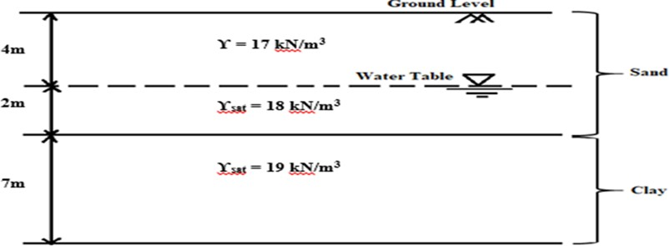 (CO3) [Application]