|  |  |  |  |  |  |  |  |  |  |  |  |
| --- | --- | --- | --- | --- | --- | --- | --- | --- | --- | --- | --- |
| Roll No |  |  |  |  |  |  |  |  |  |  |  |



PRESIDENCY UNIVERSITY BENGALURU

**SET-A**

SCHOOL OF ENGINEERING

**MAKE-UP EXAMINATION – JULY 2024**

**Semester :** Semester IV & V

**Course Code :** PET2012

**Course Name :** Reservoir Fluid Mechanics

**Program :** B. Tech. Petroleum Engineering

**Date :** 10JULY 2024

**Time :** 9:30 AM - 12:30 PM

# Max Marks : 100

**Weightage :** 50%

# Instructions:

1. *Read all questions carefully and answer accordingly.*
2. *Question paper consists of 3 parts.*
3. *Scientific and non-programmable calculator are permitted.*
4. *Do not write any information on the question paper other than Roll Number.*

**PART A**

**ANSWER ANY FIVE QUESTIONS 5QX2M=10**

1. Define Reynold’s Number. State its significance in fluid mechanics.

(CO3) [Knowledge]

1. The coefficient of discharge of a venturi meter is greater than that of an orifice meter. Give reasons.

(CO3) [Knowledge]

1. Define shear velocity and give its mathematical expression.
2. Describe Darcy Weisbach Equation along with its mathematical expression.
3. Define stagnation properties.
4. State Pascal’s law. Also, write down its mathematical expression.
5. Define uniform and non-uniform flow.

(CO4) [Knowledge] (CO4) [Knowledge] (CO4) [Knowledge] (CO1) [Knowledge] (CO2) [Knowledge]

**PART B**

**ANSWER ANY FIVE QUESTIONS 5QX10M=50**

1. An orifice meter with an orifice diameter of 10 cm is inserted in a pipe of 20 cm diameter. The pressure gauges fitted upstream and downstream of the orifice meter give readings of 19.62 N/cm2 and 9.81 N/cm2 respectively. The coefficient of discharge for the orifice meter is given as 0.6. Predict the discharge of water through the pipe.

(CO3) [Comprehension]

1. Bernoulli's equation is a cornerstone of fluid mechanics. It links pressure, velocity, and elevation, illustrating the conservation of energy in fluid flow. Understanding these relationships helps in analyzing and predicting fluid behavior in various practical applications, from engineering systems to natural phenomena. Establish a relationship between pressure, velocity, and elevation, illustrating the conservation of energy in fluid flow.

(CO3) [Comprehension]

1. At a location of a horizontal pipe, the pressure head is 32 cm and the velocity head is 4 cm. The reduction in area at a location 2 is such that the pressure head drops down zero. Predict the ratio of velocity at location-2 to that at location-1.

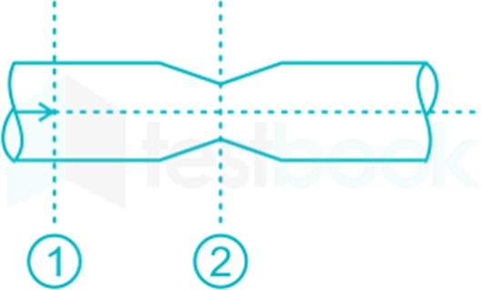

(CO3) [Comprehension]

1. The venturi meter is a valuable tool for accurate flow measurement with significant advantages in efficiency, durability, and versatility across various industries. Discuss in detail Venturimeter with a neat diagram.

(CO3) [Comprehension]

1. Pitot static tube is mounted on an aircraft travelling at a speed 300 kmph against a wind velocity of 20 kmph. If the specific weight of air is 12 N/m3 estimate the pressure difference the instrument will register.

(CO3) [Comprehension]

1. A syringe with a frictionless plunger contains water and has at its end a 100 mm long needle of 1 mm diameter. The internal diameter of the syringe is 10 mm. The plunger is pushed in at 10 mm/s and water comes out as a jet. Neglect losses in the syringe and assume fully developed laminar viscous flow throughout the needle. Estimate the force F in Newton required on the plunge. Given that the viscosity of the water is 0.001 N.s/m2.

(CO4) [Comprehension]

1. In a laminar flow through a pipe of 10 cm radius, the average fluid velocity is 5 meter per second. Predict the velocity at 5 cm radius.

(CO4) [Comprehension]

**PART C**

**ANSWER ANY TWO QUESTIONS 2QX20M=40**

1. An upward flow of crude oil (mass density 800 kg/m3, dynamic viscosity 0.8 kg/m-s) takes place under laminar conditions in an inclined pipe of 0.1 m diameter as shown in the figure. The pressures at sections 1 and 2 are measured as p1=435 kN/m2 and p2=200kN/m2.

If the flow is reversed, keeping the same discharge, and the pressure at section 1 is maintained as 435 kN/m2, Compute the pressure at section 2.

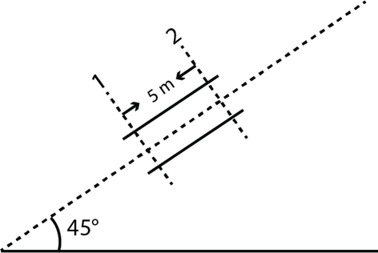

(CO4) [Application]

1. Air flows steadily through a duct with a varying cross-sectional area, such as a nozzle, at a mass flow rate of 3 kg/s. The air enters the duct at a pressure of 1400 kPa and a temperature of 200°C with a low velocity, and it expands in the nozzle to a pressure of 200 kPa. The duct is designed to approximate isentropic flow. Determine the (a) density, (b) velocity, (c) flow area, and (d) Mach number at each location along the duct that corresponds to a pressure drop of 100 kPa. Assume Cp =

1.005 KJ/Kg.K and γ = 1.4.

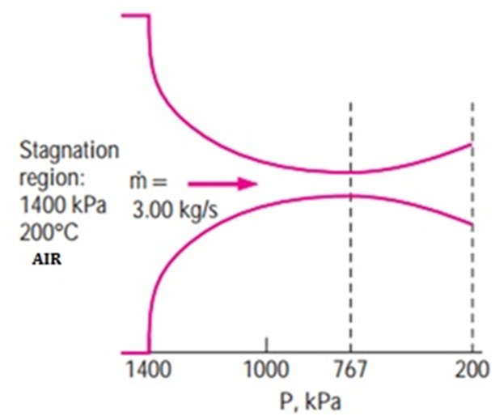

(CO4) [Application]

1. A venturimeter is installed in a pipeline of 400 mm diameter. The throat-pipe diameter ratio is 1/3. Water flows through the installation. The pressure in the pipeline is 1.405 kg/cm2 and the vacuum in the throat is 37.5 cm of mercury. If 4% of the differential head is lost between the gauges, calculate the flow in the pipeline (m3/s). (Answer correct up to two decimal places).

(CO3) [Application]