|  |  |  |  |  |  |  |  |  |  |  |  |  |
| --- | --- | --- | --- | --- | --- | --- | --- | --- | --- | --- | --- | --- |
| Roll No |  |  |  |  |  |  |  |  |  |  |  |  |



**Presidency University**

**Bengaluru**

**SCHOOL OF ENGINEERING**

**MAKE UP EXAMINATION JULY -2024**

**Date**: 01 July 2024

**Time**: 09:30 AM To 12:30 PM

**Max Marks**: 100

**Weightage**: 50%

**Semester**: V

**Course Code**: CIV 3002

**Course Name**: Analysis of Indeterminate Structures

**Program**: B. Tech

**Instructions:**

1. *Read the all questions carefully and answer accordingly.*
2. *Question paper consists of 3 parts.*
3. *Scientific and Non-programmable calculators are permitted.*

**Part A [Memory Recall Questions]**

**Answer Any 4 Questions. Each question carries 5 marks. (4Qx 5M= 20M)**

1. Calculate the Fixed end moments for AB and BC beams loaded as shown in fig. (C.O.No.1) [Knowledge]

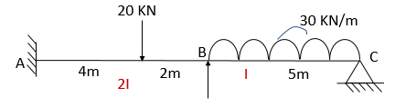

2. Calculate the Distribution factors for the joint B for the given continuous beam:

(C.O.No.2) [Knowledge]

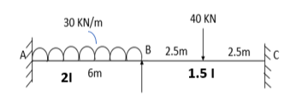

3. Calculate the Maximum Bending moment for the given beam AB:

(C.O.No.2) [Knowledge]

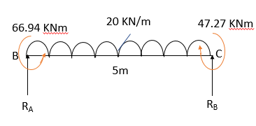

4. Calculate the Rotation factors for the joint B and C for the given continuous beam:

(C.O.No.3) [Knowledge]

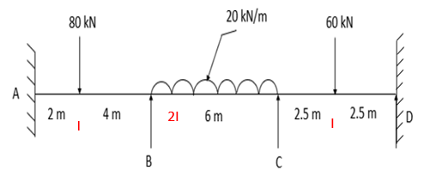

5. Calculate the Maximum Bending moment for the given beam AB: (C.O.No.3) [Knowledge]

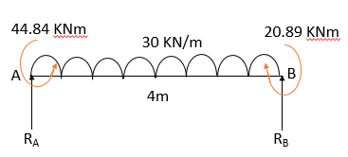

**Part B [Thought Provoking Questions]**

**Answer Any 4 Questions. Each question carries 10 marks. (4Qx10M=40M)**

1. Hardy Cross developed a structural analysis method called Moment distribution method for statically indeterminate beams and frames. For a continuous beam to be used in a RCC residential building, the engineers wants to analyze the beam for obtaining the Final end moments. The continuous beam ABCD is loaded as shown with fixed supports at A and D. Analyze the continuous beam using the Moment Distribution Method and draw the BMD. Assume EI as constant.  (C.O.No.2) [Comprehension]

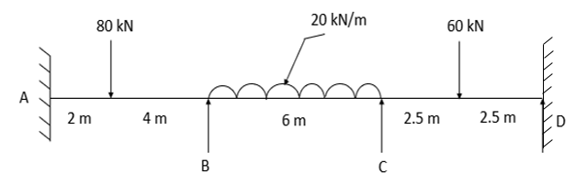

1. A room of size 8m X 16m is supported by portal frames. The beam BC is subjected to a udl of 60KN/m over a span of 8m. The beam is supported by elastic columns AB and CD with rigid joints B and C restrained at A and D as shown in figure. Analyze the given frame using Moment Distribution method. Determine the Final end moments for the frame ABCD and the Maximum Bending moment at BC. **(BMD not required)**  (C.O.No.2) [Comprehension]

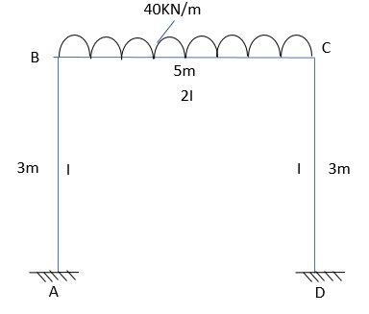

1. A continuous beam ABC is loaded as shown in the figure. Using Slope deflection method, determine the Final end moments and draw the SFD and BMD for the beam. Also Calculate the maximum positive bending moment for span AB and BC. (C.O.No.1) [Comprehension]

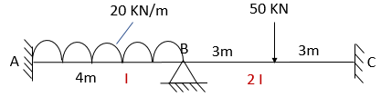

1. A continuous beam ABCD is supported at B and C and ends of the continuous beam are constructed along with supporting elements to achieve the fixity. Analyze the given beam using Slope deflection Method. Draw the BMD for the beam and Calculate the maximum positive bending moment for span AB, BC and CD. (C.O.No.1) [Comprehension]

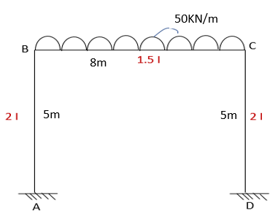

1. A continuous beam ABCD is loaded as shown in the figure. Using Kani’s method, analyze the given beam and draw the SFD and BMD for the beam. Also Calculate the maximum positive bending moment for span AB, BC and CD. (C.O.No.3) [Comprehension]

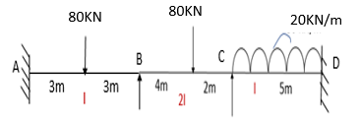

**Part C [Problem Solving Questions]**

**Answer Any 2 Questions. Each question carries 20 marks. (2Qx20M=40M)**

1. Analyze the given portal frame using Kani’s method. Draw the BMD for the frame and Calculate the Maximum positive bending moment for the span AB, BC and CD. (C.O.No.3) [Application]

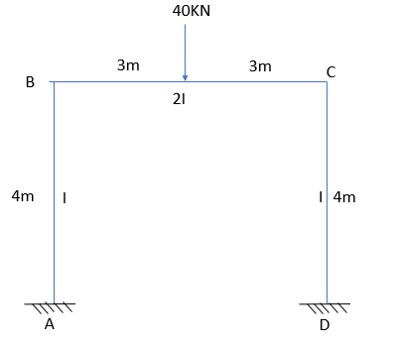

1. Analyze the given beam using **Stiffness Matrix Method**. Draw the SFD and BMD for the beam and Calculate the Maximum positive Bending moment for the span AB and BC. (C.O.No.4) [Application]

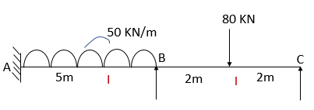

1. Analyze the given beam using **Flexibility Matrix method**. Draw the SFD and BMD for the beam and Calculate the Maximum positive Bending moment for the span AB and BC. (C.O.No.4) [Application]

