|  |  |  |  |  |  |  |  |  |  |  |  |
| --- | --- | --- | --- | --- | --- | --- | --- | --- | --- | --- | --- |
| Roll No |  |  |  |  |  |  |  |  |  |  |  |

PRESIDENCY UNIVERSITY BENGALURU

**SET B**

SCHOOL OF ENGINEERING

**MAKE-UP EXAMINATION JULY 2024**

**Semester :** Semester VI

**Course Code :** CIV3001_v02

**Course Name :** Estimation Costing and Valuation

**Program :** B.Tech.

**Date :** 01 JULY 2024

**Time :** 09.30am - 12.30pm

# Max Marks : 100

**Weightage :** 50%

# Instructions:

1. *Read all questions carefully and answer accordingly.*
2. *Question paper consists of 3 parts.*
3. *Scientific and non-programmable calculator are permitted.*
4. *Do not write any information on the question paper other than Roll Number.*

**PART A**

**Answer any 4 questions 4*5M=20M**

1. The unit of measurement is the most important factor in estimation. State the unit of measurement for the following items of works.
   1. Skirting
   2. Pointing
   3. water supply pipes
   4. Brick masonry
   5. Reinforcement steel

(CO1) [Knowledge]

1. Estimation is prepared before execution of work and it is the probable cost of construction. List the various types of estimation.
2. There are various types of estimation. Explain supplementary and revised estimate.

(CO1) [Knowledge]

(CO1) [Knowledge]

1. Various items of work have different units of measurement. State the unit of measurement for the following items of works.
   1. Nosing
   2. Door frames
   3. Stone masonry
   4. Cornice
   5. Railing for staircase
2. Explain capitalized value and Year's Purchase in valuation of buildings.

(CO1) [Knowledge] (CO3) [Knowledge]

1. A pumping set with motor has been installed in a building at a cost of Rs. 25000, assume life of pump as 20 years, work out the amount of annual installment of sinking fund required to be deposited to accumulate 4% compound interest.
2. Explain various outgoings in valuation of buildings..
3. Explain scrap value and salvage value in valuation of buildings.

**PART B**

**Answer any 4 questions 4*10M=40M**

(CO3) [Knowledge] (CO3) [Knowledge] (CO3) [Knowledge]

1. Prepare an estimate which needs to be prepared in short duration of time for a building at Mangalore having a carpet area of 25000 sq. ft, given the following data. It may be assumed that 35% of built-up area will be taken up by corridors, verandahs, lavatories, staircases, etc. and 11% of built up area will be occupied by wall and other supports.
2. Plinth area rate - Rs. 1000.00 per sq. m
3. Extra for special Architectural treatment – 1% of the building cost (BC)
4. Extra for water supply and sanitary installation – 5% of the building cost
5. Extra for electrical installations – 12% of Building cost
6. Extra for services – 5% of the building cost
7. Contingencies – 3%
8. Supervision charges - 8%

(CO1) [Comprehension]

1. Detailed estimation is the working out the quantities for various items of work before the construction of the building based on the drawings and specifications. Explain the factors to be considered during the preparation of detailed estimate.

(CO1) [Comprehension]

1. Contingency and work charged establishment are the two important terminologies in estimation. Explain them.

(CO1) [Comprehension]

1. There are various data required for preparing an estimate. Explain the various data required for preparing an estimate.

(CO1) [Comprehension]

1. A two storied building is standing on a plot of land measuring 1000 sqm at Guntur. The plinth area of each storey is 500 sqm. The building is a RCC structure with a usable life of 60 years. The building fetches a gross rent of Rs. 10000 per month. Workout the capitalized value of the property on the basis of 6%prevalent interest rate (Year’s Purchase). For sinking fund 4% compound interest rate may be assumed. Cost of land may be taken as Rs. 1000 per sqm. Other data required are given below. (i) Annual repair cost = 8% of gross rent. (ii) Municipal and property tax = 20% of gross rent.

(iii) Management and other charges = 8% of gross rent. (iv) Sinking fund required to accumulate the cost of building at the end of design life is calculated with Rs. 1500 per sqm of Plinth area. Estimate total value of the property including land cost.

(CO3) [Comprehension]

1. A colonizer from Itagalpura wants to purchase a land of 1, 00,000 square meter located at Rajanukunte, Bengaluru so as to develop into plots of 700 square meter after providing necessary roads, parks and other amenities and for which 30% of the land area is allotted. The current sale prize of the plot in neighborhood is Rs. 10, 00,000. The colonizer wants a net profit of 20%. Workout the maximum prize of the land at which the colonizer ca purchase the land. Assume
2. Cost of improving the land at Rs. 1, 00,000 per square meter
3. Cost of providing metaled roads, drainage etc. Rs. 50,000 per square meter
4. Architects and engineers fees at 3% of the sale prize
5. Other miscellaneous expenses at 1% of the sale prize

(CO3) [Comprehension]

**PART C**

**Answer any 2 questions 2*20M=40M**

1. 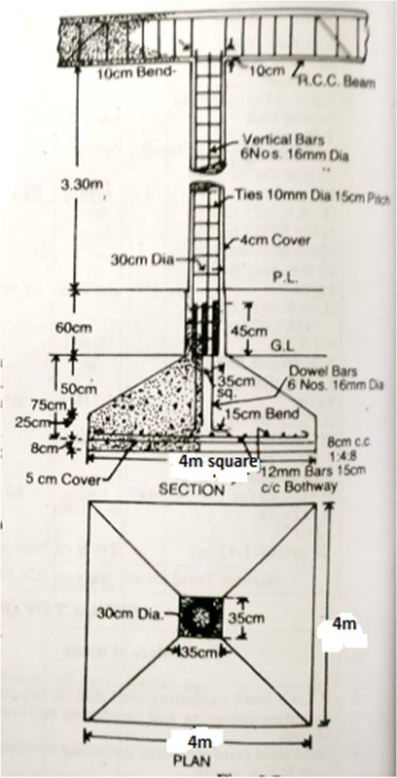For a building at Goa an estimate has to be prepared for a RCC column shown in Fig.1 with foundation footing. Prepare the estimate for the following items work. A) Earthwork in excavation in foundation, B) Cement concrete 1:4:8 at the base C) RCC work 1:2:4 in footing D) RCC work 1:2:4 in column and E) Steel reinforcing bar.

(CO2) [Application]

1. Estimate the quantities of the following items of a residential building from the given plan and section shown in the figure by center line method.
2. Earth work in excavation in foundation
3. Lime concrete in foundation
4. I class Brickwork in 1:6 cement mortar in foundation and plinth
5. 2.5 cm thick Damp proof course

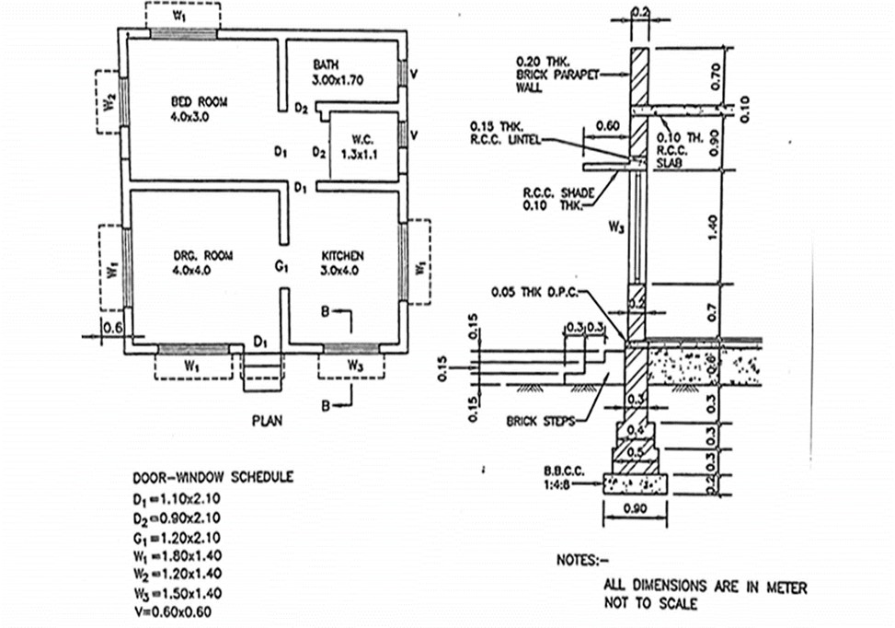

(CO2) [Application]

1. 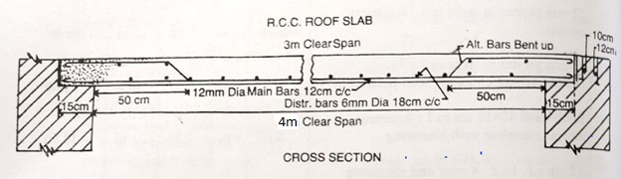Prepare an estimate for a RCC roof slab of a building at Jamnagar, 4m clear span and 6m length from the given drawing. RCC work including centering and shuttering can be taken out separately.

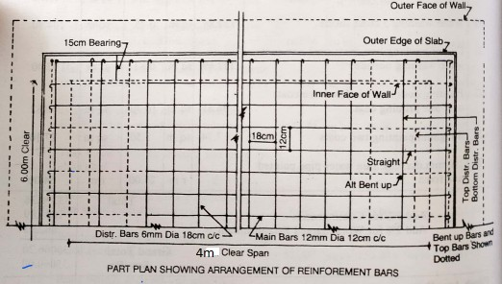

(CO2) [Application]

1. An estimate needs to be prepared for a building situated at Vasanthnagar. In this context, prepare an estimate by center line method for the following items of works by center line method for the building plan whose line diagram is given below. The Fig. show the plan of superstructure wall of a 2 BHK residential building and section represents the cross sections of the walls with foundation. a) Earthwork in excavation in foundation. b) Plain cement concrete (PCC) in foundation. c) Brickwork in foundation and plinth in 1:6 cement mortar. d) First class brickwork in super structure in 1:6 cement mortar, e) 2.5 cm thick damp proof course (DPC). The openings such as doors and windows sizes and lintels over all the openings are mentioned in the drawing.

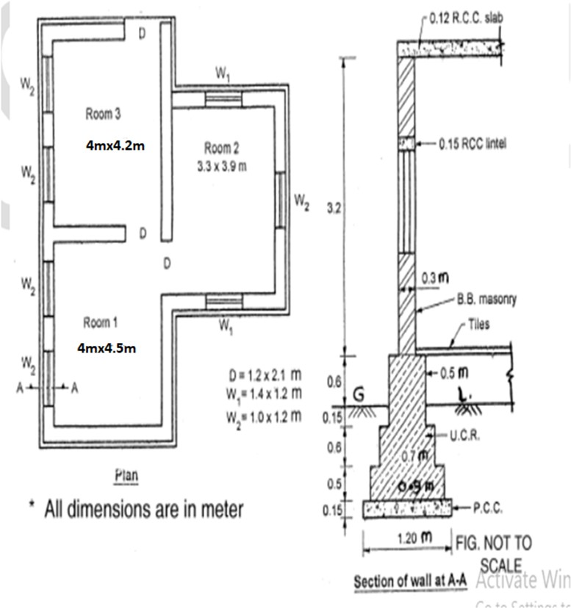

(CO2) [Application]